
®
®

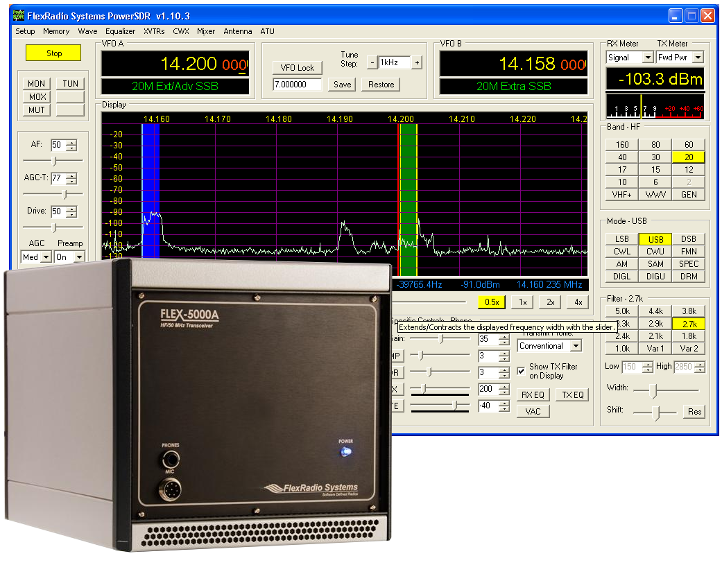


owner's Manual
Version 1.10.3
SOFTWARE DEFINED RADIO

FLEX-5000 Owner's Manual
© 2003−2007 FlexRadio Systems
All Rights Reserved

Reproduction of this document in any form
is expressly forbidden unless
explicitly authorized by FlexRadio Systems

FlexRadio Systems
12100 Technology Boulevard • Austin, TX 78727
Phone: (512) 250-8595 • Fax: (512) 233-5143
Email: sales@flex-radio.com

Editor: Joe de Groot – AB1DO

Table of Contents
Preface viii
Acknowledgments ix
1 Hardware Installation 1
Unpacking and Deciding on a Location 1
Contents of the Carton 1
Location Considerations 2
Physical Connections 3
Front Panel 3
(1) LED Push Button Power Switch 4
(2) Headphone Jack 4
(3) Microphone Connector 4
Back Panel 5
(1) Primary Antenna Ports (ANT1, ANT2 & ANT3) 5
(2)-(3) Receive Only Antenna Ports (RX1 IN & RX2 IN) 5
(2) External RX1 OUT to RX1 IN Receive Loop 6
(4)-(5) Dedicated Transverter Connections 6
(6) 13.8 VDC Power Socket 6
(7) Dual IEEE 1394 FireWire® Jacks 6
(8) Straight Key or Paddles (KEY) 7
(9) External Keying Lines (AMP RLY TX1, TX2 & TX3) 7
(10) External Frequency Reference Input 8
(11) Powered Speaker/Line Out Jack 8
(12) FlexWire™ Peripheral Interface Bus 8
(13) Line-Out and Line-In Audio Jacks 9
(14) Balanced Line Input 9
Connecting to a Balanced XLR Connector 10
(15) PTT Jack 10
(16) RF Ground Terminal 11
Installing the FLEX-5000 FireWire Driver 11
Switch Off the FLEX-5000 and Install the Driver 11
Power Up the FLEX-5000 16
Configuring the Driver with the FLEX-5000 Control Panel 19
Sampling Rate and Buffer Size 20
Operation Mode 21
2 Software Installation & Setup 23
Upgrading From an Earlier Version 23
PowerSDR Executable Installation 23
PowerSDR Setup Wizard 28
Initial PowerSDR Configuration 32
Transfer of Calibration Data 33
Audio Parameters 35
Antenna Port and External Keying Lines 35
Audio Mixer 37
No Calibration Required 38
3 Front Console 39
(1) VFO A 41
(2) Tuning Controls 41
(3) VFO B 42
(4) Multimeter 42
RX Meters 42
TX Meters 43
(5) Band Selection & Band Stacking Memories 44
(6) Mode Selection 45
(7) Filter Controls 46
Labeled Filter Buttons 46
Variable Filter Buttons 47
(8) Mode Specific Controls 48
Phone Controls 48
CW Controls 49
Digital Controls 51
(9) Display Controls 51
Panadapter/Waterfall Viewing Controls 52
Display Type Controls 52
Display Type Descriptions 52
Spectrum 53
Panadapter (Panoramic Adapter) 53
Histogram 54
Waterfall 55
Scope 56
Phase 56
Off 57
Cursor and Peak Position 57
(10) MultiRX Controls 58
(11) DSP Controls 58
(12) VFO Controls 59
(13) CPU % 60
(14) Start/Stop Button 60
(15) MON (Monitor) 60
(16) MOX (Manually Operated Transmit) 61
(17) MUT (Mute) 61
(18) TUN (Tune) 61
(19) AF (Audio Frequency Gain) 62
(20) AGC-T (AGC Maximum Gain) 62
(21) Drive (Transmitter Power Output/Tune Power) 62
(22) AGC (Automatic Gain Control) 62
(23) Preamp 63
(24) SQL (Squelch) 63
(25) Date/Time Display 64
(26) Setup Form 64
(27) – (35) Operating Forms 64
4 Setup Form 65
General Tab 66
Hardware Config Sub-Tab 66
Radio Model 66
DDS 67
Options Sub-Tab 68
Options 69
Process Priority 69
Update Notification 69
Click Tune Offsets (Hz) 70
Miscellaneous 70
Keyboard 71
Custom Title Text 71
Calibration Sub-Tab 72
Filters Sub-Tab 73
Audio Tab 74
Primary Sub-Tab 74
Buffer Size 74
Sample Rate 74
Mic Boost 75
Expert 75
Latency 75
VAC Sub-Tab 75
Virtual Audio Cable Setup 76
Gain (dB) 76
Latency 76
Mono/Stereo 76
Auto Enable 76
DSP Tab 77
Options Sub-Tab 77
Noise Reduction 77
Automatic Notch Filter 78
Buffer Size 79
Noise Blanker 80
Noise Blanker 2 80
Window 81
Image Reject Sub-Tab 82
Expert 83
Receive Rejection 83
Transmit Rejection 83
Keyer Sub-Tab 84
CW Pitch 85
Connections 85
Options 85
Signal Shaping 86
Break In 86
AGC/ALC Sub-Tab 87
AGC 87
Leveler 88
ALC 88
Display Tab 89
Spectrum Grid 90
Refresh Rates 90
Waterfall 91
Multimeter 91
Phase Resolution 92
Scope Time Base 92
Averaging 92
Polyphase FFT 92
Transmit Tab 93
TX Profiles 94
Transmit Filter 94
Noise Gate 95
VOX 95
TX Monitor 96
Compression 96
AM Carrier Level 97
PA Settings Tab 98
Gain By Band (dB) 98
Appearance Tab 99
Display Sub-Tab 99
Overall Display 100
Cursor/Peak Readout 100
Panadapter 101
General Sub-Tab 102
VFO 103
Band Data 103
Meter Sub-Tab 104
Original Style 105
Edge Style 105
Keyboard Tab 106
Cat Control Tab 107
Cat Control 108
PTT Control 109
DigL/U Returns LSB/USB 109
Test 110
Tests Tab 111
Two Tone Test: 111
Audio Balance Test 111
Signal Generator 112
Enable HW Signal Generator 113
5 Operating Forms 114
(27) Memory Form 115
Save… 115
Recall… 116
(28) Wave Form 117
Playback 117
Playlist 118
Record 118
TX Gain (dB) 118
Record Options 118
Receive 119
Transmit 119
Sample Rate 119
(29) Equalizer Form 120
3-Band Equalizer 120
10-Band Equalizer 121
100-Band Equalizer 121
(30) XVTRs Form 122
(31) CWX Form 123
Standard CWX Controls 123
CWX Memories 124
Special Characters 124
Keyboard and Extended Controls 125
Extended CWX Controls 126
Morse Definition Editor 127
(32) Mixer 128
Input 128
Output 128
(33) Antenna 129
Simple 129
Expert 130
(34) ATU 132
Operating Mode 132
Tuning Options 132
SWR Threshold 133
Tuner Feedback 133
Voltage and Temperature Information 133
6 Operation 134
Power-Up Procedure 135
Power-Down Procedure 135
Tuning Methods 136
Spectrum Drag and Click 136
Mouse Wheel 136
Mouse Wheel Hover 136
Spectrum Click Tuning 136
Keyboard Keys 137
USB Tuning Knob 137
Voice Transmission Operation 138
CW Transmission Operation 142
Initial Settings 143
Internal Keyer 144
External Keyer 146
CWX Form 146
Third Party Program 148
Digital Mode Operation 151
CAT Control Setup 154
Install VCOM 154
Configure the VCOM Port Pairs 160
Configure PowerSDR CAT Control 162
Configure PowerSDR Keyer Connections 163
Virtual Sound Connection 164
Create the Virtual Audio Cables 164
Setup VAC in PowerSDR 166
Setting up Third Party Digital Programs 167
Using MixW with PowerSDR 167
Programs Needing to Connect to the Default Sound Device 171
7 Specifications and Architecture 174
FLEX-5000A Specifications 174
FLEX-5000 Architecture 176
Declarations of Conformity 177
FCC 177
EU Compliance 177
A Buffers and Sample Rate 178
Filter Effects 178
Latency Effects 181
Underlying Theory 181
B Updating the Flex-5000 Firmware 183
Download and Extract the Firmware 183
Update the Firmware 183
C Optimizing the AGC 186
D Window Functions 188

Preface
Welcome to the exciting world of software defined radio. The FLEX-5000™ software defined transceiver is the culmination of many years of experience gained with FlexRadio's ground breaking SDR-1000™ transceiver. The experience gained and lessons learned have resulted in an SDR platform that is truly state of the art, offering unsurpassed Amateur Radio performance. And unlike most other transceivers, which once acquired, rarely if ever change, the FLEX-5000 will continue to (rapidly) evolve, offering future capabilities currently only dreamed of.
Although the rapid development of the FLEX-5000 can be exhilarating, it can also be somewhat daunting. When first confronted with an FLEX-5000 and its PowerSDR™ operating software, the sheer number of connections, controls, and settings can seem mind boggling even to the most seasoned Ham radio operator. This operating manual attempts to both guide a user step by step through the setup process (both hardware and software) and to act as a reference once the radio has been set up. Additionally, the freely downloadable PowerSDR software will install with default settings that, in most cases, will require little adjustment. Any adjustments that you make are automatically saved and can be imported into an updated version of the software.
Due to the nature of the FLEX-5000, the largest part of this operating manual, by far, will refer to software. The operating manual has numerous screenshots of windows and forms to detail the various steps. Although the manual describes the latest official release of the PowerSDR software, you may occasionally notice an earlier version identified in the title bar of a screenshot. This is because FlexRadio Systems® has decided to only update a screenshot if it changes.
If you have any ideas on how to improve the FLEX-5000, please feel free to contact us, or better still, to join our email reflector. Not only is the FLEX-5000 a software defined radio; it is also a user defined radio.
FlexRadio Systems is committed to ensuring that your experience with the FLEX-5000 will be one of the most enjoyable you have with Ham radio. If you have any questions, issues or problems operating PowerSDR and/or the FLEX-5000, you may be able to find the solution on the Support Pages of our website, in our Knowledge Base, our Forum, or through our highly active email reflector. If none of these sources provide you the assistance required, please contact FlexRadio Systems using the information provided on the Contact page of our website.

Acknowledgments
FlexRadio Systems could not be as successful, nor could the FLEX-5000 radio be what it is today without the many selfless contributions from our users all over the world. These contributions have spanned and continue to span improvements to our hardware and software, ranging from bug reports and feature requests to actual design and implementation of certain functionality.
Identifying contributors by name would only risk leaving out others with equally valuable contributions. We therefore wish to suffice with a heartfelt thank you for your support and continued commitment.

[The rest of this page has been left blank intentionally]

Hardware Installation
The FLEX-5000 hardware installation is a four step process.
- Unpacking and deciding on a location
- Physical connections to the radio, such as power supply, antenna(s), microphone, key, etc. Although not necessary, you should preferably make all these connections in advance.
- Installing the FLEX-5000 FireWire® Driver This driver is required to enable the computer to interface with the FLEX-5000. Before installing the driver, you must at least connect the FLEX-5000 to a 13.8VDC power supply and an IEEE 1394 FireWire host controller (PC FireWire port).
- Configuring the FLEX-5000 FireWire Driver by setting the sampling rate, buffer size and operation mode.

Unpacking and Deciding on a Location

Contents of the Carton
Inside the carton you should find the following items:
- FlexRadio Systems FLEX-5000A transceiver
- 6-pin to 6-pin FireWire cable (6 feet )
- Unterminated 12 AWG power cable (8 feet)
- Quick Start Guide for Experienced SDR Users

[The rest of this page has been left blank intentionally]
- CD-ROM or USB Flash drive containing
  - FLEX-5000 Owner’s Manual
  - FLEX-5000A Installation and Configuration Manual
  - Quick Start Guide for Experienced SDR Users
  - PowerSDR 1.10 or later
  - FLEX-5000 FireWire driver
(Other items may be included that are not listed above)
The FLEX-5000 power cable is unterminated on one end so that you can adapt it to various DC power connectors, such as Anderson Power Poles, Banana plugs, screw terminals or spade lugs.
Note: Retain the FLEX-5000 packaging for future use. This packaging was specially designed for the radio to prevent damage which may occur during shipping. If you ever need to ship your FLEX-5000 anywhere, especially back to FlexRadio Systems, this is the preferred packaging to use.

Location Considerations
To facilitate integrating your FLEX-5000 into your shack you may want to consider the following:
- Place the FLEX-5000 in close proximity to your computer. It is best to use the shortest FireWire cable possible to connect to your computer to minimize data errors and limit possible RFI getting into the computer. High quality, quad-shielded FireWire cables up to 10m in length have been used successfully with the FLEX-5000.
- Ensure convenient access to the back panel. The FLEX-5000 back panel is where most of your connections will be made. Having easy access to the back panel without moving the transceiver is optimal while getting started.
- Avoid placing the FLEX-5000 in direct sunlight. Placing the transceiver in direct sunlight will increase the ambient temperature inside the chassis (especially while transmitting) and make the high volume cooling fan’s job more difficult.
- Heed air flow requirements. Air is drawn in through the filtered bottom air vent in the front of the FLEX-5000 and is exhausted through the top vent in the rear for optimal cooling. Do not block either the front intake or the rear exhaust vent since this will reduce the cooling efficiency.
- Avoid contact with liquids. Although this is usually not a problem unless you are operating maritime mobile, accidental spills of liquids in the shack on the FLEX-5000 could result in voiding the warranty. Placing the FLEX-5000 away from food and drinks is highly recommended.

Physical Connections
To facilitate integrating the FLEX-5000 into your station, it is worth taking a moment to study the radio's front back and panels. The many antenna and audio connections are not immediately intuitive. This is a direct consequence of the FLEX-5000's versatility in accommodating many configurations, including receive-only antennas, external signal enhancing equipment and transverters, all of which can be assigned on a per band basis, without requiring complex external switching arrangements.
We will now discuss first the front panel and then the back panel connections.
Hint: You can also visit the interactive virtual tour on our website of the front panel and back panel respectively, where you can hover over a connector with your mouse to pop up its description.

Front Panel
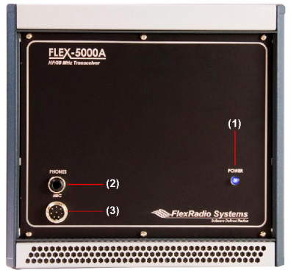Figure 1: FLEX-5000A Front Panel

[The rest of this page has been left blank intentionally]

(1) LED Push Button Power Switch
The FLEX-5000 uses a delayed start push button to power up the radio.
- To turn on the radio, push the button in fully and release. After a few seconds you will hear the power relay click and see the blue LED illuminate to indicate that the radio is powered up.
- To turn off the radio, again push the button fully and release.
Note 1: Make sure the FLEX-5000 is turned on before starting PowerSDR. If this happens, PowerSDR will indicate a communication error and offer the option to run in Demo mode. Click No to close PowerSDR, turn on the FLEX-5000 and restart PowerSDR.
Note 2: Make sure PowerSDR is shut-down before turning off the radio. If this happens, close PowerSDR and power cycle the FLEX-5000 (turn on, off and on again) and restart PowerSDR.

(2) Headphone Jack
Accepts headphones with standard 1/4” stereo (TRS) plug. Recommended ratings for headphones are 40 mW into 16 Ohm load (typ) with a 1% THD+N. Higher impedance headphones will also work.
Note: Lower impedance headphones and headphones using a mono plug can result in popping audio as soon as PowerSDR is started.

(3) Microphone Connector
The 8-pin microphone connector offers the ability to connect a microphone and to key the radio via a PTT line. The pin-out is shown in Table 1 below. To engage PTT, pin 6 must be grounded to pin 5 (Shield Ground) and not to pin 7, which is the microphone ground.
Table 1: Microphone Connector Pin-Out
Pin # |  | Signal | Diagram
1 | Not Connected |  | 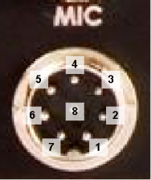
2 | +5V DC (max 65mA)
3 | Not Connected
4 | Not Connected
5 | Chassis GND (Shield)
6 | PTT (+)
7 | Mic (–)
8 | Mic (+)

We recommend use of the Heil microphones, especially the PR series; however, the HM-10 and Goldline microphones will also work well with the FLEX-5000.

Back Panel
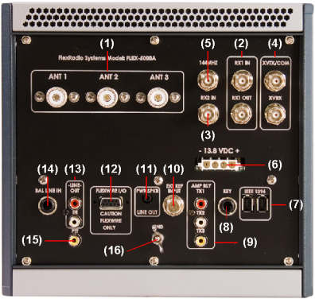Figure 2: FLEX-5000A Back Panel
The FLEX-5000 has the ability to connect up to three different antennas to the receiver and or transmitter and and up to two additional receive only antennas. All of these are assignable on a per band basis. The antenna connections are as follows:

(1) Primary Antenna Ports (ANT1, ANT2 & ANT3)
Three SO239 antenna ports that can be software selected on a per band basis and assigned as either receive, transmit or both.

(2)-(3) Receive Only Antenna Ports (RX1 IN & RX2 IN)
Up to two additional receive only antennas can be connected, each of which is separately selectable on a per band basis.
- RX1 IN is the receive only antenna port for the first receiver.
- RX2 IN can be used to connect a receive only antenna to the optional second receiver.

[The rest of this page has been left blank intentionally]

(2) External RX1 OUT to RX1 IN Receive Loop
With PowerSDR a dedicated receive path can be selected by band so that all of the receive signals input to either ANT1, ANT2 or ANT3 are output to the RX1 OUT port and input back into the RX1 IN port. This enables the insertion of external signal enhancing devices such as preamps, filters and preselectors, without requiring complicated switching mechanisms to avoid transmitting through them.

(4)-(5) Dedicated Transverter Connections
The FLEX-5000 has been designed to support transverters through both a 28MHz and/or 144MHz IF interface.
- XVTX/COM outputs a 28MHz IF signal, adjustable up to +5dBm to drive external transverters
- XVRX accepts a 28MHz IF signal from external transverters. If your transverter does not have a separate IF output, then only use XVTX/COM
- 144MHz is the output of the optional, internal transverter. This transverter can be used as such for the 2m band or to provide a 144MHz IF to/from external transverters.

(6) 13.8 VDC Power Socket
The FLEX-5000 requires a stable 13.8 VDC power source rated for at least 25 Amps and 30 Amps peak for proper operation. Supplied with your radio was an unterminated 4-pin keyed Molex type power connector and cable set. Terminate this cable in the appropriate connector (if needed) for your DC power source such as Anderson PowerPoles®, banana plugs, spade or ring lugs, or tinned ends for screw terminals. The Molex type connector is inserted into the white Molex receptacle labeled -13.8 VDC+.

(7) Dual IEEE 1394 FireWire® Jacks
The FLEX-5000 has two 400 Mb/s 6-pin IEEE 1394 FireWire jacks. These are 1394a connections not the 1394b (FireWire 800) type which run at 800 Mb/s. Even though the 1394b standard is supposedly downward compatible (9-pin to 6- or 4-pin cables are used), you should preferably only use 1394a host adapters to connect to the FLEX-5000. Please also refer to the Knowledge Base article Selecting High Performance FireWire Cards for FlexRadio Transceivers.
Connect the supplied 6-pin FireWire cable between your computer’s FireWire jack (the host controller) and the FLEX-5000. Either of the two jacks can be used. The second FireWire jack can be used to “daisy chain” or extend the FireWire bus so that additional IEEE 1394 FireWire devices may be connected.
CAUTION: Do not connect the second FireWire jack to a second PC. Only one PC can be connected to the FLEX-5000.

[The rest of this page has been left blank intentionally]
Note: The FLEX-5000 FireWire controller does not supply voltage, so if you are connecting a device “down stream” that normally receives power from the FireWire cable, such as the Edirol FA-66, you must supply external power to use that device.

(8) Straight Key or Paddles (KEY)
For CW operation, the ¼” TRS KEY jack will accept a TRS plug for operating a keyer with paddles or a TRS/TS plug for a straight key. The pin-out is shown in Table 2 below.
Table 2: Key Jack Pin-Out
Connector | Keyer Signal | Straight Key
Tip | Dot | Key
Ring | Dash | Key
Sleeve | Common | Common

Note: Although not necessary, if you prefer to connect your paddles to a serial port on your PC you may do so using the pin-out shown in Table 3.
Table 3: PC Serial Port Pin-Out
Serial Port Pin* | Keyer Signal
4 (DTR) | Common
6 (DSR) | Dot
8 (CTS) | Dash
* Assumes a 9-Pin connector

(9) External Keying Lines (AMP RLY TX1, TX2 & TX3)
These three independent keying lines can be used to key external devices such as linear power amplifiers or transverters. One or more of the keying lines can be used at any one time and can be assigned on a per band basis on the Antenna Form (see page 129). For example, you may have an HF amplifier that covers 160-10 meters and another amplifier for 6 meters. You can assign TX1 to bands 160 -10 meters to key the HF amplifier and TX3 to 6 meters to key that amplifier when you select the 6 meter band.
These keying lines each use an open collector Darlington transistor switch that is rated at 400mA, 50VDC maximum. To ensure that your amplifier keying circuit does not damage the Darlington transistor switch, insert the circuit shown in Figure 3 below between each of TX1, 2 and/or 3 and your amplifier(s).
[The rest of this page has been left blank intentionally]

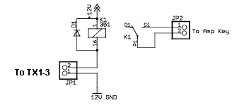
Figure 3: Protective PTT Circuit Between TX1-3 and Amplifier

(10) External Frequency Reference Input
Accepts input from an optional 10MHz, 0 to +10dBm reference source, such as a GPS disciplined or high precision clock source. This enables greater frequency stability for those operators requiring such, e.g. for VHF+ operators operating in the GHz range.

(11) Powered Speaker/Line Out Jack
This standard 1/8” TRS jack provides line-level (-10dBV, 600 Ohms) receive audio. Connect to an external audio amplifier, to computer-type powered speakers or any other external equipment that accepts line-level audio input. This jack provides two-channel (stereo) audio to enable binaural audio, MultiRX (single receiver) or dual receive (with optional second receiver installed). The audio level can be set on the FLEX-5000 Mixer Form (see page 128).
For more information on powered speakers used with FlexRadio products, refer to the Knowledge Base article What Kind of Speakers Should I buy for my SDR?

(12) FlexWire™ Peripheral Interface Bus
FlexWire is an intelligent, high speed, bi-directional communications interface that allows PowerSDR to communicate with a host of peripheral devices such as antenna tuners, rotor controllers, band switchers, etc. A family of FlexWire peripherals will be forthcoming from FlexRadio Systems. This is not another “CAT” port, but an industry standard bidirectional communications bus based on the I2C (pronounced “I squared C”) protocol along with AF I/O lines.

[The rest of this page has been left blank intentionally]
Table 4: FlexWire Connector Pin-Out
Pin # | Signal | Diagram
1 | Ground | 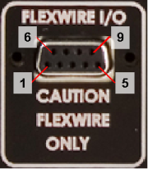
2 | Line In
3 | (Blocked Pin)
4 | Interrupt (/INT 1)
5 | Ground
6 | I2C Clock (SCL)
7 | I2C Data (SDA)
8 | +13.8V, 1A max
9 | Line Out (in parallel with RCA Line Out)

Table 4 above Shows the FlexWire connector pin-out. Complete specifications and the programming interface will be published to allow home brew and third-party add-on products.
CAUTION: Do NOT attempt to connect a PC serial port to the FlexWire connector (pin 3 has been blocked to stop this). Doing so may void your warranty and severely damage your FLEX-5000.

(13) Line-Out and Line-In Audio Jacks
Consumer level (-10 dBV) audio connections. Audio levels can be set on the FLEX-5000 Mixer Form (see page 128).
- Line-Out can drive external sound card-based applications if VAC is not, or cannot be used. It can also provide audio for external audio equipment such as recorders and audio spectrum analyzers. Line Out impedance equals 600 Ohms.
- Line-In allows the connection of external audio equipment, VAC or an external sound card, e.g. to play back prerecorded audio over the air. Line In impedance equals 5 kOhms.

(14) Balanced Line Input
1/4” TRS jack to connect to audio processing equipment supplying balanced audio (+4dBμ max), such as a microphone pre-amplifier or (chain of) equalizers, compressor/limiters, aural exciters and other effects processors. This jack can be used instead of the MIC connector on the front panel. The Pin-Out is shown in Table 5 below. Balanced Line Input input impedance is >50 k Ohms.
Table 5: Pin-Out of Balanced Line-In Connector
Contact | Description |  | Connector
Tip |  | Positive phase for balanced mono signals or mic (+) | 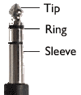
Ring |  | Negative phase for balanced mono signals or mic (-)
Sleeve |  | Ground or shield connection

Connecting to a Balanced XLR Connector
The most common way to use the balanced line-in connector is when using a balanced microphone, usually having a male XLR connector (see Table 6 below).
Table 6: XLR Male and Female Connector Pin-out
Contact | Description |  | Connector
Pin 1 |  | Ground or shield connection | 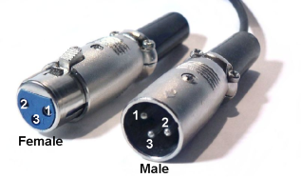
Pin 2 |  | Positive phase for balanced mono signals or mic (+)
Pin 3 |  | Negative phase for balanced mono signals or mic (-)

To interface this type of microphone to the FLEX-5000 a balanced XLR (female) to balanced ¼” TRS (male) cable is necessary, which should be wired as shown in Figure 4a. You can also connect audio processing equipment using a similar cable. If you have a ground loop or a lack of proper grounding (indicated by hum or buzz in your output), adding a simple filter to the shield may resolve the problem (see Figure 4b). The filter consists of typically a 100 Ohm resister to attenuate small DC currents, decoupled for RF by typically a 4pF – 10nF capacitor.
a. Connecting Balanced XLR Microphone to Balanced TRS Plug
b. Connecting XLR Audio Processing Equipment to Balanced TRS Plug – Eliminating Ground Loop

Figure 4: Wiring Diagrams to Connect Between Balanced TRS and XLR Connectors

(15) PTT Jack
Connect to external hardware devices such as foot pedals or hand switches to key the rig. The transmitter will be engaged when the center conductor is grounded.

(16) RF Ground Terminal
Connect to the single point ground system in your shack. Alternatively, if you have no single point grounding system, ground the FLEX-5000 to the metal chassis of your computer with a low impedance ground strap, such as a 1” braid or copper strip (the screws that hold the computer power supply in place make an excellent grounding point).

Installing the FLEX-5000 FireWire Driver

Switch Off the FLEX-5000 and Install the Driver
Note 1: To install the FLEX-5000 FireWire Driver, you must at least connect the FLEX-5000 to a 13.8VDC power supply and an IEEE 1394 FireWire computer port.
Note 2: If there is an Edirol FA-66 or Presonus Firebox sound card connected to the same FireWire host controller you are planning to use with the FLEX-5000, disconnect it until the installation is complete and the FLEX-5000 is fully operational.

WARNING! It has been reported that data corruption occurred when trying to use a FireWire hard disk. We do not recommend that you have a FireWire connected hard disk to the same FireWire controller (bus) as the FLEX-5000. Both of these devices extensively use the FireWire bus and performance of both will be degraded significantly.
Download the FLEX-5000 FireWire Driver from the downloads page of our website and save the zip file to a convenient location on your computer. Then go to the saved zip file and extract its contents.
Before proceeding with the installation, make sure the power switch on the FLEX-5000 is turned off (blue LED is off, see Figure 2 on page 5). It is also a good idea to close all other applications.
Double click on the extracted driver installation file to open the FLEX-5000 Setup Wizard (Figure 5).

[The rest of this page has been left blank intentionally]
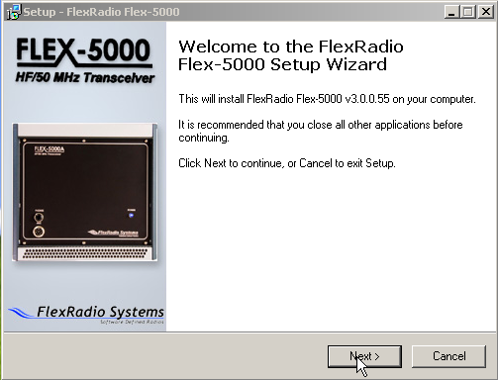Figure 5: FLEX-5000 Driver Setup Wizard
Click the Next button to continue to Figure 6 .

[The rest of this page has been left blank intentionally]
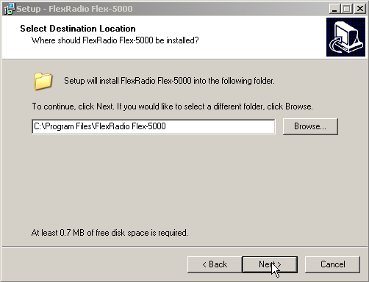Figure 6: FLEX-5000 Driver Setup Wizard - Select Destination Location
We recommend you accept the default location to install the FLEX-5000 FireWire to. Click the Next button to continue to Figure 7.

[The rest of this page has been left blank intentionally]
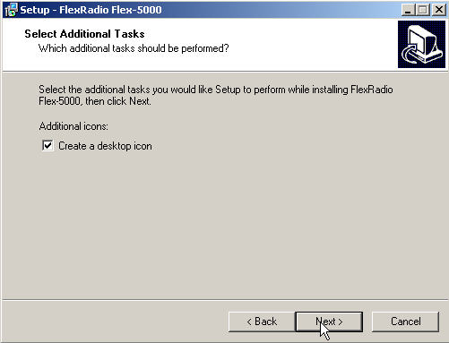Figure 7: FLEX-5000 Driver Setup Wizard - Select Additional Tasks
If you do not want the FLEX-5000 Control Panel icon on your desktop, uncheck the “Create a desktop icon” option. Click the Next button to continue to Figure 8.

[The rest of this page has been left blank intentionally]
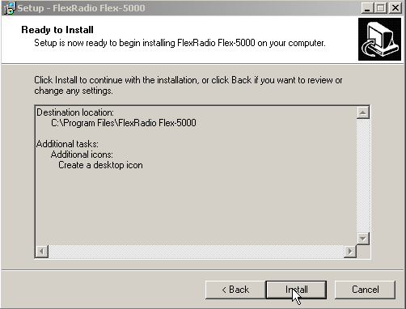Figure 8: FLEX-5000 Driver Setup Wizard - Ready to Install
Verify that the options selected in the previous two steps are correct. If not, click the Back button to make any changes. Click the Next button to confirm these settings and to copy the necessary files to the selected install directory. If a Software Installation warning appears, click the Continue Anyway button to proceed.
Once the files have been copied, you will see the screen shown in Figure 9.

[The rest of this page has been left blank intentionally]
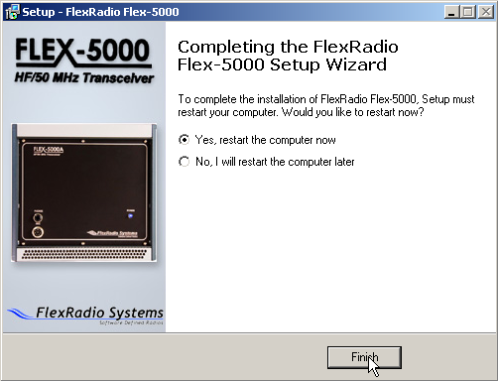Figure 9: Completing the FlexRadio FLEX-5000 Setup Wizard
You will need to restart your computer before you can continue. We recommend you do this now by accepting the default selection, verifying that the FLEX-5000 in not powered on and clicking on the Finish button.

Power Up the FLEX-5000
After your computer has rebooted, press and release the power button on the FLEX-5000 to power it up. After a brief moment, you will hear the power relay click and the blue LED will illuminate the power button. When this happens, Windows XP will detect the FLEX-5000 and display the Found New Hardware Wizard (Figure 10).

[The rest of this page has been left blank intentionally]
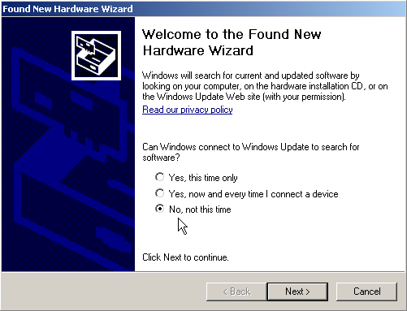Figure 10: Found New Hardware Wizard
Select the option No, not this time when you are prompted to use Windows Update to search for software. Click on the Next button to continue to Figure 11.
Note: Figure 10 above may not show up in some systems.

[The rest of this page has been left blank intentionally]
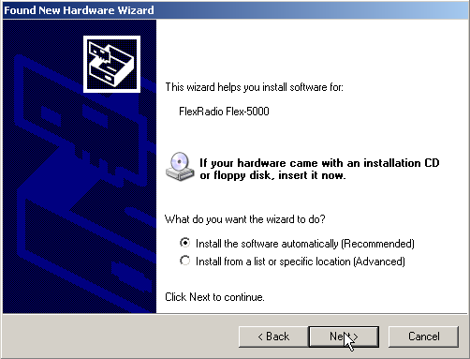Figure 11: Found New Hardware Wizard - Installing the Software
The Found New Hardware Wizard will recognize that you are trying to install a FlexRadio FLEX-5000. Select the option Install the software automatically (Recommended). Click on the Next button to continue.
The Found New Hardware Wizard will request you to please wait while it installs the software (Figure 12). If a Hardware Installation warning appears, click the Continue Anyway button to proceed.

[The rest of this page has been left blank intentionally]
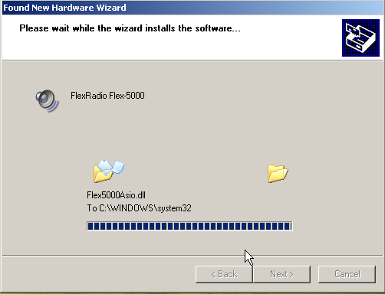Figure 12: Found New Hardware Wizard - Software Installation Indicator
After the driver files are installed you will see the Completing the Found New Hardware Wizard screen to indicate that the wizard has finished installing the software for the FlexRadio FLEX-5000. Click on the Finish button to continue. You should see a prompt in the bottom right hand corner of your display that indicates that your new hardware is ready to use.

Configuring the Driver with the FLEX-5000 Control Panel
Before operating the FLEX-5000 you will need to select the driver's appropriate Sampling Rate, Buffer Size in Samples and Operation Mode using the FLEX-5000 Control Panel (see Figure 13 on page 20). If you elected to create a desktop icon during driver installation (see Figure 7 on page 14), simply double click on this icon to open the control panel. Alternatively, click on the Start button (bottom left of your screen) and then on All Programs. Select the FlexRadio FLEX-5000 program folder and double click on the FlexRadio FLEX-5000 application.

[The rest of this page has been left blank intentionally]
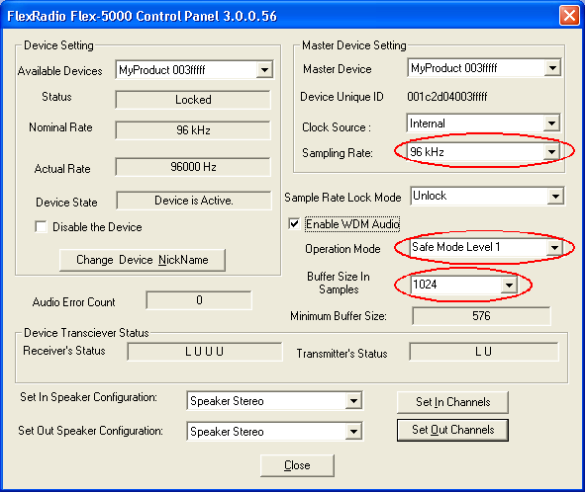Figure 13: FLEX-5000 Control Panel Settings

Sampling Rate and Buffer Size
These settings depend on the modes you primarily operate. For CW, minimum latency is paramount; for digital and phone modes, larger buffers may increase stability, especially if using VAC or other third-party audio programs.
- The lower the sampling rate, the smaller the buffer size can be to achieve the same overall system latency.
- The minimum buffer size at a certain sample rate depends on the available computing power: smaller buffers require more interrupts per unit of time (audio dropouts are an indication of too low a buffer size). Therefore, the lowest sampling rate will achieve the lowest latencies.
Table 7 below shows initial settings for the driver's Sampling Rate, Buffer Size and Operation Mode. You should start with these values and if you desire you can experiment with other settings. In some cases, where audio drop outs are being experienced, larger buffers may need to be used. Also, see Appendix A for more detail.
Table 7: Initial Driver Configuration Settings
Modulation Mode | Sampling Rate (kHz) | Buffer Size | Operation Mode
CW | 48 | 512 | Safe Mode 1
CW | 96 | 512 | Safe Mode 1
CW | 192 | 1024 | Safe Mode 1
Phone | 48 | 512 | Safe Mode 1
Phone | 96 | 1024 | Safe Mode 1
Phone | 192 | 2048 | Safe Mode 1

Note: If this is the first time you are using a software defined radio, a conservative sampling rate such as 96 kHz is recommended until you know how your PC is going to perform.

Operation Mode
There are four Operation Modes to choose from: Normal and Safe Mode Levels 1 – 3, where Normal is the most aggressive and Safe Mode 3 the safest. The default operation mode is Safe Mode Level 1 and should be used in almost all cases. If you choose to operate with the Normal mode and your FLEX-5000 freezes up, you should revert to Safe Mode Level 1. In very rare circumstances your PC may have internal latencies where Safe Mode Level 1 does not work optimally with your system. In these cases, you should select either Safe Mode 2 or Safe Mode 3 to provide a stable environment to run the FLEX-5000.
Once you have verified that all is working well, you may fine tune the settings to best match your system and favored modulation mode.
Note 1: We strongly recommend you leave the Operation Mode in Safe Mode Level 1, which offers the best trade-off between ability to recover (no freeze-ups) and audio latency. However, if you experience regular freeze-ups, you should increase the Safe Mode Level to either 2 or 3
Note 2: We strongly suggest you select buffer sizes that are powers of 2 (256, 512, 1024 and 2048)

[The rest of this page has been left blank intentionally]
Note 3: The Minimum Buffer Size shown in Figure 13 is not an absolute value, but rather an estimate. It is perfectly reasonable to select a buffer size smaller than the minimum recommended if your PC has enough processing power to overcome inherent system latency. However, if you hear audio drop-outs, you will need to either increase the buffer size or reduce the sampling rate.

[The rest of this page has been left blank intentionally]

Software Installation & Setup

Upgrading From an Earlier Version
We recommend that you leave older versions of PowerSDR installed when upgrading from a previous version. After reviewing the new version and verifying that your setup works, uninstalling previous versions is fine (but not necessary). Note that in order to completely remove previous versions you must manually delete the database file (PowerSDR.mdb) from the application directory (usually c:\Program Files\FlexRadio Systems\PowerSDR x.y.z).

PowerSDR Executable Installation
Download PowerSDR v1.10.3 or later from the FlexRadio downloads page to a directory on your hard drive (we recommend saving to the Desktop). If you downloaded the zip file, extract its contents. Double click the Setup file (Setup.exe) to start the installation process. The PowerSDR installation will prompt you to install the .NET framework version 1.1 if it is not installed and it will point you to the appropriate web address for downloading as seen in Figure 14.
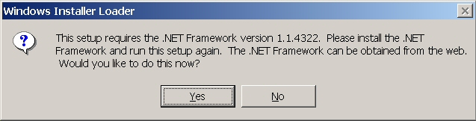
Figure 14: Prompt for .NET Framework
Follow the instructions to install the framework using the download from Microsoft’s website and then restart the Setup.exe program. You should see the screen shown in Figure 15.

[The rest of this page has been left blank intentionally]
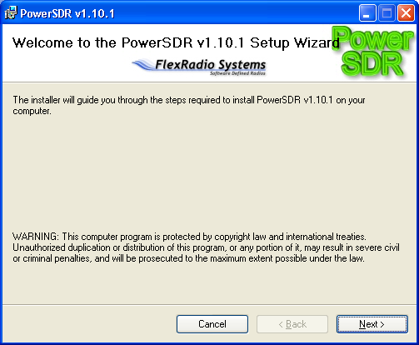
Figure 15: PowerSDR Installation Welcome Screen
Click the Next button to continue to Figure 16.

[The rest of this page has been left blank intentionally]
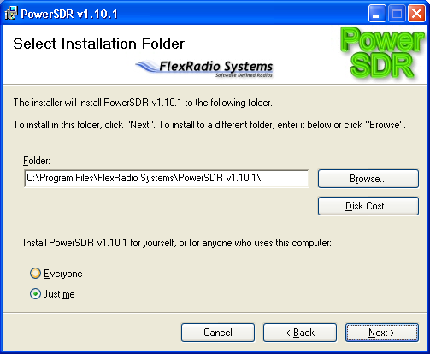
Figure 16: PowerSDR Installation Folder Selection
You can change the installation directory here, though we recommend you use the default for troubleshooting purposes. Click the Next button to continue to Figure 17.

[The rest of this page has been left blank intentionally]
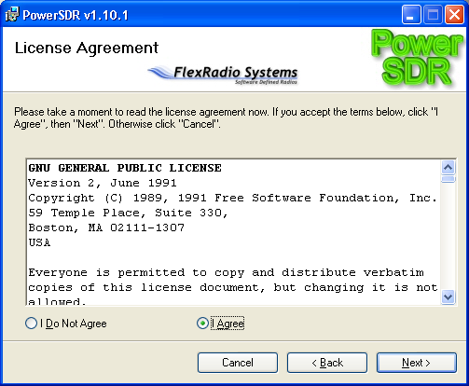
Figure 17: PowerSDR Installation License Agreement
Read the GNU Public License. If you accept, click I Agree and click the Next button to continue to Figure 18. Otherwise click Cancel.

[The rest of this page has been left blank intentionally]
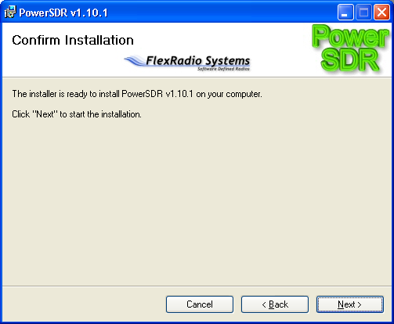
Figure 18: PowerSDR Installation Confirmation
Click the Next button to confirm these settings and to copy the necessary files to the selected install directory. Once the files have been copied, you will see the screen shown in Figure 19.

[The rest of this page has been left blank intentionally]
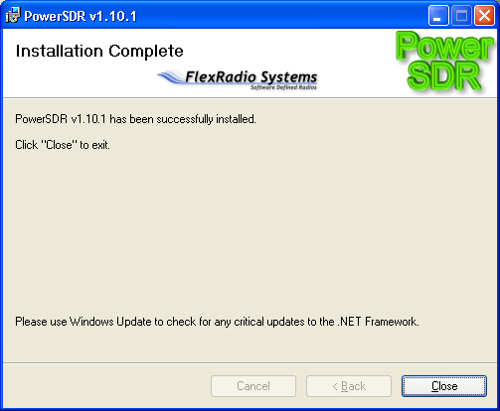
Figure 19: PowerSDR Installation Complete
Click the Close button to complete the installation and close the dialog.

PowerSDR Setup Wizard

Power up the FLEX-5000 to load its driver and start up the PowerSDR console using the shortcut on the Desktop (or through the Start menu). When you run a new release of PowerSDR for the first time an optimization routine will run and the screens shown in Figure 20 will appear.

[The rest of this page has been left blank intentionally]

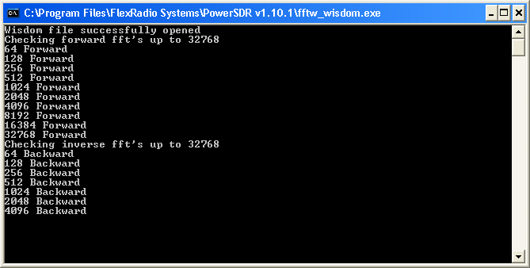
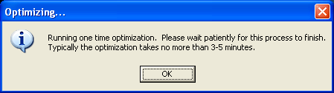
Figure 20: Optimization Routine
Click OK and let the routine run.
Note: This routine aims to optimize the FFT calculations for the environment (hardware and software) in which the calculations will be performed. For optimal performance, you should therefore close all applications you will normally not be running simultaneously with PowerSDR. The routine will save a file called wisdom to the directory in which PowerSDR resides. If you wish to run FFTW again, delete this file from the directory and start up PowerSDR, or simply run the fftw_wisdom.exe file in the PowerSDR directory.
When the routine has completed, a brief startup sequence will follow, after which you should be greeted by the PowerSDR Setup Wizard as shown in Figure 21 below.

[The rest of this page has been left blank intentionally]
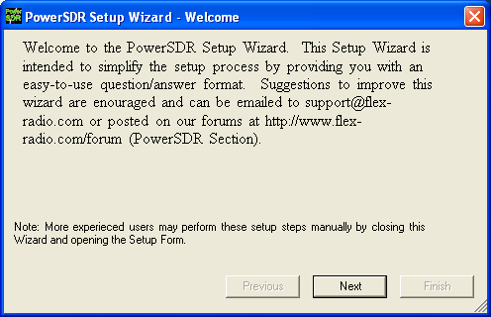
Figure 21: PowerSDR Setup Wizard Welcome

CAUTION: Starting with PowerSDR 1.10.2 you will not be prompted to import a previous database. The FLEX-5000 database is significantly different in structure than the one used with the SDR-1000 and you need to start out with a fresh (automatically created) database where all of the parameters are configured to their system defaults.

Hint: You can copy selected tables from your existing SDR-1000 (or previous FLEX-5000) database to the new default database by using K9DUR's Table Migration Utility, available from the Downloads page of our website. We recommend that you only transfer the tables BandStack, BandText, EQForm, GroupList, Memory, TXProfile, UCB and/or WaveOptions if any.
We recommend you keep a copy of your original database before transferring any tables.
Click the Next button to continue to Figure 22.

[The rest of this page has been left blank intentionally]
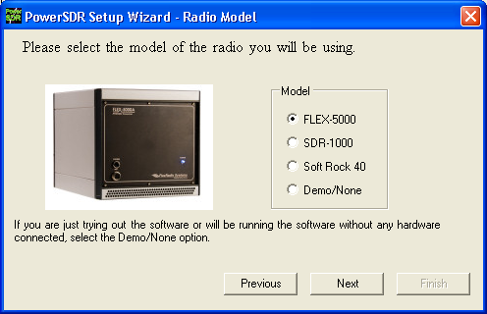
Figure 22: PowerSDR Setup Wizard - Radio Model
Select the FLEX-5000 radio model as shown in Figure 22 above. Click the Next button to continue to Figure 23.
Note: If you are running without a radio, e.g. for demonstration purposes, select Demo/None. For the SDR-1000 see the SDR-1000 Owner's Manual.

[The rest of this page has been left blank intentionally]
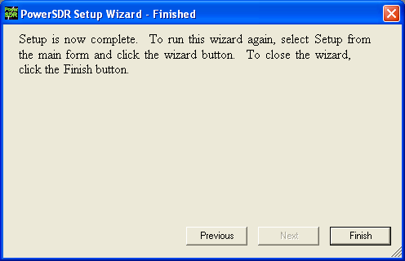
Figure 23: PowerSDR Setup Wizard – Finished
The Setup Wizard is now complete. Click the Finish button to complete the wizard.
Note: If you forgot to power up the FLEX-5000 before starting PowerSDR, a communication error message will be displayed and PowerSDR will offer the ability to start in demo mode. Click No to close PowerSDR, power up the FLEX-5000 and restart PowerSDR.

Initial PowerSDR Configuration
Before operating the FLEX-5000 several PowerSDR parameters need to be configured. To do so, start up PowerSDR to open the Front Console, but do not yet click on the Start button.

Note: From time to time the FLEX-5000 firmware may need to be updated. If PowerSDR detects an incompatible version of the firmware, it will display an error message similar to that shown in Figure 24 below.
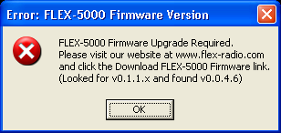Figure 24: FLEX-5000 Firmware Version Error
Click OK and if a Driver Error message follows, click OK again. PowerSDR will start up, but the Start button will be grayed out. Close PowerSDR and refer to the procedure described in Appendix B to update your firmware.

Transfer of Calibration Data
PowerSDR will need to transfer your radio's calibration data from its EEPROM to the new database. In this case you will see the message shown in Figure 25.

[The rest of this page has been left blank intentionally]
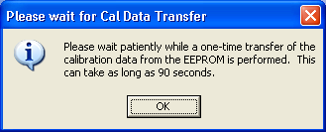Figure 25: Calibration Data Transfer Message

Click the OK button to start the transfer of calibration data. You will see the progress indicator shown in Figure 26. When the transfer is complete, PowerSDR will complete starting up.
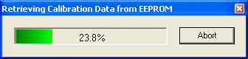Figure 26: Calibration Retrieval Progress Indicator

Do not click Start just yet as you will first need to configure Audio parameters, Antenna ports and Mixer settings.

[The rest of this page has been left blank intentionally]

Audio Parameters
Click on Setup at the left of the menu at the top of the Front Console to open the Setup Form. Select the Audio tab and then the Primary sub-tab shown in Figure 27.
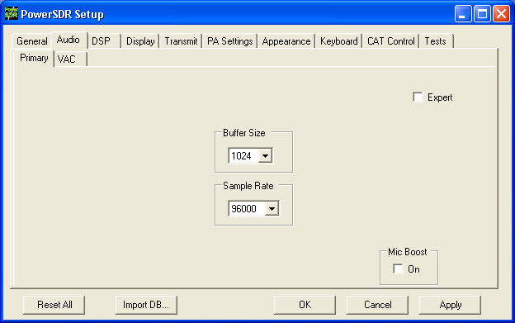Figure 27: Setup Form - Audio Tab, Sound Card Sub-Tab
Change the Buffer Size and the Sample Rate to the same values you entered in the FLEX-5000 Control Panel (see Figure 13 on page 20). Click on the OK button when done.
Note: If the sample rate and buffer size set for the FLEX-5000 hardware driver (see Figure 13 on page 20) are different than the PowerSDR sample rate and audio buffer size (Figure 27), audio drops will most likely occur due to buffer alignment issues.

Antenna Port and External Keying Lines
You will next need to configure the antenna ports such that the correct antenna is selected for each band as well as the correct keying line(s), if any. To do so, click on Antenna in the menu of the Front Console (Figure 28). We will only describe the Simple complexity level here. For more detailed information, including Expert level, see page 129).
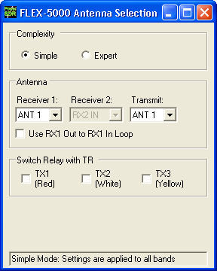Figure 28: Antenna Form - Simple
- Complexity: Simple uses the same antenna port for all bands, whereas Expert allows you to select different antenna ports for each band If you use only one antenna, choose Simple.
- Antenna: The following selections are possible:
  - Receiver 1: ANT1 (default), ANT2, ANT3 or RX1 IN
  - Receiver 2: (if installed) Either RX2 IN (default), or the same antenna port as selected for receiver 1.
  - Transmit: ANT1 (default, except for 6m), ANT2 or ANT3. For 6m, the antenna port is fixed to ANT3 and cannot be changed.
WARNING! Make sure you have an antenna connected to the Transmit antenna port you selected. Failing to do so may damage your radio and void your warranty.
WARNING! Do not switch the transmit antenna while transmitting (hot switching). You could damage your radio and void your warranty.
- Switch Relay with TR: Select the keying line(s) you use, if any, to key your amplifier(s) or other external equipment..
Close the Antenna Form when you are done.

Audio Mixer
The FLEX-5000 input and output audio channels are managed with an audio mixer, much the same as for your Windows sound card(s). To configure the audio mixer, click on Mixer on the Front Console menu (Figure 29).
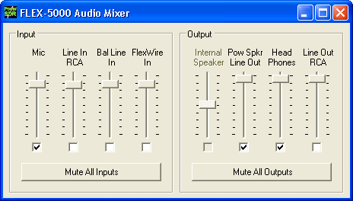Figure 29: Audio Mixer
Select the desired Input and Output channels. Only one Input channel can be selected, but multiple Output channels can be selected. Mic is the front panel microphone connector, whereas all other channels refer to the various audio inputs and outputs on the back panel. For more detailed information see page 128).
Note: The Internal Speaker output is unavailable for the FLEX-5000A, which has no internal speaker.

[The rest of this page has been left blank intentionally]

No Calibration Required
The FLEX-5000 comes to you completely factory calibrated and therefore, unlike the SDR-1000, no further calibration is required. If due to some unlikely event you suspect your radio needs to be recalibrated, please contact FlexRadio Support, who will guide you through the process.
You are now ready to use your FLEX-5000. Click on Start on the Front Console and you should hear receive audio. If you do not, double check all your connections and settings (especially for the Mixer and Antenna forms).
We urge you to read the remainder of this manual to help you fully understand the FLEX-5000 and PowerSDR. This will enable you to optimize your radio for your personal operating style and environment. You may also want to visit our extensive and ever expanding Knowledge Base for more detailed and more up-to-date information on many topics.
Note: Experienced PowerSDR users may also find it beneficial to read the remainder of this manual, as the FLEX-5000 has several options and settings in PowerSDR unavailable to the SDR-1000. Especially new are the Mixer, Antenna and ATU forms.

[The rest of this page has been left blank intentionally]

Front Console
In this chapter and those following many types of software controls will be referred to. The myriad of various bells and whistles can sometimes be a bit overwhelming. Figure 30 below is a key that will help to introduce the basic controls for those less familiar with windows software.
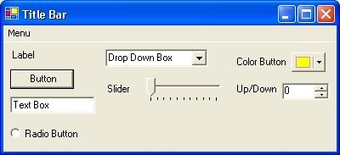
Figure 30: Control Key
- The Form refers to the entire window with the Title Bar showing the Form Name.
- The Menu is just under the Title Bar. Menu controls generally open other forms.
- Labels are callouts usually for other controls.
- Buttons can trigger events or act like an On/Off switch.
- Text Boxes allow text to be entered or displayed.
- Radio Buttons allow the user to choose between several options.
- Drop Down Boxes (also called Combo Boxes) enable the ability to offer many options without taking up as much window space as a Radio Button.
- Sliders allow easy modification of a numerical value.
- Color Buttons are used as color selectors. You can pick a generic color (yellow or green) or even make your own using the drop down menu.
- Up/Down controls are similar to a Text Box, but are limited to numeric input. They also have arrows for simple increment/decrement behavior.
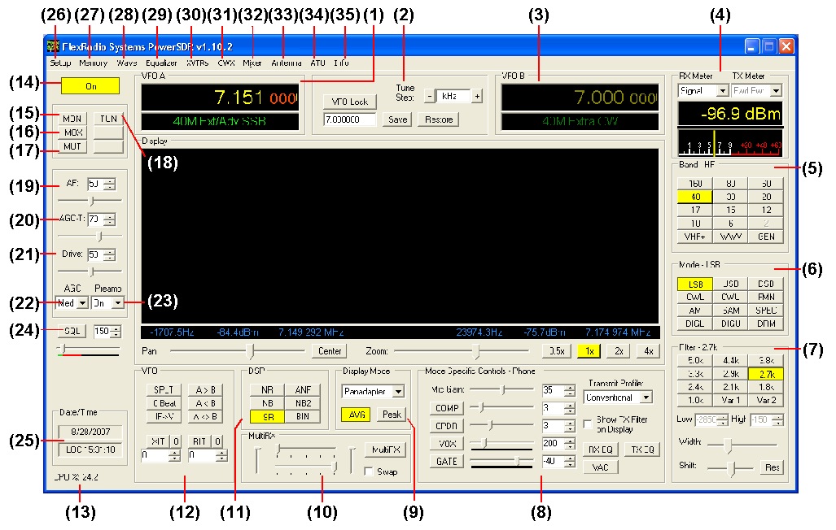
Figure 31: PowerSDR 1.10.2 Front Console
Note: The front console controls the basic functions of the radio: frequency, mode, filters, and display. In addition to these basic features, there are many other controls that are described in detail below. The exact behavior of many of these controls can be configured with the Setup Form.

Hint: Hovering with your mouse over any control will show a brief description of that control’s function.

[The rest of this page has been left blank intentionally]

(1) VFO A
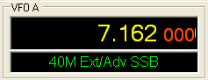
Figure 32: VFOA
VFO A is the main tuning VFO for the radio. It consists of a frequency and a band description (related to the selected frequency). The frequency area is a Text Box and may be edited as such (click and drag highlighting, etc). Entering a numeric character (without any mouse interaction) is also a good way to change your frequency quickly. An underline will indicate the digit that will be tuned when hovering over the frequency display. See the Tuning Methods on page 136 for more details on how to tune. Note that when using the keyboard to enter a frequency, you can return to the previous frequency at any time by pressing the ‘Escape’ key.
The band text information below the frequency gives general information about the FCC Amateur bands as well as the Short Wave Radio bands and WWV. If not on a recognized frequency, the text will display “Out Of Band”. If not in an amateur band, the text background will change from black to gray. Note that this information is only a lookup in a database and has no bearing on the current operating mode. The band text information can be edited in the BandText table using Microsoft Access.

(2) Tuning Controls
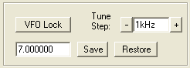
Figure 33: Tuning Controls
VFO Lock keeps the frequency from being changed inadvertently. This is a handy feature to use while in a QSO to keep from accidentally losing the frequency due to clicking in the wrong area or hitting the wrong key on the keyboard.
The Tune Step displays the current tuning rate for using the mouse wheel (or Ctrl + Up/Down Arrow) to tune the radio. Rotating the mouse wheel away from you will increase the frequency by the step rate per click while rotating the wheel toward you will decrease the frequency. You can change the Tune Step by clicking either of the – or + buttons, clicking the mouse wheel button (or using Ctrl + Left/Right Arrow).
The Save button quickly saves a frequency, mode and filter. The saved frequency is shown in the box to its left. The Restore button restores the most recently saved frequency (displayed), mode and filter.

(3) VFO B
Split Transmit Frequency | MultiRX Frequency
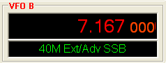 | 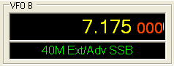
Figure 34: VFOB
The operation of VFO B is similar to that of VFO A. However, VFO B is used only in specific instances. When operating split (SPLT button under VFO), VFO B displays in red the transmit frequency. When activating the multi receive function (MultiRX button under MultiRX), VFO B displays in yellow the second receive channel's frequency within the receiver's bandwidth (which is directly proportional to the audio sampling frequency). Otherwise, it can be viewed as a storage container to copy VFO data to and from VFO A (see the VFO Controls section on page 59).

(4) Multimeter
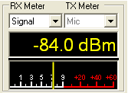
Figure 35: Multimeter
The multimeter displays both digitally and graphically various RX and TX signal parameters as determined by the selection from the two drop down boxes at the top.
The text display below the meter selections shows the digital data for either the receiver or the transmitter (Signal strength in Figure 35 above). The lower display at the bottom of this section shows the data graphically as an edge meter. Alternatively a bar graph display can be selected (see the description of the Setup Form - Appearance Tab, Meter Sub-Tab on page 104).

RX Meters
- Signal (Signal Level): Calculates the true RMS power in dBm of the current signal within the passband, as measured at the selected FLEX-5000 antenna port.
- Sig Avg (Signal Average): Calculates the true RMS power in dBm of a time-averaged signal within the passband, as measured at the selected FLEX-5000 antenna port.
- ADC L (Analog To Digital Left): Calculates the level in dBFS (decibel full scale) of the Left input from the internal I/Q ADC.
- ADC R (Analog To Digital Right): Calculates the level in dBFS (decibel full scale) of Right input from the internal I/Q ADC.
- Off: Used for debugging purposes or to save CPU cycles on slower machines.

TX Meters
- Fwd Pwr: Reads out forward power minus reflected power in Watts as measured by the internal ADC on the PA. The meter shows average power.
Note: In SSB, the typical male voice peak to average ratio is 14dB. This means that without the compressor and/or compander enabled an average meter will only read 4-10W (with a typical voice) when peaking at 100W.
With the ALC we are using the average power. With these controls, very high average power can be tolerated.
- Ref Pwr (Reflected Power): Reads out reflected power as measured by the internal ADC on the PA.
- SWR (Standing Wave Ratio): Reads out the standing wave ratio as calculated from the measured forward and reflected power. (Only available with TUN on)
- Mic: Reads modulation power from -20 dB to 3 dB. Ideal operation will peak around 0 dB and will rarely if ever hit 3 dB. If it is hitting 3 dB, the ALC is cutting back the power. Adjust the MIC control on the front console to give more or less modulation.
- EQ: Reads the power in dB following the equalizer, where 0dB is ideal. If the equalizer is not enabled, the equalizer power is equal to the Mic power.
- Leveler: Reads the power in dB following the leveler, where 0dB is ideal. The leveler attempts to level the voice coming from the microphone as the head and mouth change position relative to the microphone element. If the leveler is not enabled, this power is identical to EQ.
- Lev Gain: Reads the gain in dB currently being applied by the leveler.
- COMP: Reads the power in dB after the compressor, where 0dB is ideal. If the compressor is not enabled, it reads the same as Lev.
- CPDR: Reads the power in dB after the compander, where 0dB is ideal. If the compander is not enabled, it reads the same as Comp.
- ALC: Reads the power in dB after the ALC, where 0dB is ideal.
- ALC Comp: Reads the gain in dB applied by the ALC algorithm. The gain is always <=0 in dB. The minus sign is implicit.
- Off: Used for debugging purposes or to save CPU cycles on slower machines.

(5) Band Selection & Band Stacking Memories
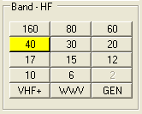
Figure 36: Band Selection
The Band Selection controls perform multiple roles in PowerSDR. First, when tuning the VFO to a specific frequency the band indicator will move to the appropriate band (GEN if not in one of the specific bands listed). This is used to quickly identify which band you are in, or when you are stepping over a band edge boundary.
The second role is a feature called Band Stacking Memories. A single memory is defined as a frequency, mode, and filter combination. Each band has several memories associated with it. Clicking on a band button repeatedly will cycle through the available memories repeating from the beginning after the last memory (hence the stacking memories). This is useful to quickly tune to various frequencies within a band. To replace one of the memories with the frequency, mode, and filter of your choice, first click the band button for the band memory you would like to modify. Then change the frequency, mode, and filter to the desired settings (the frequency must be in the band selected). Finally click the band button again to save the values.
The modified memories will be saved to the database upon graceful exit of the console. A crash will prevent changed memories from being saved in order to keep faulty data from making it into the database.
Note : Some band memory frequencies (such as 60m and WWV) are fixed in software and cannot be changed.
The VHF+ button will swap between the typical HF bands and any configured transverter bands (see the description of the XVTRs Form on page 122). The VHF band buttons work in the same way, but for the frequencies within the transverter frequency range.

[The rest of this page has been left blank intentionally]

(6) Mode Selection
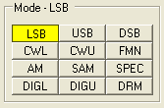
Figure 37: Mode Selection
The Mode Selection controls allow you to change the selected demodulation routine. Changing modes will select the last frequency and filter used for that mode. Additionally, it will display the (configurable) filter settings available for that mode (see Figure 39 below) as well as display the appropriate mode specific controls on the front console (see page 48). Following is a list of the available modes:
- LSB: Lower Side Band
- USB: Upper Side Band
- DSB: Double Side Band
- CWL: CW Lower Side Band
- CWU: CW Upper Side Band
- FMN: Frequency Modulation (FM) Narrow
- AM: Amplitude Modulation
- SAM: Synchronous (PLL) Amplitude Modulation
- SPEC: Spectrum mode (DC IF, max bandwidth determined by the selected sampling rate)
- DIGL: Digital Lower Side Band (Enables VAC if VAC Auto Enable is engaged, see page 76)
- DIGU: Digital Upper Side Band (Enables VAC if VAC Auto Enable is engaged, see page 76)
- DRM: Digital Radio Mondiale (requires licensed external demodulator software not available from FlexRadio Systems; Enables VAC if VAC Auto Enable is engaged, see page 76)
Hotkeys are available in the Setup-Form, Keyboard Tab to cycle through the various modes using the keyboard (see page 106).

[The rest of this page has been left blank intentionally]

(7) Filter Controls
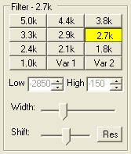
Figure 38: Filter Controls
The filter controls consist of ten customizable, mode-specific, labeled filter buttons and two variable filter buttons.

Labeled Filter Buttons
Clicking on any of the labeled buttons in the top half of the filter controls section sets the filter bandwidth. The available filters depend on the selected modulation mode. The 3 groups of default filter selections for CW (CWL, CWU), SSB (LSB, USB, DIGL, DIGU) and DSB (DSB, FMN, AM, SAM) are shown below. The SPEC mode has no filters associated with it and the DRM filter is fixed at 12kHz.
CW Default Filters | SSB Default Filters | DSB Default Filters
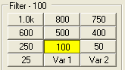 | 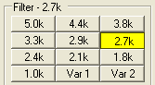 | 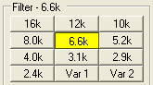
Figure 39: Default Mode Dependent Filters
Each of the 10 labeled filter buttons can be customized for any of the modes. To do so, right click on a filter button and select Configure… to bring up the screen shown in Figure 40.

[The rest of this page has been left blank intentionally]
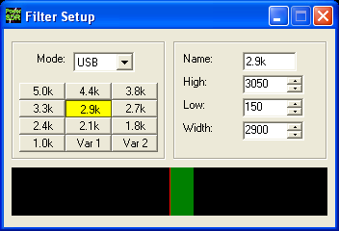
Figure 40: Filter Setup Screen
On the left, select the Mode for which to setup the filter and select the filter button to change. Then on the right adjust its settings. An indication of the filter is displayed in the lower section of this screen. When done, you can select another button and/or mode to change the filter for. When finished, just close the Filter Setup Screen. To revert back to the default settings, right click on a filter button, select Reset to Defaults and click Yes.
Note: Although there are 3 groups of mode-dependent default filter settings, you can customize the labeled filter for each mode independently. E.g. you can have different filters for LSB and USB, for FMN and AM, etc.

Variable Filter Buttons
The variable filter buttons Var 1 and Var 2 offer two separate filters, each of which can be adjusted with the Low, High, Width, Shift and Res controls described below as well as the mouse. The Panadapter display setting is good for visualizing changes to variable filter controls
- Low: Selects the low cutoff frequency for the filter. The value is the plus or minus offset from the center frequency as shown in the VFO display. Note that in lower side band modes (LSB, CWL and DIGL) this value can be negative.
- High: Selects the high cutoff frequency for the filter. Note that in lower side band modes (LSB, CWL and DIGL) this value can be negative.
- Width: Widens the filter as the slider is moved right, and narrows the filter as it is moved left. The behavior of this control is set in the Setup Form – General Tab, Filter Sub-Tab (page 73).
- Shift: Shifts the selected filter passband up or down from its normal center frequency. This can help to eliminate interference caused by signals in close proximity of the received signal. The behavior of this control is set in the Setup Form – General Tab, Filter Sub-Tab (page 73).
  - After a variable filter (Var 1, Var 2) has been shifted you can use the IF→V button to translate a filter shift to a new VFO frequency (see the VFO Controls section on page 59)
- Res: Returns the Shift control to the default middle position and restores the filter to its original position (i.e. before the Shift was used).
- When the display is set to Panadapter, the mouse can be used to directly adjust the selected variable filter (Var 1 or Var 2). To do so right click with the mouse on the Panadapter display until no cross- hairs are showing. Then click on the filter and drag it to shift the filter as a whole or click on a band edge and drag it to adjust the filter bandwidth.
The Var 1 and Var 2 filters are saved just like the labeled filters and are mode-dependent (i.e. you can save a different Var 1 filter for LSB than for AM). Hotkeys are available in the Setup Form-Keyboard Tab (described on page 106) to change the filters using the keyboard.

(8) Mode Specific Controls
This section of the front console displays key controls specific to the selected modulation mode. There are three sets of controls: Phone, CW and Digital.

Phone Controls
The phone controls, shown below, are available for all phone modes (LSB, USB, DSB, FMN, AM and SAM). Most of these controls can also be found on the Setup Form-Transmit Tab (see page 93, where a more detailed description may also be found)
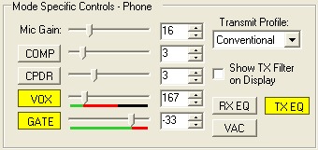
Figure 41: Mode Specific Controls - Phone
- Mic Gain: adjusts the software microphone gain. This is a simple multiplier applied to the input samples when in transmitting. The control can be adjusted using either the slider or the text box. Note that increasing the MIC Gain control will also raise the amount of noise in the signal. A hardware preamp will give the best performance for amplifying microphone signals. Having said that, the software gain works very well in many setups. Voice modes are typically optimized when the peak reading on the TX Mic Meter reads just below 0dB (see page 43 above)
- COMP: click to enable the feed forward compression and adjust its level with either the slider or the text box. See also the Setup Form-Transmit Tab (page 96)
- CPDR: click to enable the compander and adjust its level with either the slider or the text box. See also the Setup Form-Transmit Tab (page 96)
- VOX: click to enable the VOX and adjust its level with either the slider or the text box. See also the Setup Form-Transmit Tab (page 95). When enabled, a bar graph will show just below the slider control. The green part of this bar graph shows the portion of the sound level that will not activate the transmitter; the red part the portion that will. VOX should be adjusted such that ambient noise will not activate the transmitter, but a normal voice will.
- GATE: click to enable the Noise Gate and adjust its level with either the slider or the text box. See also the Setup Form-Transmit Tab (page 95). When transmitting, a bar graph will show just below the slider control. The green part of this bar graph shows the portion of the sound level that will not open the Noise Gate; the red part the portion that will. The level should be adjusted such that ambient noise will not open the Noise Gate, but a normal voice level will.
Hint: The Noise Gate can (and should) be enabled in all situations where ambient noise will render your transmissions less clear, irrespective of whether VOX is engaged.
- Transmit Profile: select the transmit profile to use for phone transmissions. See also the Setup Form-Transmit Tab (page 94)
- Show TX Filter on Display: when checked, the band edges of the transmit filter, set on the Setup Form-Transmit Tab (page 94) will be shown as 2 yellow lines on the display when set to Panadapter. It can be an especially useful visual aid when operating split to position your transmit frequency where desired (in a pile-up) using VFO B. Additionally, it will give you a quick visual impression of whether your transmit filter needs to be adjusted or not.
- RX EQ: activates either the receive three-band or ten-band equalizer. See also the Equalizer form described on page 120.
- TX EQ: activates either the transmit three-band or ten-band equalizer. See also the Equalizer form described on page 120.
- VAC: activates Virtual Audio Cable, a third party program (written by Eugene Muzychenko) to enable digital audio transfer between PowerSDR and other third party (digital) programs. See also the Setup Form – Audio Tab, VAC Sub-Tab described on page 75. VAC is not automatically enabled for phone modes, even if Auto Enable has been checked on the VAC Sub-Tab.

CW Controls
The CW controls, shown in Figure 42 below are available when either CWL or CWU is selected. Most of these controls can be found on the Setup Form-DSP Tab, Keyer Sub-Tab (see page 84, where you can also find a more detailed description).

[The rest of this page has been left blank intentionally]
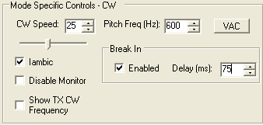
Figure 42: Mode Specific Controls - CW
- CW Speed: sets the CW speed when using the internal keyer in Iambic mode. Adjust the speed with either the text box or the slider.
- Iambic: check to set the internal keyer to Iambic mode (see also page 85)
- Disable Monitor: check to disable the monitor (this can be useful when using an external keyer).
- Show CW TX Frequency: check to show the CW TX frequency as a single yellow line when the display is set to Panadapter. It can be an especially useful visual aid when operating split to position your transmit frequency where desired (in a pile-up) using VFO B.
- Pitch Freq (Hz): sets the desired audio frequency for CW listening at the center of the CW filters. This will determine the offset that is applied to the carrier in receive and transmit. The display will continue to read the actual carrier frequency (if the radio is calibrated) but the software will provide for an offset to get the desired CW tone. This pitch will determine the automated tuning frequency using the display and mouse “click tune” functions.
- VAC: click to enable Virtual Audio Cable, a third party program (written by Eugene Muzychenko) to enable digital audio transfer between PowerSDR and other third party (digital) programs. See also the Setup Form – Audio Tab, VAC Sub-Tab described on page 75. VAC is not automatically enabled for CW modes, even if Auto Enable has been checked on the VAC Sub-Tab.
- Break In: check the Enabled box to activate Break In for the internal keyer. Set the delay in the Delay text box. See also page 86.

[The rest of this page has been left blank intentionally]

Digital Controls
The digital controls, shown below are available when either DIGL, DIGU or DRM is selected. These controls can mostly be found on the Setup Form- Audio Tab, VAC Sub-Tab (see page 75, where you can also find a more detailed description).
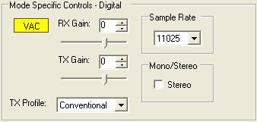
Figure 43: Mode Specific Controls - Digital
- VAC: click to enable Virtual Audio Cable, a third party program (written by Eugene Muzychenko) to enable digital audio transfer between PowerSDR and other third party (digital) programs. See also the Setup Form – Audio Tab, VAC Sub-Tab described on page 75. If Auto Enable (page 76) has been checked on VAC Sub-Tab, then VAC will automatically be enabled when either DIGL, DIGU or DRM is selected.
- RX & TX Gain: Adjust the gain for signals coming in and out of the VAC interface. Use the RX Gain control to adjust the audio level going to third party programs. (Note that for third party applications this control supersedes the front panel AF control). Similarly, use the TX control to adjust the volume of audio coming from third party applications (adjust for 0 dB on the ALC meter).
- Sample Rate: sets the sample rate of the VAC interface. This needs to be matched to your third party software sample rate.
- Mono/Stereo: sets the VAC interface to operate either mono or stereo. This can be of importance, depending on your third party software. (E.g. MixW requires the mono setting, whereas DREAM requires stereo).

(9) Display Controls
The main display controls, shown in Figure 44 below, consist of two sections: Panadapter/Waterfall viewing controls and display type controls.

[The rest of this page has been left blank intentionally]
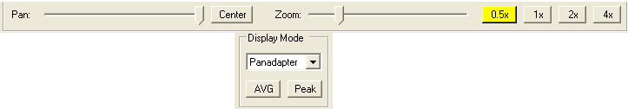
Figure 44: Display Controls

Panadapter/Waterfall Viewing Controls
The Panadapter/Waterfall viewing controls adjust the view of the Panadapter or Waterfall display (see Figure 46 and Figure 48 below), they are not functional for any of the other display types.
- Pan: adjust the slider to pan the Panadapter or Waterfall display from left to right. Click on Center to quickly center the display.
- Zoom: adjust the slider to zoom in on or out of the display. Additionally click on either on of the 4 buttons to the right to quickly zoom to the labeled setting. (The maximum frequency span of the Panadapter or Waterfall is dependent on the audio sample rate setting)

Display Type Controls
The main display is able to visualize received (and transmitted) signals in various ways (display types), which can be selected from the list box. These various display types are detailed below with a snapshot of each type. The sampling rate (Frames Per Second, FPS) of the main display can be modified on the Setup Form-Display Tab (see page 90).
- AVG (Average): click to view time-averaged signals. This will smooth fast-changing signals and is a good way to separate real from stochastic (noise) signals. The averaging time can be set on the Setup Form-Display Tab (see page 92). AVG must be enabled for the 0 Beat VFO Control to be available.
- Peak: click to hold the peak value for each frequency in the display.

Display Type Descriptions
Note: The actual display in PowerSDR is crisper than the compressed images shown below.
There are four frequency domain display types (Spectrum, Panadapter, Histogram, and Waterfall) and three time domain display types (Scope, Phase and Phase2). All the colors used in the display (text, data line, background, etc) are completely customizable using the Setup Form-Appearance Tab, Display Sub-Tab (page 99).

Spectrum
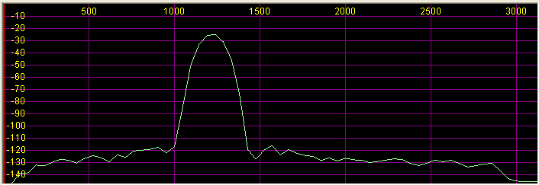
Figure 45: Spectrum Display
The Spectrum Display shows a classical spectral view of the frequency with the ends of the display determined by the bandwidth of the filter. The scale across the top shows the frequency offset in Hz from the VFO A frequency. Rather than only using half the display window when in lower or upper sideband, we expand the display moving the 0Hz line to the left or right margin (1.2kHz tone in USB mode with a 2.7kHz filter shown).

Panadapter (Panoramic Adapter)
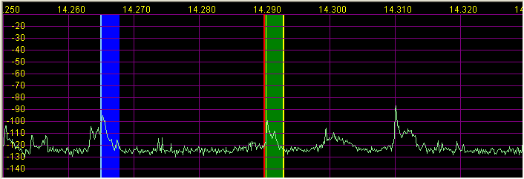
Figure 46 Panadapter Display
The Panadapter Display is similar to the Spectrum Display with several differences.
- The maximum display width is a function of the selected sampling rate, no matter what filter bandwidth is selected.
- The selected filter is displayed as an overlay to help the user visualize the filter. Shown are the main RX filter (green, VFO-A), the MultiRX filter (blue, VFO-B) and the TX filter edges (yellow vertical lines). The color of all the filter overlays can be changed independently using the Setup Form-Appearance Tab, Display Sub-Tab (page 99).
- The frequency scale shows the actual frequency (in MHz).
- The edges of the amateur bands are marked as red vertical lines and the corresponding frequencies are displayed in red
- With the mouse, filters and filter edges can be varied by dragging and dropping
- Point click tuning is available with mouse and cross hairs showing.
The Panadapter is useful because although you hear only the signals within the audio passband, you can see in real time all signals within the receiver’s passband (as determined by the sampling rate). This gives a much more complete picture of the surrounding area in the band, especially when there is abundant signal activity (e.g. contest and DX situations).

Histogram
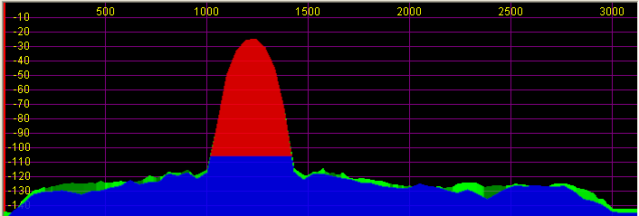
Figure 47: Histogram Display Mode
The Histogram Display is similar to the Spectrum Display, but instead of a single color data line, additional colored data is used. Blue signals are real-time (current) signals that are below a signal threshold (roughly below the average plus a small margin). The red signals are real-time (current) signals that are above that same threshold. The green signals are previous peaks on that same frequency that will fade as time goes by (a type of history, hence the name).

[The rest of this page has been left blank intentionally]

Waterfall
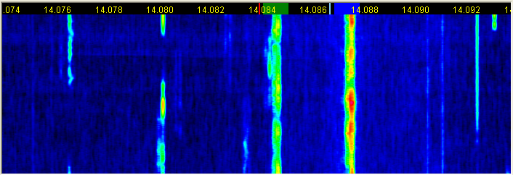
Figure 48: Waterfall Display
The Waterfall Display shows a scrolling view of activity within the receiver's passband (as determined by the sampling rate). This makes tracking narrow band signals much easier and can even allow visualization of CW signals at slower speeds (longer line is a dash, short line is a dot, no line is a pause).
- Across the top the audio passband filters are displayed, similar to the panadapter.
- The filter widths and positions can be adjusted with the mouse, similar to the panadapter.
- All mouse tuning methods available in the panadapter are also available in the waterfall.
- The frequencies corresponding to the Amateur band edges are displayed in red.
- The Waterfall Display can be customized on the Setup Form- Display Tab This allows custom setting of the dynamic range and coloring for the display. (See the Setup Form-Display Tab on page 91 for more details.)

[The rest of this page has been left blank intentionally]

Scope
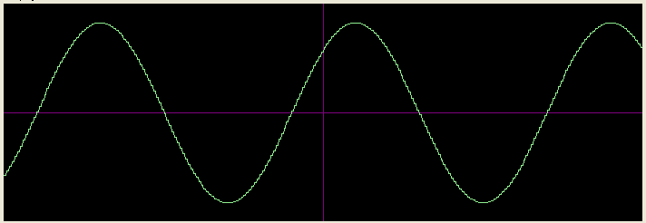
Figure 49: Scope Display
The Scope Display shows a single channel in the time domain. In essence this is a traditional waveform view of the input data. Shown is effectively a 1kHz tone (tuned to 7.0411MHz with the signal at 7.0401MHz). The Scope Display is particularly useful when transmitting to monitor your transmitted waveform. The time base can be adjusted on the Setup Form- Display Tab (see page 92).

Phase
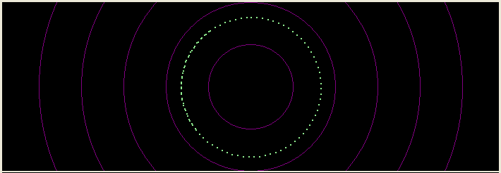
Figure 50: Phase Display
The Phase Display maps the filtered I and Q (Left and Right) channels to the X and Y coordinate planes. This is useful for making sure the two channels are 90 degrees out of phase as they should be. There is also a Phase2 Display that maps the unfiltered data directly from the ADC. When a continuous carrier signal is received, the unfiltered data in the Phase2 Display should produce as near to a perfect circle as possible. If the circle distorts into an oval or a straight line, the input phase is off balance which would indicate a connection or hardware problem.

Off
In this setting the display is turned off. It is mainly used for debugging purposes, but can also be used with slower systems to decrease the CPU load to more reasonable levels.

Cursor and Peak Position
There are two sets of data side by side under the display that are used to communicate cursor (left) and peak signal (right) information to the user. For each the data shown equals Offset from VFO, Signal Level and Frequency. For example, in Figure 51 below, the peak signal is offset -8639.4 Hz from the VFO frequency (14.187 MHz). The peak signal level is –81.6 dBm, and the peak signal is at 14.178361 MHz. Note that these values are fairly low resolution due to the discrete nature of the pixel display.
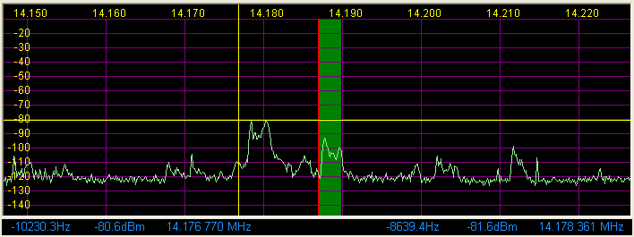
Figure 51: Cursor and Peak Position Information
- In the frequency domain displays (Spectrum, Panadapter, Histogram, Waterfall), right clicking the mouse cycles through yellow crosshairs, red crosshairs (only if SPLT or MultiRX is enabled), or no crosshairs. The crosshairs span the width and height of the display (yellow cross hairs are shown in Figure 51 above).
- Together with the AVG control they allow easy measurement of signals on the display. For example, in Figure 51 the cursor position is offset -10230.3 Hz from the VFO frequency and is at 14.176770 MHz. Its “level” is at -80.6 dBm.
- Another feature of the crosshairs is click tuning. Clicking the left mouse button with the yellow crosshairs visible tunes VFO A to the frequency indicated by the cursor position data. The red crosshairs tune VFO B. This is an excellent way to tune CW signals as it will zero beat the tone to the set CW pitch.

[The rest of this page has been left blank intentionally]

(10) MultiRX Controls
The MultiRX controls, shown below, allow you to enable a second receive channel within the receiver's passband, which is determined by the audio sample rate setting. Both the primary and the secondary receive channel can be positioned independently in the audio spectrum to facilitate separating the two signals in your head.
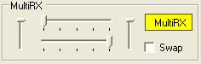
Figure 52: MultiRX Controls
Click MultiRX to enable the second receive channel. The second receive channel will be tuned to the frequency shown in VFO B. In the Panadapter and Waterfall Displays, its passband is shown in blue, but only if it is within the range of the Panadapter/Waterfall. Use the upper and lower horizontal sliders to position the primary and secondary channel respectively anywhere in the left-right audio spectrum. Use the left and right vertical sliders to adjust their respective volumes. Check mark Swap to swap the audio between the left and right speakers.
Hint: In split operation you can use the secondary receive channel to listen to the pile-up, while using the primary receive channel to listen to the DX.

(11) DSP Controls
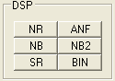
Figure 53: DSP Controls
These controls enable the DSP functions. The first four are described in detail in the Setup Form-DSP Tab, Options Sub-Tab (see page 77).; SR is described in the Setup Form-General Tab, Options Sub-Tab (page 69).
- NR (DSP Noise Reduction): Activates the DSP Noise Reduction algorithm (see page 77).
Note: NR is not available when Binaural (BIN) audio is selected unless Block LMS is checked on the Setup Form.
- ANF (Automatic Notch Filter): Activates the Automatic Notch Filter algorithm.
Note: ANF is not available when Binaural (BIN) audio is selected unless Block LMS is checked on the Setup Form.
- NB (Impulse Noise Blanker): Activates the Noise Blanker algorithm (see page 80).
- NB2 (Mean Rank Noise Blanker): Activates the Mean Rank Noise Blanker algorithm (see page 80).
- SR (Spur Reduction): Activates the Spur Reduction algorithm (see page 69).
- BIN (Binaural Audio): Activates the Binaural algorithm. Binaural audio is a special feature of PowerSDR. It generates a pleasing effect as the two phased channels (I and Q) are mapped to the left and right audio channels. The phasing of the demodulated and filtered audio signal within the passband gives a stereo-like, spatial effect to the received signal. When tuning across CW signals, they will seem to move in “space” as you tune the radio. Many experienced operators feel that binaural audio gives them a competitive advantage under contest conditions where the effect allows them to more easily pick signals out of a pile up. Wearing headphones increases the effect of the spatial separation.

(12) VFO Controls
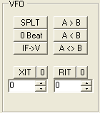
Figure 54: VFO Controls
- SPLT (Split): Enables Split operation using VFO B for the transmit frequency. The frequency text in VFO B will turn red to indicate that it is the transmit frequency.
- 0 Beat: Centers the signal peak within the filter passband. An exception is made in CW mode if the CW Pitch is within the passband. In this case, the signal is tuned to the CW Pitch.
Note: 0 Beat is only available if AVG is enabled for the Display.
- IF→V: Translates any offset created by Filter Shift and shifts it back to baseband. Useful when chasing a signal with the Filter Shift control (see also page 47).
- A >B: Transfers the contents of VFO A to VFO B (frequency, mode, and filter).
- A< B: Transfers the contents of VFO B to VFO A (frequency, mode, and filter).
- A< >B: Swaps the contents of VFO A and B (frequency, mode, and filter).
- XIT (Transmit Incremental Tuning): Click to enable XIT. XIT may be used as a quick way to operate split at a specific offset. When enabled, the transmit frequency is increased from the VFO A frequency by the amount shown in Hz while leaving the receive frequency intact. With SPLT activated, XIT modifies the VFO B frequency. Click the 0 button next to the XIT button to clear the XIT control to 0.
- RIT (Receive Incremental Tuning): Click to enable RIT. When enabled, the receive frequency is increased from the VFO A frequency by the amount shown in Hz while leaving the transmit frequency intact. Click the 0 button next to the RIT button to clear the RIT control to 0.

(13) CPU %
This displays the total CPU load as seen in the Windows Task Manager under the Performance Tab. Note that running other applications will cause the CPU load to increase. If your CPU load is peaking at close to100%, audio and possibly video artifacts will become noticeable. In this case closing additional applications and turning down some of the functions may improve the performance.

(14) Start/Stop Button
Click Start to activate PowerSDR, click Stop to deactivate it. As Figure 55 shows, the button also acts as a RX/TX indicator.
Start | Stop | Stop/Transmit
Figure 55: Power Button States
Note: Please see also the Power-Up/Down procedures described on page 135 for information on best practices.

(15) MON (Monitor)
When enabled, the transmitted audio is monitored through the receiver’s speakers. The MON function is not available in AM, SAM, or FM modes as those modes are transmitted at the Intermediate Frequency (IF, usually 9kHz). In voice operation the MON feature will allow you to hear the effects of MIC gain, TX equalization, compression and compansion and to adjust them in real time. The AF control can be used to adjust the monitor volume.

(16) MOX (Manually Operated Transmit)
When enabled MOX activates the transmitter. It is used primarily for voice operation. MOX will not generate a CW carrier. To generate a carrier for tuning, refer to the tune (TUN) button description on page 61.
Note 1: If the radio ever seems like it is stuck transmitting, try disabling the Push-To-Talk (PTT) function by selecting Disable PTT on the Setup Form-General Tab, Options Sub-Tab.
Note 2: To use PowerSDR without any hardware attached to the PC you must disable PTT. On the Setup Form-General Tab, select either Disable PTT on the Options Sub-Tab, or Demo/None on the Hardware Config Sub-Tab

(17) MUT (Mute)
This button Mutes the speaker audio. The receiver may also be muted by pressing the * (asterisk) key on the keyboard.

(18) TUN (Tune)
- Without the ATU, TUN transmits a continuous (CW) carrier at the level set with the Tune Power control (default 10W) on the Setup Form-Transmit Tab (page 93) and outputs a tone at the CW Pitch. This power is shown on the Drive control while TUN is activated. Any changes to the Drive control while TUN is active are saved when the TUN button is turned off. This feature is used to simplify the antenna tuning process for proper load matching.
WARNING! Do not operate the 100W Amplifier above 40W in continuous carrier modes (e.g. CW, AM, FM and Digital) for longer than 15 seconds. Higher levels can cause damage to the Amplifier. The Amplifier is rated at 100W PEP for SSB duty cycles.
- With the ATU, TUN performs the ATU tuning function. When the ATU is in Bypass, the TUN function operates just as if the ATU were not present.
Note: The TUN button will stay enabled after a tune cycle with the ATU set to Memory or Full. The button will become deselected when the ATU is bypassed, whether it be due to tuning to another band or manually selecting Bypass in the ATU form.

(19) AF (Audio Frequency Gain)
This control sets the monitor audio gain. The AF gain may also be adjusted by pressing the + (plus) and – (minus) keys on the numeric keypad. For best performance, the external speaker volume control should be set to the high end of the scale so that the AF control can be set to a lower value.

(20) AGC-T (AGC Maximum Gain)
This control sets the maximum gain of the AGC. It is the same control as can be found on the Setup Form-DSP Tab, AGC/ALC Sub-Tab (page 87). The operational use of the AGC control is essentially the same as that of an RF gain control found in more traditional receivers.
Hint: For optimal use, set the AGC control such that the band noise level is comfortable, yet weak signals still jump out of the noise. Then adjust the AF control to comfortably hear the received signal. See also Appendix C and the Knowledge Base article How to Effectively Use the PowerSDR 1.x AF[Gain] and AGC[Threshold] Controls.

(21) Drive (Transmitter Power Output/Tune Power)
This control adjusts the percentage of maximum power that will be available in when transmitting. The Drive control may be adjusted while either receiving or transmitting.
Note: The control doubles in function as the power level setting for the TUN (Tune) button described above. The Tune power may be adjusted while the TUN button is activated or by using the control on the Setup Form-Transmit Tab.
While great care is taken to ensure that this value is accurate and that selecting a Drive value will give approximately that amount when using the 100W PA, there are variances in the filter components and transmitter characteristics that make it difficult for this to be exactly right over the whole range (1-100).

(22) AGC (Automatic Gain Control)
This control sets the receiver Automatic Gain to one of the following settings: Fixd (Fixed or off), Long, Slow, Med (Medium), Fast, or Custom. The Custom setting uses the controls on the Setup Form-DSP Tab, AGC/ALC Sub-Tab (page 87), where also a more expansive explanation of the AGC can be found.

[The rest of this page has been left blank intentionally]

(23) Preamp
This control switches the 15dB preamp on or off. For the HF frequencies best results are achieved with the preamp on for the upper bands and off for the lower.
Note: The preamp is unavailable for the 160m band to avoid interference from the broadcast bands. However, you can either insert a dedicated preamp using the RX1 Out/In receive loop (see page 6), or connect one at a receive only antenna and configure the appropriate antenna selection with the Antenna Form (see page 129).

(24) SQL (Squelch)
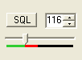
Figure 56: Squelch Controls
The SQL button enables the Squelch function. The threshold can be set with either the value to its right or the slider below. The bar graph displays in green the signal level below the threshold (squelch closed) and in red above (squelch open: only the red level is audible with SQL enabled). Squelch can be very useful to remove all noise from CW signals, especially in narrow filter settings.

[The rest of this page has been left blank intentionally]

(25) Date/Time Display
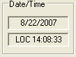
Figure 57: Date/Time Display
The date and time display can be especially helpful when taking screenshots, but can also be a quick reference to UTC time for those of us who are “time zone challenged.” Click inside the Date or Time area to cycle between LOC (Local Time), UTC (UTC Time), and Off .

(26) Setup Form
The Setup Form contains numerous controls for everything from the hardware configuration to transmit settings. Please refer to the next chapter for more detailed information.

(27) – (35) Operating Forms
Each of these items open forms, which are used while operating. Please refer to the Operating Forms chapter below for more detailed information on each one.

[The rest of this page has been left blank intentionally]

Setup Form
The Setup Form contains a vast assortment of controls and settings from hardware setup to detailed DSP options. These controls are available on Tabs of the Form. Due to space concerns, several of the Tabs (e.g. General, Audio and DSP) have been split into Sub-Tabs. Take care when changing the controls to pay attention which Tab (and Sub-Tab) you are on.
Along the bottom of the Setup Form are five global buttons. These are:
- Reset All: Resets all of the controls on all tabs to their default values. An exception is made for the hardware configuration controls. These will not be reset. A warning will pop up to ensure that accidentally pressing this button does not cause inadvertent loss of settings.
- Import DB (Database): Allows a backwards-compatible database to be imported. The database saves all of the radio options and its current state. To import another database, click this button and then browse to the directory of the database to import. If you have used the default directory during installation as recommended, the database file will be in C:\Program Files\FlexRadio Systems\ PowerSDR x.y.z\. The database file is called PowerSDR.mdb. Double click this file and it will attempt to import all the settings. A confirmation message will let you know if the import was successful.
- OK: Saves the current values to the database and closes the form.
- Cancel: Reloads the values from the database into the Setup Form and closes the form. This button can be used to reverse unintended changes to the Setup controls.
- Apply: Immediately saves the current values to the database.

[The rest of this page has been left blank intentionally]

General Tab

Hardware Config Sub-Tab
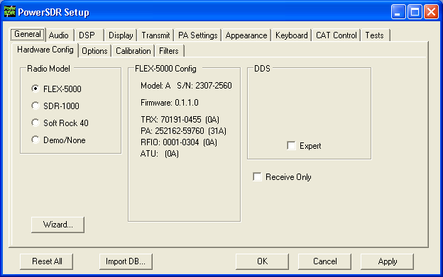
Figure 58: Setup Form - General Tab, Hardware Config Sub-Tab
Wizard…: Click this button to repeat the wizard that runs the first time you run the software (see Figure 21 on page 30). This is a handy way to update your configuration if your hardware has changed.
Receive Only: Check this box to use only the receiver, while disabling the transmitter. When checked, MOX, TUN and VOX will become unavailable on the Front Console and PTT (either via the MIC connector or the back panel PTT connector) will also not function.

Radio Model
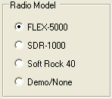
Figure 59: Radio Model Selection
Use this selection to choose the hardware (if any) that is connected to the computer running the PowerSDR software. When the FLEX-5000 is selected, the center block shows its configuration. Displayed are the radio model and serial number, the firmware version and the serial numbers of the various internal circuit boards.

DDS
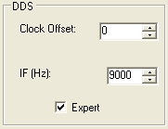
Figure 60: DDS
DDS Stands for Direct Digital Synthesis. The DDS chip in the FLEX-5000 produces an analog sine wave at up to micro Hertz resolution. The DDS is used as a local oscillator to tune the radio.
- Clock Offset: Allows software corrections to be made manually if the DDS clock oscillator is not running at exactly 500MHz. Changing the clock offset will change the frequency calibration of your radio. Typically there will be no need to do so as the radio has been completely factory calibrated. However, as the radio ages, the oscillator frequency may change slightly.
  - To adjust the frequency calibration of your radio, first use the automatic Frequency Calibration controls described on page 72.
  - To manually adjust the frequency calibration of your radio, start the internal signal generator by opening the Setup Form, Tests Tab (page 111) and checking Enable HW Signal Generator. Select DSB mode and tune VFO A to the desired frequency. With SPLT turned off you should see a -25 dBm signal at the VFO frequency. Change the display to the Phase display and you will see a single dot. Next, go to the Setup Form - General Tab, Hardware Config Sub Tab and check Expert to reveal Figure 60 above. Adjust the Clock Offset control until the dot in the phase display is (almost) standing still. Don't forget to turn the internal signal generator off, when you are done.
  - The Clock Offset can also be calculated as follows. Divide the DDS frequency (500MHz) by the known signal frequency (say, 10MHz WWV) and then multiply by the difference between the known and the measured frequency. For example, say you tune the VFO to 10MHz and the peak shows up at 9.999700MHz (difference is 10.0 – 9.999700 = +300Hz). The Clock Offset would be 500/10 * 300 = 15000. Plugging in 15000 into the Clock Offset control should zero beat the signal. Note that if the measured frequency were 10.000300MHz, the offset would be -15000. Fine adjustments may be made directly on the Clock Offset control using the phase display as described above.
Note: Any adjustments you make are saved to your database only and not to the radio's EEPROM. Therefore, if you start PowerSDR with a clean database, you will lose these adjustments.
- IF (Hz): Controls the Intermediate Frequency used in the software to avoid low frequency noise. The default value is 9,000 Hz and can be varied between 0 and 20,000 Hz. Normally there will be no need to adjust this. However, if you are experiencing low frequency noise, such as spurs that cannot be eliminated with the Spur Reduction (SR) enabled, you might trying adjusting the IF.

Options Sub-Tab
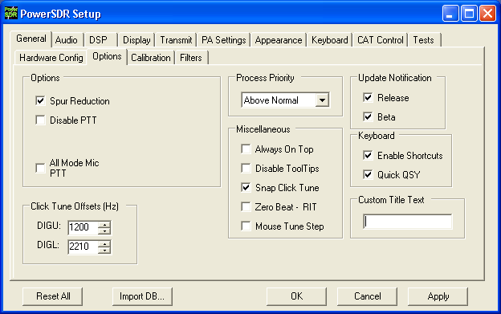
Figure 61: Setup Form - General Tab, Options Sub-Tab

[The rest of this page has been left blank intentionally]

Options
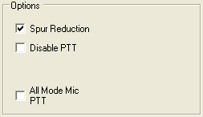
Figure 62: Options
- Spur Reduction: Adds the use of a software oscillator to avoid DDS frequencies known to have a higher phase truncation related spurious response. In short, rather than tuning each frequency using the DDS (this is what happens when this option is turned off), the software tunes the DDS in 3kHz steps and does fine-tuning in software. Tuning in 3kHz steps also has the advantage of having to send fewer command signals to the hardware. For a complete description of the spur reduction algorithm used, see A Technical Tutorial On Digital Signal Synthesis available from Analog Devices.
- Disable PTT: Disables the ability to use external Push-To-Talk lines (MIC and PTT connectors) to key the radio.
- All Mode Mic PTT: When checked, PTT through the Front Panel MIC connector will be enabled. Otherwise, this PTT line will be disabled for digital (DIGL, DIGU) and DRM modes.

Process Priority
Sets the process priority for PowerSDR. Some users have reported that setting the priority higher than Normal can allow slower systems to perform more reliably and with smoother audio. While FlexRadio Systems recommends using the Normal setting, if you are experiencing audio glitches or are using a slower machine, selecting Above Normal or High might improve the performance of the software. Note that FlexRadio Systems does not recommend using the Real Time setting as this could cause timing problems with the operating system.

Update Notification
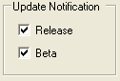
Figure 63: Update Notification
Use these check boxes to enable a pop-up notification when new versions come out. Check the Beta box to receive update messages when new Beta versions are available. Similarly, check the Release box to receive update messages when official release versions become available.

Click Tune Offsets (Hz)
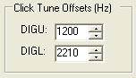
Figure 64: Digital Click Tune Offsets
- DIGU: Sets the offset in Hz to use when click tuning in DIGU mode. Defaulted to 1200 for SSTV.
- DIGL: Sets the offset in Hz to use when click tuning in DIGL mode. Defaulted to 2210 for RTTY.

Miscellaneous
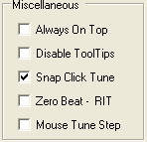
Figure 65: Always On Top
- Always On Top: Check to paint the Front Console on top of any other windows (even an active window).
- Disable ToolTips: Check to avoid seeing the explanatory tool tips that appear when you hover with your mouse over a control.
- Snap Click Tune: When checked, clicking (with the yellow or red cross hairs) on a signal in either the Panadapter or Waterfall will tune the VFO to the nearest multiple of the Tune Step (see page 41). E.g. if Tune Step is set to 1 kHz, the VFO will jump to the nearest kHz.
- Zero Beat – RIT: When checked and with RIT activated, the 0 Beat button on and the Front Console will offset the peak of a signal by the RIT frequency, such that VFO = actual peak frequency – RIT frequency. This can be useful if you want to zero beat the receive frequency without changing the transmit frequency.
- Mouse Tune Step: When checked, clicking the mouse button (middle click) will cycle through the tune steps.

[The rest of this page has been left blank intentionally]

Keyboard
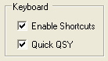
Figure 66: Quick QSY
- Enable Shortcuts: Enables the use of keyboard keys to perform various PowerSDR functions. The keyboard shortcuts can be set on the Setup Form-Keyboard Tab, described on page 106).
- Quick QSY: Enables the user to quickly enter a frequency in MHz on the keyboard and hit [Enter] to jump to that frequency. With this option disabled, using a mouse to tune or to click inside the VFO is the quickest way to change frequency. This feature is normally enabled by default, but can be disabled to prevent changing the VFO frequency due to accidental key presses.

Custom Title Text
Enter the text you would like appended to the standard text (FlexRadio Systems PowerSDR v1.x.y) in the title bar of the Front Console.

[The rest of this page has been left blank intentionally]

Calibration Sub-Tab
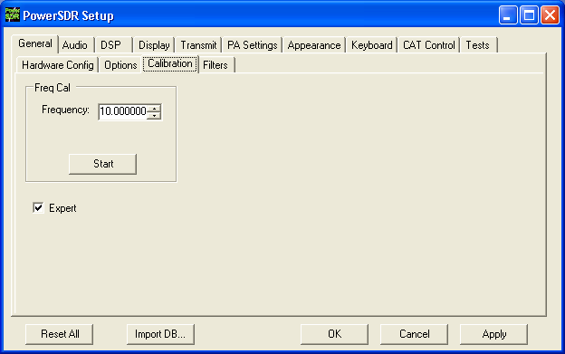
Figure 67: Setup Form - General Tab, Calibration Sub-Tab
To reveal the Frequency Calibration Sub-Tab, you will need to check the Expert box, which will generate a warning that this is meant only for experienced users. If you decide to proceed tune your radio to a known accurate frequency source (e.g. WWV), enter the frequency in the Frequency control and click the Start button.

[The rest of this page has been left blank intentionally]

Filters Sub-Tab
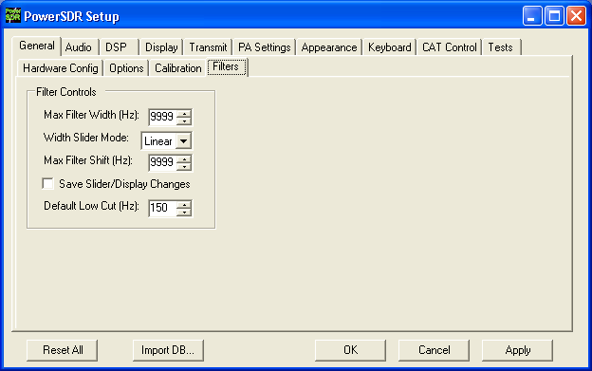
Figure 68: Setup Form - Filters Tab
- Max Filter Width: Sets the maximum filter width to be set by the Filter Width Slider on the front console.
- Width Slider Mode: Sets the behavior of the Width Slider. Linear, Log, and Log10 are the options. The log options offer more resolution on the smaller filter sizes.
- Max Filter Shift: Sets the maximum swing in Hz that the Filter Shift Slider on the front panel will allow in either direction.
- Save Slider/Display Changes: If checked, any changes to the filters made by the filter sliders or by using the click and drag on the filter edges on the display will be saved to the Variable filters and will be recalled as such. If not checked, the Var filters can only be changed by adjusting the Filter Low and High Cut controls on the front panel.
- Default Low Cut (Hz): Sets the default low frequency cut-off for the USB/LSB filters.

[The rest of this page has been left blank intentionally]

Audio Tab

Primary Sub-Tab
Figure 69: Setup Form - Audio Tab, Primary Sub-Tab

Buffer Size
You should set your audio Buffer Size as low as your computer system will tolerate. Larger buffers mean more delay, but smoother audio. Smaller buffers yield less latency, but at the cost of CPU load. The 2048 sample buffer size means that a single buffer at 48kHz sample rate is 2048/48000 = 42.7ms in length. Faster machines should be able to run with a buffer size of 512 without issue at the lower Sample Rate settings (see below). For best CW performance, set the audio buffer to 512 or less. (see also the DSP Buffer Size on page 79).

Sample Rate
The sample rate can be set to 48kHz, 96kHz or 192kHz. Using the higher sample rates will result in a wider frequency range in the panadapter and waterfall displays. For best CW performance set the sample rate to at least 96kHz. However, when using very narrow CW filters, 48kHz may be a better choice (see Appendix A).

Note: Make sure your audio Buffer Size and Sample Rate are identical to those set in the FLEX-5000 Driver (see page 20).

Mic Boost
Check this check box if your microphone audio is sounding too weak and you cannot increase it further with the Mic Gain control on the Front Console and the Mic Input control on the Mixer Form

Expert
This check box will show additional controls that you should only consider using if you are an experienced user. You should proceed with caution. Vary rarely, if ever, will you need to access these controls.

Latency
Using the manual option, the user may add additional latency (in milliseconds) to the audio buffering system for better audio performance. When the manual setting is off, the delay is set to 0ms. Note that some systems will have trouble with the manual setting on and values below approx. 15ms. We recommend using the default automatic latency setting for best results.

VAC Sub-Tab
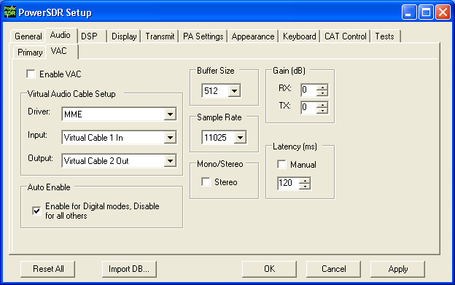
Figure 70: Setup Form - Audio Tab, VAC Sub-Tab
Use these controls to configure the VAC (Virtual Audio Cable) settings for use with PowerSDR. This is ideal for running digital modes, but can serve as another way to get audio in and out of PowerSDR. The Buffer Size, Sample Rate are similar to those described in the previous section. Below we describe the unique controls on this form.

Virtual Audio Cable Setup
Select the driver type you wish to use. With most digital software MME will work well. Select the Input and Output channels as shown in Figure 70.

Gain (dB)
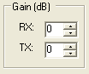
Figure 71: Gain (dB) Controls
These settings adjust the gain for signals coming in and out of the VAC interface.
- Use the RX control to adjust the audio level going to third party programs. Note that this control supersedes the front panel AF control for third party applications.
- Use the TX control to adjust the volume of audio coming from third party applications. Use this control instead of the MIC control on the front panel to calibrate transmit (adjust for 0 dB on the ALC meter).

Latency
Using the manual option, the user may add additional latency (in milliseconds) to the audio buffering system for better audio performance. When the manual setting is off, the delay is set to 0ms. Note that some systems will have trouble with the manual setting on and values below approx. 15ms. We recommend using the default automatic latency setting for best results.

Mono/Stereo
Check this check box for stereo audio channels. Most third party applications require monaural audio. In this case leave the box unchecked. However, several DRM applications such as DREAM and HamPal require stereo audio.

Auto Enable
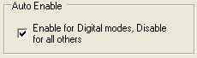
Figure 72: Auto Enable
Use this control to automatically enable VAC when operating digital modes (DIGL, DIGU, DRM). This allows the user to easily switch between digital modes and SSB/AM/FM without having to separately enable/disable VAC.

DSP Tab

Options Sub-Tab
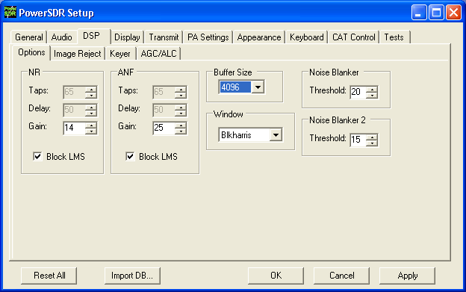
Figure 73: Setup Form - DSP Tab, Options Sub-Tab

Noise Reduction
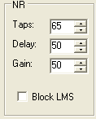
Figure 74: Noise Reduction Controls
Noise Reduction (NR) attempts automatic computation of a filter that maximizes the coherent or non-noise like signals and as a result, filters out the rest of the signal, which includes noise. It is best used for speech signals with a good signal to noise ratio or tones. There are two calculation routines available: the Original routine and the Block LMS routine.

- Original Calculation Routine
  - Taps: The number of taps determines the length of the computed filter. The longer the filter, the better the non-coherent signals (noise) will be canceled. It also introduces latency equal to the number of filter taps divided by the sample rate in samples per second and is in addition to Delay (see below). The larger the number of taps, the longer it takes for the filter to converge but upon achieving convergence, the better the filter will be.
  - Delay: Determines how far back to look in the signal before beginning to compute a coherent signal enhancement filter. With large delays, there is a higher likelihood of detrimental affects to normal speech. Latency is also introduced that is equal to the Delay.
  - Gain: Determines the adaptation rate of the filter. The larger the number, the faster the filter will converge but the less stable it will be.
- Block LMS: The Block LMS (least means square) routine is a faster converging routine than the original routine, gives more taps in the filter, and will work on I/Q signals, which enables BIN (binaural audio) to remain available.
  - Only Gain is available when Block LMS is selected. Set Gain such that there is almost no difference in the audio level of a signal with or without NR activated. The noise level will be lower of course when NR is activated, but ideally, the audio level of the actual signal will remain about the same with NR engaged or not.

Automatic Notch Filter
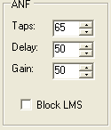
Figure 75: Automatic Notch Filter Controls
The Automatic Notch Filter (ANF) attempts automatic computation of a filter to remove one or more carrier tones that are interfering with the signal of interest. There is an Original calculation routine available and a faster converging Block LMS routine

[The rest of this page has been left blank intentionally]
- Original Routine
  - Taps: This determines the length of the computed notch filter. The longer the filter, the larger the number of tones that can be canceled and the more effective the cancellation will be. It also introduces latency (signal delay) equal to the number of filter taps divided by the sample rate in samples per second and is in addition to Delay (see below). The larger the number of taps, the longer it takes for the filter to converge but upon achieving convergence, the better the filter will be.
  - Delay: Determines how far back to look in the signal before beginning to compute a cancellation filter. The larger the delay, the less the impact on normal speech, and the more likely the filter will be able to concentrate only on longer term coherent signals such as carrier tones. Latency is introduced that is equal to the Delay.
  - Gain: Determines the adaptation rate of the filter. The larger the number, the faster the filter will converge and the less stable it will be.
- Block LMS: The Block LMS (least means square) routine is a faster converging routine than the original routine, gives more taps in the filter, and will work on I/Q signals, which enables BIN (binaural audio) to remain available.
  - Only Gain is available when Block LMS is selected. Set Gain such that there is almost no audio level difference with or without ANF activated.

Buffer Size
This controls the size of the DSP buffers, which determines the size of the FFT filter and therefore the group delay (latency) through the digital filter. Higher values will result in more latency and sharper (“brick wall”) filters. Lower values will allow nearly real time monitoring with filters that “roll off” (as opposed to the typical “brick wall” filters).
- For example if the sample rate equals 192kHz and the DSP buffer equals 2048 then the minimum attainable 3dB filter width equals 1.5*192000/2048 ≈ 140Hz, where the factor 1.5 is due to the Blackman-Harris windowing function (see below). The same filter shape is achieved for 96kHz and 1024 or 48kHz and 512. Either lowering the sample rate or increasing the DSP buffer size will enable narrower and sharper filters.
To dramatically illustrate this effect Figure 76 below shows two traces of the same 25Hz CW filter. The red trace is at a Sample Rate of 192kHz and a DSP Buffer size of 512, yielding a minimum filter width of 1.5*192000/512 ≈ 563Hz!! The blue trace at 48kHz and 4096 yields a minimum 3dB filter width of 1.5*48000/4096 ≈ 18Hz.

[The rest of this page has been left blank intentionally]
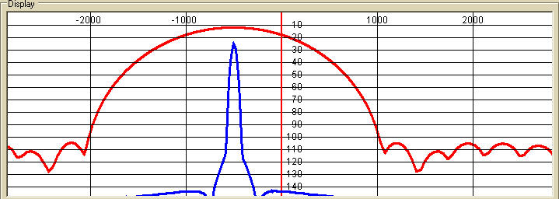Figure 76: 25Hz CWL Filter at 192kHz Sample Rate/512 Buffer Size (Red) and 48kHz/4096 (Blue)
- The minimum audio latency is determined by the maximum of the group delay and the delay due to audio buffering (see page 74). In the above example the group delay equals 2048/192000 = 11ms. If the audio buffer is set to say 1024 then its latency equals 1024/192000 = 5ms. In this case the overall latency is determined by the DSP buffer size and the group delay of 11ms.
- Therefore, you should set your Audio Buffer as low as your computer system will tolerate at the set Sample Rate. Next you should set your DSP Buffer as high as you can, without experiencing noticeable latency. Finally, for the narrowest (CW) filters you may need to lower your Sample Rate further, especially in extreme conditions such as contests.

Noise Blanker
This controls the detection threshold for impulse noise. If a signal sample exceeds this detection threshold, the sample will be set to zero and the filtering in the radio serves to interpolate through this zero sample. This noise blanker is identical in theory to those in traditional radios. The detection threshold in our noise blanker has the unique feature that they are signal strength dependent. This enables them to function properly at all signal levels.
This control is preferable when the spikes are very large in comparison to the average signal. However, when the spike is smaller, Noise Blanker 2 provides a much cleaner reconstruction of the signal since the signal is more likely to look like the mean. For this reason, the Noise Blanker 2 threshold should always be about four or five less than the Noise Blanker threshold.

Noise Blanker 2
This controls the detection threshold for a pulse. If a signal, pulse or not, exceeds this detection threshold, the sample will be replaced by a computed estimation of what the signal sample should have been given an interpolation of the signal samples around it in time. By replacing the noise pulse with an interpolation of the signal, distortion is greatly reduced over that of traditional noise bankers.
When seeing a significant amount of impulsive noise, being too aggressive with Noise Blanker (NB) can damage the signal. However, completely removing the large pulses is desirable prior to operating the smoother acting Noise Blanker 2 (NB2). Therefore, when seeing many repetitive noise pulses, it is probably best to use both NB and NB2. The NB Threshold is adjusted to just begin to lower the noise from the pulses, after which NB2 is turned on, with a threshold of four or five less than that of NB. Both together can spectacularly reduce impulse noise, resulting in increased intelligibility of the signal under severely adverse conditions.

Window
This control selects the DSP windowing function that will be applied to the power spectrum in the main display when using Spectrum, Panadapter, Histogram, and Waterfall displays. The default is Blackman-Harris, which is the best setting for many high-level signal measurement needs. The purpose of the windowing is to diminish bleed-through to adjacent “bins” which results from a tone that is not exactly on the center frequency of one of the “bins” (or parallel filters) in the power spectrum calculation. The bleed-through is caused by using the Fast Fourier Transform (FFT) to calculate the power spectrum, which we need to use for the sake of efficiency. That said, it is important to understand that the FFT writes the data (mathematically speaking) on a circle and not on a line. When the last sample meets the first sample on a circle, it is very probable that it will not meet up or join in a continuous fashion. This discontinuity acts in exactly the same manner a key click causes a wide spectrum. The window is used to mitigate this key click-like phenomenon. The Rectangular Window bleeds through the worst. The best in our selection is the Blackman-Harris Window, which bleeds through the least, but at a penalty of a slightly reduced spectral resolution. Appendix D describes in more detail several of the window functions available in PowerSDR.
Figure 77 shows the effect of using various windows with a 1kHz DSB filter. The effect is most obvious in the stop band attenuation of the filter, where the Rectangular Window (Black) shows the worst result. In this case, the Blackman-Harris Window (Red) is obviously superior.
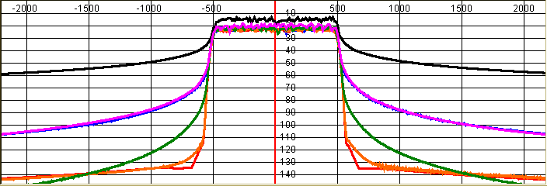Figure 77: Effect of Various Windows: Rectangle (Black), Welch (Violet), Bartlett (Blue),
Hanning (Green), Blackman 3 (Orange) and Blackman-Harris (Red)

[The rest of this page has been left blank intentionally]
Figure 78 displays a 25Hz CW filter with a Hanning and a Blackman-Harris. It is clear that the Hanning window offers a narrower passband at the cost of a higher stop band. Blackman-Harris offers a much improved stop band, but at the cost of a slightly wider passband. In almost all cases Blackman-Harris will be preferred, except possibly for weak CW signals, where dynamic range is much less important than a narrower passband.
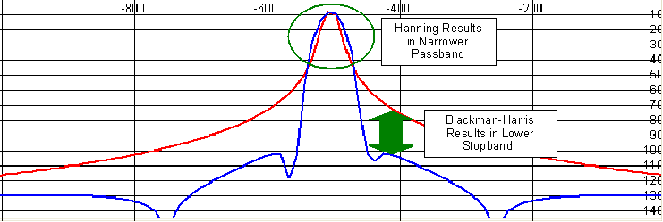Figure 78: 25Hz CW Filter with Hanning (Red) and Blackman-Harris (Blue) Windows

Image Reject Sub-Tab
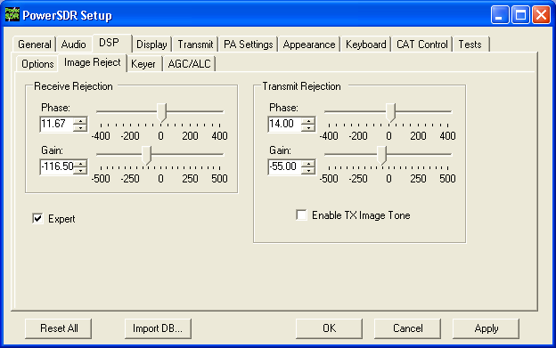
Figure 79: Setup Form - DSP Tab, Image Reject Sub-Tab
Note: Your FLEX-5000 is completely calibrated, including both receive and transmit image rejection and needs no further adjustments.

Expert
This Expert check box will show controls that you should only consider using if you are an experienced user. You should proceed with caution. Very rarely, if ever, will you need to access these controls.

Receive Rejection
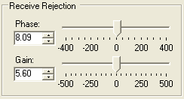
Figure 80: Receive Rejection
Image Rejection means finding adjustments for phase angle and gain differences between the left and right channels in the in-phase (I) and quadrature (Q) signals.
- Phase: Sets the phase offset between the I and Q channels. Ideally, the phase angle difference between I and Q (right and left channels) of a tone in our passband will be 90 degrees.
- Gain: Sets the amplitude offset between the I and Q channels. Ideally, the amplitude of both I and Q (left and right) channels of a received tone will be equal.

Transmit Rejection
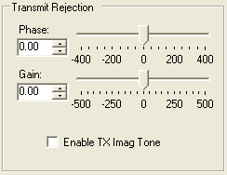
Figure 81: Transmit Rejection
Similar to above, these controls enable the user to adjust the image rejection for the transmitter. The calibration requires external instruments. A spectrum analyzer is ideal but a second receiver should enable you to get satisfactory rejection levels.
To minimize the transmit image, proceed as follows:
- Set the radio to either USB or LSB. Connect the radio to a dummy load and select Enable TX Image Tone.
- Click MOX (front console) and a full strength tone will be transmitted at the frequency shown in VFO A. Adjust the output power with the Drive control (front console).
- If the radio is set to USB, look at the image signal BELOW the carrier in either the spectrum analyzer or the second receiver. If set to LSB, look at the image signal ABOVE the carrier.
- Using Phase and Gain controls, null the relevant image signal.
Note: The image rejection will only work in an asymmetric voice mode (SSB). In a symmetric voice mode, like AM, SAM, and FMN any small amount of image problem will likely be covered up.
[The rest of this page has been left blank intentionally]

Keyer Sub-Tab
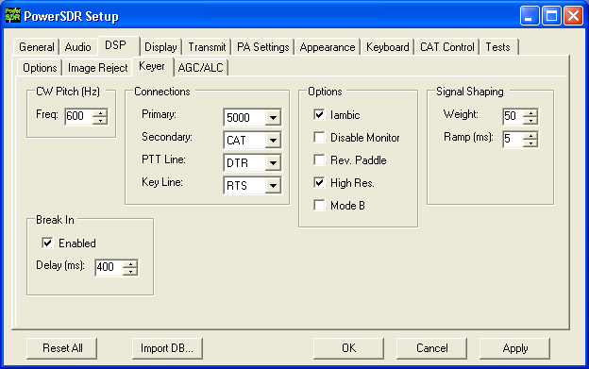
Figure 82: Setup Form - DSP Tab, Keyer Sub-Tab

CW Pitch
This enables the user to set the desired audio frequency for CW listening at the center of the CW filters (1kHz and lower filters). This will determine the offset that is applied to the carrier in receive and transmit. The display will continue to read the actual carrier frequency, but the software will provide for an offset to get the desired CW tone. This pitch will determine the automated tuning frequency using the display and mouse “click tune” functions.

Connections
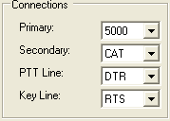
Figure 83: Connections
The internal keyer supports two inputs. We call these inputs the primary and secondary connections. The primary connection will override the secondary input. This was designed with the idea that the secondary connection might be used for automatic CW generation while the primary could be used with manual paddles to override the automatic output.
- Primary: Select the connection to be used for the primary connection. Selecting “5000” allows the use of the jack on the back of the FLEX-5000.
- Secondary: Select the connection to be used for the secondary connection. Selecting “CAT” will allow use of the COM port that is currently being used by the CAT connection. This is useful as some programs allow both CAT commands and COM port line keying for CW. Note that the lower two controls will not show up if “None” is selected.
- PTT Line: Select the COM port line used for PTT.
- Key Line: Select the COM port line to be used to activate the key.

Options
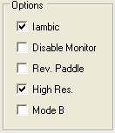
Figure 84: Internal Keyer Options
- Iambic: Check this box to enable Iambic mode A emulation unless mode B is selected (see below). With the box unchecked, the key input will act like a straight key.
- Disable Monitor: The monitor is typically turned on when using Break In with the internal keyer. In order to keep the monitor off, check this option.
- Rev. Paddles: Using this option will reverse the paddle inputs so that the dot becomes a dash and vice versa.
- High Res.: This option will attempt to achieve fastest CW latency by using the high frequency event timer (if present) on motherboards containing Intel Pentium 4+ (and AMD equivalent) type processors. If the CW timing or tone production becomes unstable after checking the box, your motherboard contains the low frequency timer and you should leave the box unchecked. The option works for both manual and automatic CW.
- Mode B: Check this box to enable Iambic mode B emulation. Uncheck it to enable mode A emulation.

Signal Shaping
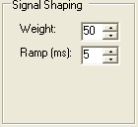
Figure 85: Signal Shaping Controls
- Weight: Sets the width ratio between the dot and dash.
- Ramp: Sets the length of the leading and trailing edge on the tones in milliseconds to avoid key clicks.

Break In
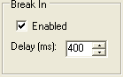
Figure 86: Internal Keyer Semi Break In Controls
- Enabled: Check this box to enable Break In for the internal keyer.
- Delay (ms): Sets the amount of time between the last detected input and when the radio will drop back to receive. The smallest possible setting is 10 ms.

AGC/ALC Sub-Tab
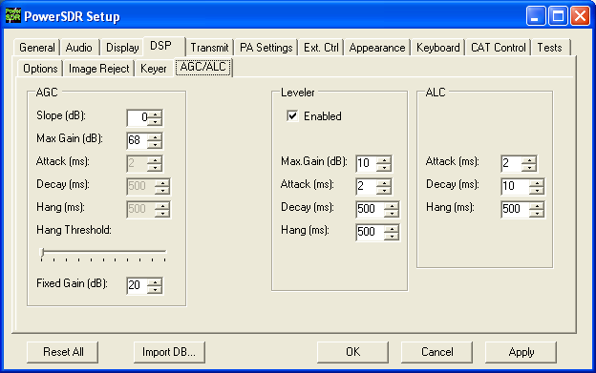
Figure 87: Setup Form - DSP Tab, AGC/ALC Sub-Tab
These controls allow the user to customize the AGC/Leveler/ALC to their own particular tastes.

AGC
The AGC is a state of the art, dual track AGC with anticipatory response on both fast and slower tracks. Or, stated differently, the AGC is in essence the combination of two AGCs, one with a very fast time constant, the other with a much slower time constant (for more detail see the AGC Article by Phil Harman (VK6APH) on the Downloads page of our web-site. The Attack, Decay and Hang settings may only be adjusted when the Front Panel AGC control is set to Custom. However, they do display the values for the other AGC settings.
- Slope (dB): The AGC gain once the signal is above the AGC threshold (or knee, not to be confused with the Hang Threshold below). Setting a Slope higher than 0dB allows stronger signals above the threshold to sound louder than weaker ones (also above the threshold).
- Max Gain (dB): The maximum amount of gain allowed by the AGC system for signals below the AGC threshold. The total AGC gain equals the Max Gain + the Slope (Gain). See also Appendix C.
- Attack (ms): This sets the time constant for the attack for the AGC, When a signal gets stronger, this determines how quickly the AGC will respond to the need for decreased gain. Note that in order for this and the two controls below it to be enabled, the AGC control on the front panel must be set to Custom.
- Decay (ms): This sets the time constant for the decay for the AGC. When a signal gets weaker, this determines how quickly the AGC will respond to the need for increased gain.
- Hang (ms): To keep the AGC system from adjusting too much, an adjustable hang time is provided. This Hang time will only be applied if the signal level is above the Hang Threshold (see below), otherwise a fixed “Fast Hang” time of 100ms is applied. After this time has expired, the Decay will then determine how quickly the AGC gain recovers.
- Hang Threshold: The Hang will NOT occur if the signal is weaker than this threshold. Instead the “Fast Hang” will be applied.
- Fixed Gain: When you choose Fixed AGC on the front panel, this number is used to amplify the signal.
Table 8 details the AGC parameters used in the various settings.
Table 8: AGC Setting Details
Setting | Attack | Decay | Hang | Fast Hang
Fast | 2ms | 100ms | 100ms | 100ms
Med | 2ms | 250ms | 250ms | 100ms
Slow | 2ms | 500ms | 500ms | 100ms
Long | 2ms | 2000ms | 750ms | 100ms

Leveler
The Leveler is intended to even out the variations in input to your microphone caused by varying distance from or angle presented to it. It is an attempt to “level” the amplitude presented to the rest of the DSP audio processing. The leveler is disabled in DIGU and DIGL modes.

ALC
The ALC is what you would typically consider ALC to be in a transmitter. It is an attempt to prevent overdrive of the amplifier and the distortion that would accompany that. Because of the dual track AGC algorithm we use, this ALC will allow very high average power while maintaining peaks at a controlled level. The Compressor and Compander (CMP and CPDR on the Front Console (Mode Specific Controls – Phone, page 48) and on the Setup Form-Transmit Tab, page 96) work very well with the ALC to increase average power without overdrive.

[The rest of this page has been left blank intentionally]

Display Tab
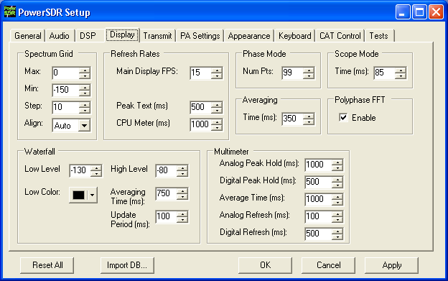
Figure 88: Setup Form - Display Tab

[The rest of this page has been left blank intentionally]

Spectrum Grid
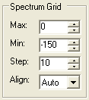
Figure 89: Spectrum Grid
The spectrum grid controls define the range and scale of the vertical axis (signal level in dBm) shown in the Spectrum, Histogram, and Panadapter displays.
- Max: The maximum displayed signal level in dBm (i.e. top of the display).
- Min: The minimum displayed signal level in dBm (i.e. bottom of the display).
- Step: Spacing between the horizontal grid lines in dBm.
- Align: Sets the position of the vertical axis. The Left, Center, Right, and Off settings are self-explanatory. The Auto option automatically places the vertical axis at the 0Hz position in the Spectrum and Histogram displays.

Refresh Rates
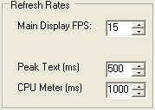
Figure 90: Refresh Rates
- Main Display FPS: Sets the update rate of the main display to the selected value in frames per second. Note that this is a good control to reduce if you are running on a slower machine to save CPU cycles. Raising this value will give faster updates at the cost of CPU load. Lowering the value will slow the display down.
- Peak Text (ms): Sets the update rate of the peak signal location text box located just beneath the display. Raising the value increases the delay between peak updates and slows the display down. Conversely, lowering the value will accelerate the updates.
- CPU Meter (ms): Sets the update rate of the CPU Meter in the lower left corner of the front console. Raising the value will add more delay between updates while lowering the value will yield faster responses. Note that the CPU Meter measures your entire system load and not just that of PowerSDR process.

Waterfall
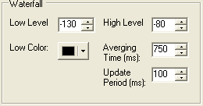
Figure 91: Waterfall
- Low Level: The lower end of the dynamic range to view in dBm. Signals at or below this level will use the Low Color.
- High Level: The high end of the dynamic range to view in dBm.
- Low Color: Color used if the signal level is at or below the Low Level.
- Averaging Time: Time in ms over which the signal is averaged for the Waterfall Display. The AVG button on the Front console has no effect for the waterfall.
- Update Period: Time in ms between updates to the Waterfall. The higher the period, the slower the Waterfall will progress from top to bottom of the display.

Multimeter
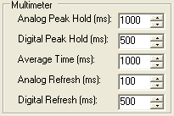
Figure 92: Multimeter Display options
- Analog Peak Hold (ms): The length of time in milliseconds to hold the peak on the analog edge or bar meter. Raising this value will lengthen the hold time and peaks will be held for a longer period of time.
- Digital Peak Hold (ms): The length of time in milliseconds to hold the digital meter when using the Fwd Pwr TX Meter. Raising this value will lengthen the hold time and peaks will be held for a longer period of time.
- Average Time (ms): The time over which the signal is averaged when using the SigAvg RX Meter setting.
- Analog Refresh (ms): Controls how often the analog meter is updated.
- Digital Refresh (ms): Controls how often the digital meter is updated.

Phase Resolution
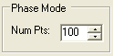
Figure 93: Phase Resolution
This control sets the Phase display resolution in number of points displayed per 360°.

Scope Time Base
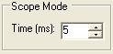
Figure 94: Scope Time Base
This control adjusts the time base in ms (horizontal time scale) of the Scope Display.

Averaging
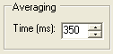
Figure 95: Display Averaging
This control sets the averaging time in ms of the Spectrum, Panadapter and Histogram displays when AVG is enabled on the Front Console.

Polyphase FFT
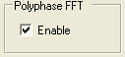
Figure 96: Polyphase FFT
Enable this feature to display peaks sharper in the spectrum displays (Spectrum, Panadapter, Waterfall, Histogram). Expect to see an up to 4 times narrower area of the displayed “spike” of a tone, especially when the displayed frequency span is relatively large in comparison.

[The rest of this page has been left blank intentionally]

Transmit Tab
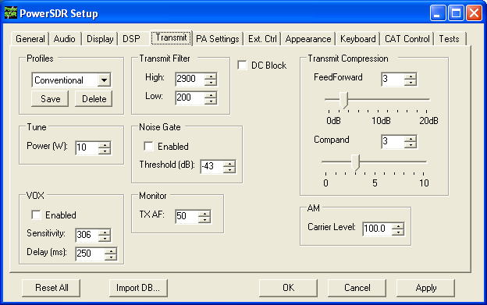
Figure 97: Setup Form Transmit Tab
The transmit Tab has controls that allow the user to tailor the transmit signal characteristics using features like compression and filtering.
- DC Block: Attempts to block any DC noise from entering the filter.
- Tune Power: Sets the power in Watts to be used whenever the TUN (Tune) function is used on the Front Console (sets the Drive control). Changes made to the Drive level while TUN is active will be reflected in this control.

[The rest of this page has been left blank intentionally]

TX Profiles
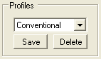
Figure 98: TX Profiles
The TX Profiles selection allows the user to save and restore the various TX settings with ease. The TX profile includes: EQ, Filter, Compression, MIC, Drive, COMP, CPDR, Leveler, and ALC settings. Click the Save button to save the current profile. You will be prompted for a name. To change profiles, select the named profile from the drop down list. To remove a profile, select it using the drop down menu, and then click the Delete button.

Transmit Filter
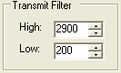
Figure 99: Transmit Filter Controls
- High: Controls the high cut of the Transmit Filter.
- Low: Controls the low cut of the Transmit Filter.
Note 1: You will receive a “good practice” warning if the transmit filter bandwidth exceeds 3kHz.
Note 2: You can view the transmit filter on the Panadapter or Waterfall displays when you enable Show TX Filter on Display on the Front Console.

[The rest of this page has been left blank intentionally]

Noise Gate
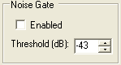
Figure 100: Noise Gate
- Enabled: Enables the transmit noise gate.
- Threshold (dB): The threshold below which the transmitter is silenced (gated). When adjusted correctly, the noise gate prevents prevailing noise in the room (ambient noise) from being transmitted while the microphone is keyed and the operator is not talking. It is very useful if there are close by fans that degrade your signal and make your transmissions disturbing to copy. The noise gate operates identically, whether using VOX or PTT.
To adjust the noise gate:
  - While wearing headphones, activate MON and MOX on the Front Console (use a dummy load). Disable the noise gate and turn up the Monitor AF so that you can hear your ambient noise clearly and preferably louder than without headphones. Without speaking, enable the noise gate.
    - If you still hear your ambient noise, increase the noise gate threshold level until the noise is just silenced.
    - If your ambient noise disappears when enabling the noise gate, decrease the threshold level until you just start to hear it. Then increase it until it just disappears.
  - With the noise gate adjusted, speak into the microphone and verify that your voice sounds as natural as possible.

VOX
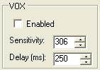
Figure 101: VOX
- Enabled: Enables/Disables the VOX operation.
- Sensitivity: The threshold above which PowerSDR automatically starts transmitting. Use this in combination with the Noise Gate for best results.
- Delay (ms): Time to stay in transmit after the last peak above the threshold.

TX Monitor
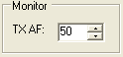
Figure 102: Transmit Monitor AF Control
Use the TX Monitor AF control to set the value that the AF control (Front Console) will use when transmitting.

Compression
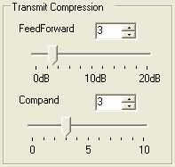
Figure 103: Transmit Compression
- Feed Forward Compression: Determines the “look forward” transmitter automatic gain setting. Unique to DSP implementations, it allows the required gain to anticipate the level before application rather than simply following the signal around. Raising the value will give higher average power without raising the peaks. It helps prevent pumping and popping with large signal onsets and allows for very high average power with low distortion. Note that depending on the microphone, higher values of compression may result in distortion to the output. This setting can be enabled by using the COMP button on the Front Console (page 48)
- Compand: The compander setting given here is really a compression setting. If you are familiar with μLaw, the compression that takes place is very similar. The setting here does not correspond to dB but to a slope of the compression algorithm near zero magnitude. In other words, how much are we pushing the signal up at small magnitudes. As the magnitude of the input signal goes up, less gain is applied and the fall-off of the gain is exponential in its decay. With the goal of introducing fully companded SSB in the near future, this control was put in to the console to allow us to gain experience with this algorithm. This setting can be enabled by using the CPDR button on the Front Console (page 48)

[The rest of this page has been left blank intentionally]

AM Carrier Level
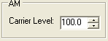
Figure 104: AM Carrier Level
The Carrier Level determines the percentage of carrier level to be applied to the transmit signal where 100% is one quarter of full power output (25W when Drive on the front console is set to 100). So a setting of 80 would yield roughly 16W when Drive is set to 100. This is useful as it allows the modulation to appear much stronger due to the weaker carrier.

[The rest of this page has been left blank intentionally]

PA Settings Tab
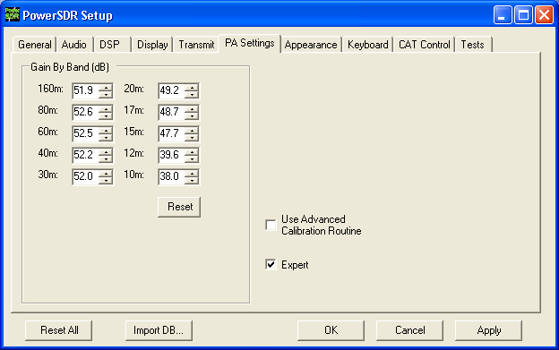
Figure 105: Setup Form - PA Settings Tab
The FLEX-5000 is fully calibrated and requires no further adjustments. If you suspect your power amplifier requires adjustments, please first contact FlexRadio Support for further guidance and how to proceed.
To view the controls, you will need to select Expert. A warning will appear, asking if you wish to proceed or not. Heed the warning.

Gain By Band (dB)
To view these controls uncheck Use Advanced Calibration Routines. This shows the total hardware (radio + PA) signal chain gain. These controls are used to manually balance the output power across the ten supported amateur bands. A higher gain figure for the hardware (as shown) means a lower audio drive gain requirement.
- Reset: this button is included to reset all of the values to 48.0dB (low power output).
When you are done, do not forget to recheck Use Advanced Calibration Routines.

[The rest of this page has been left blank intentionally]

Appearance Tab
The appearance controls allow the user to completely customize the appearance of the front console.

Display Sub-Tab
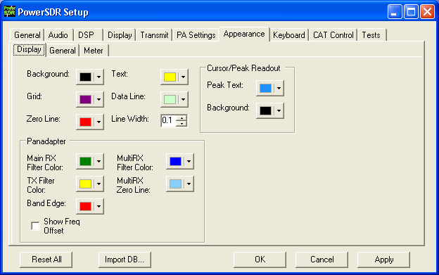
Figure 106: Setup Form-Appearance Tab, Display Sub-Tab

[The rest of this page has been left blank intentionally]

Overall Display
These controls change the appearance of all the display types, where relevant.
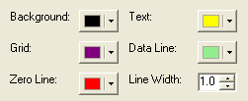
Figure 107: Overall Display Appearance Controls
- Background: The background color for the display.
- Grid: The color of the grid in display types where a grid is necessary.
- Zero Line: The color of the zero line in frequency displays.
- Text: The color of the text on the display for frequency and level callouts.
- Data Line: The color of the actual data being displayed.
- Line Width: The width in pixels of the actual data being displayed.

Cursor/Peak Readout
These controls change the appearance of the cursor and peak texts under the frequency domain displays.
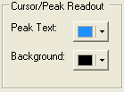
Figure 108: Cursor/Peak Readout Appearance Controls
- Peak Text: The color of the Peak signal location text located under the display.
- Background: The background color of the Peak signal location text.

[The rest of this page has been left blank intentionally]

Panadapter
These controls change the appearance unique to the Panadapter display (and Waterfall for the filters across the top).
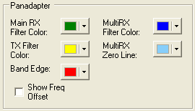
Figure 109: Panadapter Appearance Controls
- Main RX Filter Color: The color of the Main RX Filter.
- MultiRX Filter Color: The color of the MultiRX Filter.
- TX Filter Color: The color of the TX filter-edges.
- MultiRX Zero Line: The color of the 0 Hz line of the Sub RX Filter.
- Band Edge: The color of the lines marking the edge of an Amateur band.
- Show Freq. Offset: When selected, the offsets from the Main RX Filter 0Hz line are shown across the top as opposed to the actual frequencies.

[The rest of this page has been left blank intentionally]

General Sub-Tab
These controls change the appearance of the buttons and the VFOs.
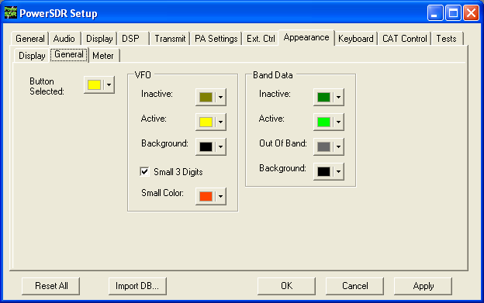
Figure 110: Setup Form-Appearance Tab, General Sub-Tab
Button Selected: The color of buttons when they are in the selected state.

[The rest of this page has been left blank intentionally]

VFO
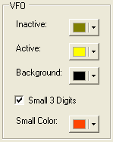
Figure 111: VFO Appearance Controls
- Inactive: The color of the text in the VFOs when they are inactive.
- Active: The color of the text in the VFOs when they are active.
- Background: The background color of the text in the VFOs.
- Small 3 Digits: When selected, the three least significant digits of the frequency displayed in the VFOs are shown smaller than the other digits for clarity.
- Small Color: The color of the smaller, least significant digits.

Band Data
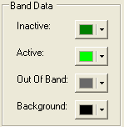
Figure 112: VFO Band Data Appearance Controls
- Inactive: The color of the band information text when that VFO is inactive.
- Active: The color of the band information text when that VFO is active.
- Out Of Band: The background color of the VFO band information when outside the amateur radio bands.
- Background: The background color of the VFO band information when inside the amateur radio bands.

Meter Sub-Tab
These controls enable selection of the analog meter style and change the appearance of the meters.
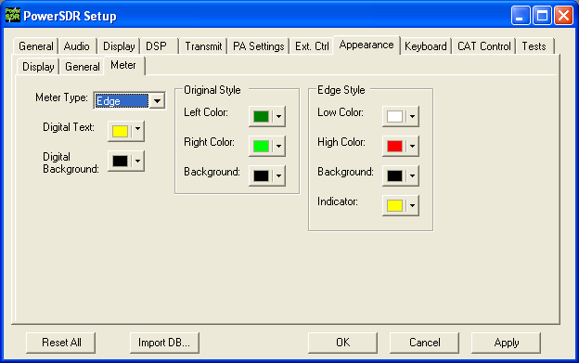
Figure 113: Setup Form-Appearance Tab, Meter Sub-Tab
- Meter Type: Selects the type of graphical meter to display: Original displays the bar graph meter and Edge displays an analog edge style meter.
- Digital Text: The color of the text of the digital meter.
- Digital Background: The background color of the digital meter.

[The rest of this page has been left blank intentionally]

Original Style
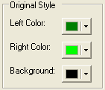
Figure 114: Appearance Controls for the Original Style Meter
- Left Color: The color of the left side of the original style meter gradient.
- Right Color: The color of the right side of the original style meter gradient.
- Background: The background color of the original style meter.

Edge Style
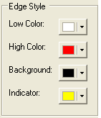
Figure 115: Appearance Controls for the Edge Style Meter
- Low Color: The color of the low values of the edge meter’s scale.
- High Color: The color of the high values of the edge meter’s scale.
- Background: The background color of the edge meter.
- Indicator: The color of the indicator in the edge meter.

[The rest of this page has been left blank intentionally]

Keyboard Tab
These controls associate keys on the keyboard with several operating functions as keyboard shortcuts.
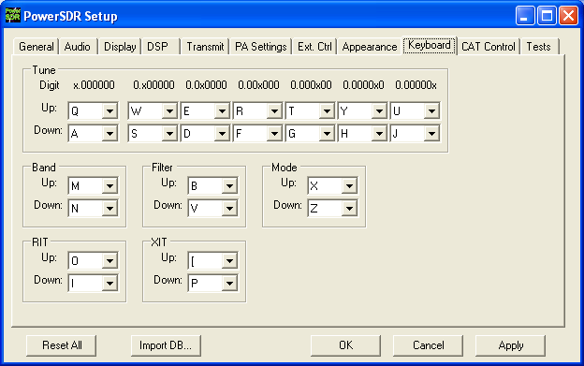
Figure 116: Setup Form - Keyboard Tab
The Tune mapping options allow you to tune each digit (with resolution to 1Hz) up or down using the key of your choice. The digit to be tuned is shown in the labels above these hot keys as an ‘x’. Similarly, you can map keys to change the Band, Filter, Mode, RIT, or XIT up or down using the drop down controls in the respective sections.
Note: Choosing any of the arrow keys will require using Alt + [arrow key].

[The rest of this page has been left blank intentionally]

Cat Control Tab
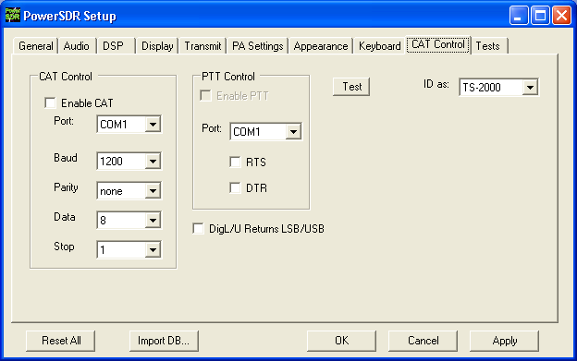
Figure 117: Setup Form - Cat Control Tab
The CAT (Computer Aided Transceiver) Controls enable the PowerSDR software to provide the user with a way to interface with third-party logging and remote control software. When used in conjunction with N8VB’s vCOM virtual serial port software (see the Digital Operations section in the Operation Chapter), the possibilities for interaction with programs such as Ham Radio Deluxe (HRD), DXLab, N1MM Contest Logger, MixW and numerous other third-party software (aids) are realized.

[The rest of this page has been left blank intentionally]

Cat Control
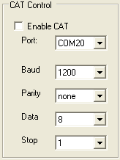
Figure 118: CAT Control
- Enable CAT: Check this box to open the com port using the settings below. Note that you will need to uncheck this box in order to adjust the settings.
- Port: Com port number to use. If using N8VB’s vCOM utility, note that you will use one end of the null-modem pair here and the other on the third-party software (e.g.. HRD).
- Baud: The speed at which to transfer data.
- Parity: Sets whether to send a parity bit.
- Data: Sets how many data bits are sent with each byte.
- Stop: Sets whether to send a stop bit.

[The rest of this page has been left blank intentionally]

PTT Control
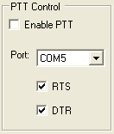
Figure 119: PTT Control
Some software utilizes a separate COM port than the CAT to activate PTT. These controls allow the user to configure this separate port to handle these signals.
- Enable PTT: Used to enable the hardware PTT. This control is unavailable (grayed out) unless a check mark is placed in at least one of the RTS or DTR boxes (see below).
- Port: The COM port used for the PTT signal.
- RTS: Select this box to use the RTS line to engage PTT.
- DTR: Select this box to use the DTR line to engage PTT.

DigL/U Returns LSB/USB
By default DigiL sends or returns the CAT command FSK-R and DigiU sends or returns the CAT command FSK. If this check box is checked, they will instead send or return LSB and USB respectively. The third party digital program you are using will determine which behavior is required.

[The rest of this page has been left blank intentionally]

Test
Click Test to bring up the CAT Command Tester form as shown in the figure below. A valid CAT command may be entered in the CAT Command text box. The command will execute when the Enter key is depressed or the Execute button is clicked. Typing the semicolon, the CAT terminator, at the end of the command is optional. The CAT response will appear in the “CAT Response” text box..

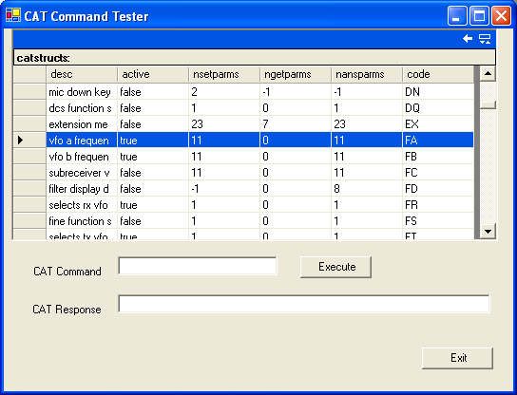
Figure 120: CAT Command Tester Form

[The rest of this page has been left blank intentionally]

Tests Tab
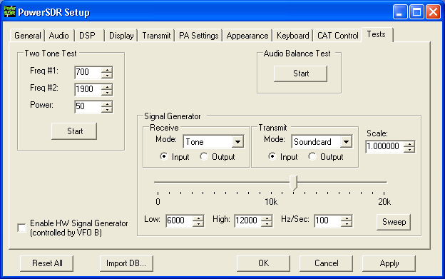
Figure 121: Setup Form - Tests Tab

Two Tone Test:
Used to test the two-tone IMD of the transmitter. To run the test, enter the two tone frequencies in the Freq #1 and Freq #2 controls. Enter the Power to be sent to the front panel Drive control. Make sure you have a dummy load connected. Click the Start button to begin transmitting a side-tone signal using the parameters entered. Manually adjust the Power control on this tab to set the tones to 6dB below PEP using a spectrum analyzer. Click the Start button again to stop the test and read the Power value thus found. A single sweep function on a spectrum analyzer is an excellent tool to capture the output for analysis.
CAUTION: Do not leave the radio in the two-tone test for periods longer than 15 seconds in order to avoid damage to the power amplifier.

Audio Balance Test
Use this test to ensure that the Powered Speaker/Line Out cable is getting both output channels. The test will send a tone to each speaker and prompt to see if you hear audio in that one speaker. If you hear no audio or audio in both channels during this test, then either the connector is not properly seated or you may have a problem with the cable going to the Powered Speaker/Line out jack on the Back Panel.

Signal Generator
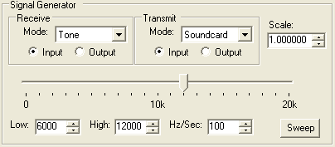Figure 122: AF Signal Generator
This Signal Generator sends an AF signal to either the input or output of either the receiver or the transmitter DSP. It is used to test the PowerSDR.
- Mode: Select the type of signal to generate. “Soundcard” means the Signal Generator is turned off and FLEX-5000 hardware can be used.
Note: When finished with the Signal Generator, do not forget to place the Signal Generator back to “Soundcard”.
- Scale: A scaling factor to adjust the level of the signal being generated. This is only available when “Tone” is selected. Only values smaller than 1 are possible.
- Input: The generated signal is sent to the Input of the DSP, as if it were coming from the ADC like your antenna signals would. The generated signal is therefore perceived as an IF signal by PowerSDR.
For example, if your IF is set at the default 9kHz, then for the Receive Signal Generator a 0Hz generated “Tone” would be displayed 9kHz below the VFO frequency on the Panadapter. As you increase its frequency, upper and lower side band mixing products appear. If you have selected USB mode on the Front Console you will only start to hear a tone when the frequency slider is above 9kHz such that the tone's upper side band is within the audio passband. If you select the Scope display, you will only see the signal when it is within the audio passband.
- Output: The generated signal is sent directly to the output, bypassing the DSP. For the Receive Signal Generator the tone is audible is available from the Line Out jack on the back panel to be viewed on an external scope, for example. The effect of the DSP can be observed by comparing the Output signal to the Input signal.
- Frequency Slider: Determines the frequency of the generated signal
- Sweep: Click this button to sweep the generated signal frequency from Low to High at a rate of Hz/Sec. While sweeping, the button will be yellow. To prematurely stop the sweep click the Sweep button again.
Hint: Together with the Peak display setting the Sweep function allows you to display the actual shape of your audio passband filter. To do so, set your display to Spectrum, activate Peak, set the Receive Signal Generator to “Tone”.
Set the Low and High frequencies to sweep through the selected filter, taking into account the selected mode and IF offset. E.g. for a 2.7kHz LSB filter the “high” end of the filter is at -2.9kHz and the “low” end at -200Hz. To include any filter skirts, you may want to set Low at -4kHz -(-9kHz) = 5kHz and High at 1kHz -(-9kHz) = 10kHz.

Enable HW Signal Generator
The so called “HW” Signal Generator is an RF signal generator as opposed to the AF Signal Generator described above. Check to activate the HW Signal Generator. Its frequency is adjusted by setting the VFO to SPLT and using VFOB.
Note 1: The Receive AF Signal Generator must be set to “Soundcard”, to use the RF Signal Generator.
Note 2: In actual fact, the RF signal is generated using the transmit DSP and sent through the QSE, which is then looped back to the QSD and the receive DSP.

[The rest of this page has been left blank intentionally]

Operating Forms
This chapter describes each of the so-called operating forms. You can access each form individually by clicking on the relevant menu item to the right of Setup at the top left of the front console (see Figure 123). For ease of reference, the numerical identifiers from the previous chapter on the Front Console are repeated in this chapter. Additionally, the key combination Ctrl-Shift-I activates the voltage and temperature form (see page 133)

Figure 123: Operating Form Identifiers

[The rest of this page has been left blank intentionally]

(27) Memory Form
Click the Memory menu allows saving and retrieving information such as frequency, mode, filter and various other settings.

Save…
Opens the Save Memory Channel form as shown in the figure below.
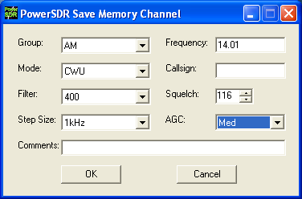
Figure 124: Save Memory Channel Form
The current Mode, Filter, Step Size, Frequency, Squelch and AGC settings are automatically transferred from the console. The Group Drop Down Box allows a further level of characterization of the type of entry. In the future this Group list will be customizable. The Callsign and Comments fields are free form and the user can enter details as desired. Clicking the OK button will save the information shown above into the memory database before closing the form. Clicking Cancel simply closes the form (the data is not saved).

[The rest of this page has been left blank intentionally]

Recall…
Presents the user with a Memory form with data from all previously stored memory locations (shown in the figure below).
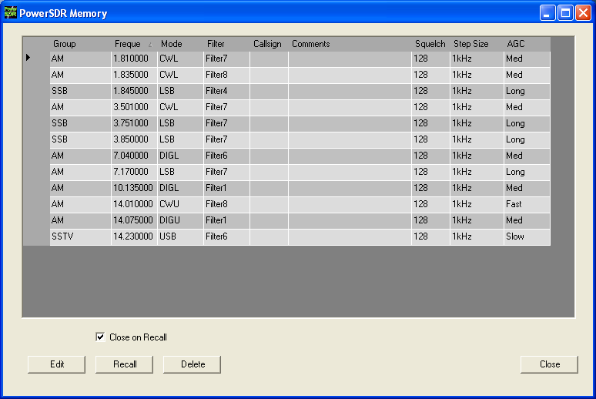
Figure 125: Memory Form
The data grid displays each memory that has been saved to the database. Clicking in the left hand margin will allows a particular memory to be selected. Clicking on the column titles will sort the data using the information in that column.
- Edit: Click the Edit button manually change the saved memories. Make sure to click the button again when finished editing to prevent unintended changes from getting saved to the database.
- Recall: Click the Recall button to send the data in the memory to the front console (i.e. restore a memory). You can also double-click on a row to accomplish this, although this method is less consistent. Select Close on Recall to close the Memory Form when clicking Recall.
- Delete: Click the Delete button to remove a memory from the database. A prompt will be shown to prevent unintended loss of memories.

(28) Wave Form
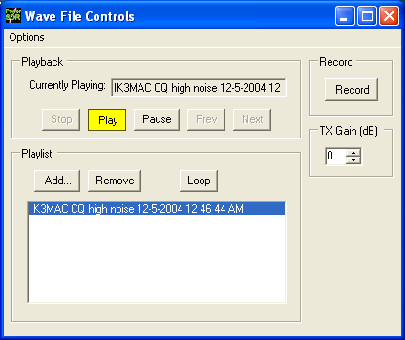
Figure 126: Wave Form
The Wave form allows the user to Record and Playback either the post-processed audio of the current station, or up to 192kHz bandwidth (as determined by the audio sample rate setting) of pre-processed IF (I and Q) “audio” from the FLEX-5000.

Playback
- Currently Playing: Displays the filename of the currently playing wave file.
- Play: Click this button to start or stop playback of the current wave file. Note that clicking this button twice while a file is playing will restart the file.
- Pause: Pauses the wave file playback. Click once to pause and again to resume playback.
- Prev (Previous): When there is more then one file in the playlist, clicking this button will cause the previous file in the list to begin playing.
- Next: When there is more than one file in the playlist, clicking this button will cause the next file in the list to begin playing.

[The rest of this page has been left blank intentionally]

Playlist
- Add…: Click this button to open a file menu to select wave file(s) to add to the playlist. Note that incompatible wave files will be removed from the list when they are played for the first time.
- Remove: Removes the currently selected file in the playlist. If the file is currently being played, then you will be prompted asking if you would like to stop playing the file and remove it from the list.
- Loop: When there is more than one file in the playlist, this option is enabled and allows playback to continue after finishing the last wave file in the list. At this point it will start playing the file at the top of the list.

Record
Click the Record button to begin recording a wave file. Click it again to complete the recording. The wave file will be date and time stamped automatically and saved in the default folder (where the PowerSDR software resides).

TX Gain (dB)
Use this control to adjust the volume of audio being played back when transmitting. Use this control instead of the MIC control on the front console to calibrate transmit (adjust for 0 dB on the ALC meter).

Record Options
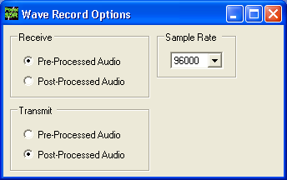
Figure 127: Wave Recording Options
The Wave Record Options can be used to modify what is recorded in either receive or transmit modes.

[The rest of this page has been left blank intentionally]

Receive
- Pre-Processed Audio will record the whole bandwidth of the receiver input. The bandwidth is determined by the sample rate you set on the Setup Form-Audio Tab, Primary Sub-Tab. This is useful for playing back through the console at a later time (e.g. for demonstration purposes).
- Post-Processed Audio will record only the filtered, AGC’d audio as you hear it coming out of the speaker. This is useful for playing back the received audio through a typical wav file player.

Transmit
- Pre-Processed Audio will capture the audio as it is seen at the microphone input without any of the effects of filtering, compression, companding, equalization or any other audio processing features that may be turned on in the transmit chain.
- Post-Processed Audio allows the recording to capture the audio after it has been filtered, compressed, companded, equalized or modified by any other audio processing feature turned on in the transmit chain.

Sample Rate
Sets the sample rate at which the wave file will be recorded.

[The rest of this page has been left blank intentionally]

(29) Equalizer Form
There are three equalizers available: a 3-band, a 10-band and a 100-band equalizer. The equalizers may be enabled either from the Equalizer Form or in the phone modes, from the Front Console (see page 48)

3-Band Equalizer
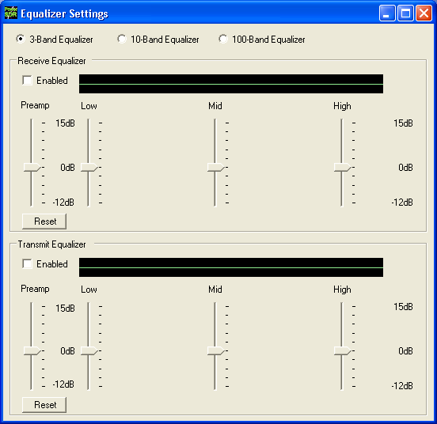
Figure 128: Three-Band Equalizer Form
In most situations the 3-Band Equalizer will suffice. The receive and/or transmit audio can be modified by adjusting the gain for the Low, Mid and High audio bands. The Preamp applies gain across the whole audio spectrum. Easily compare the audio with and without the equalizer using the Enabled check box. The Reset button will reset all of the sliders to the 0dB position.
Hint: Hover with your mouse over a slider to see its frequency range of operation.

10-Band Equalizer
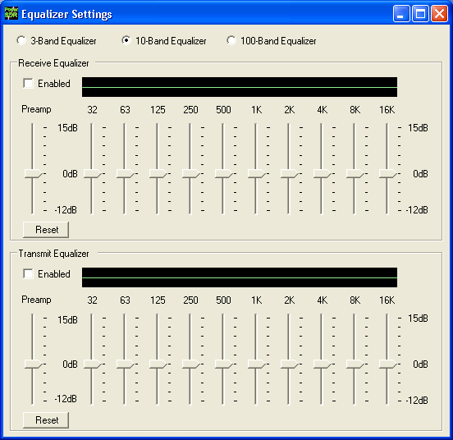Figure 129: Ten-Band Equalizer Form
The 10-Band Equalizer offers a finer degree of audio frequency control than does the 3-band equalizer. You may want to use this equalizer if the 3-band equalizer does not give you the result you want.

100-Band Equalizer
For the real audio buffs.

(30) XVTRs Form
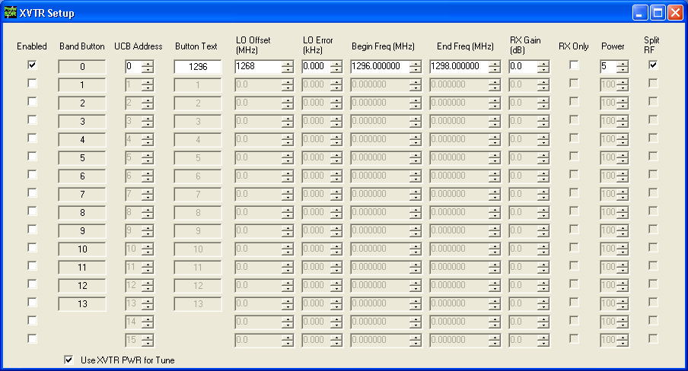
Figure 130: XVTR Setup Form
The XVTR (transverters) Setup Form allows the user to configure up to 16 external transverters for use with the PowerSDR software.
- Enabled: Enables that particular Band Button on the front console with the options selected.
- Band Button: Band button to use for the particular transverter that is being configured.
- UCB Address: Used to set the FlexWire to switch the correct external device (or a relay that controls the external device).
- Button Text: The text that will be shown on the Band Button.
- LO Offset (MHz): The difference between the transverter low frequency and the IF frequency. For example, on 2m, you might use 144-28MHz = 116.0.
- LO Error (kHz): This setting allows the user to correct for any error in the transverter’s oscillator.
- Begin Frequency (MHz): The lower frequency bound for the transverter.
- End Frequency (MHz): The upper frequency bound for the transverter.
- RX Gain (dB): Amount of gain to apply to the incoming signals to compensate for gain within the transverter. Please note that this does not yet work as intended.
- RX Only: If this box is checked, the radio will not transmit while in this configured band.
- Power: Sets the Drive control on the front console to this value whenever the VFO is within the configured band.
- Split RF: Check if the transverter you are using for this band uses separate connectors for transmit and receive RF. In this case connect your transverter to the Back Panel XVTX/COM port for transmit RF and the XVRX port for the receive RF. Otherwise, connect it to the XVTX/COM port only.
- Use XVTR PWR for Tune: When you click the TUN button on the Front Console the power will be set to the value you enter in the Power control on this form (see above). Otherwise, the Tune Power setting on the Setup Form – Transmit Tab (page 93) will be used.

(31) CWX Form
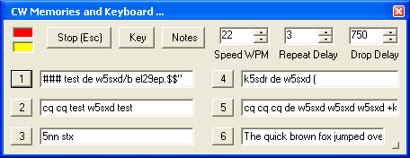
Figure 131: Standard CWX Form

The CWX form is designed to allow you to control automatic Morse code transmission and to send code from your computer keyboard. Pressing the CWX button on the main console menu opens this form. The radio must be in either CWL or CWU mode for transmission to take place.

Standard CWX Controls
- Red Indicator: The small red indicator shows when the radio is transmitting.
- Yellow Indicator: The yellow indicator shows when the key is being ‘pressed’ by the program.
- Key: Clicking this button will cause the radio to start transmitting a steady carrier for up to one minute. Clicking Key again will stop the steady sending.
- Stop (ESC): Clicking this button or the pressing the Esc key on your keyboard will terminate most functions and prepare the program to receive new orders or allow the iambic paddle to be used.
- Notes: Clicking this button will cause a small page of useful notes to be displayed. You can leave the notes up on the screen while you continue to work.
- Speed WPM: This control lets you set the speed of the Morse code being sent. The speed is computed by the standard PARIS method. The softness of the edges may be set by the RAMP control on the Setup Form - DSP Tab, Keyer Sub-Tab. The weighting is always 50% for the memory/keyboard keyer.
Note: This setting is separate from the control on the front console.
- Repeat Delay: This control specifies the amount of time that the keyer will wait when a special pause character is encountered.
- Drop Delay: This control specifies the amount of time that the semi-break in keying will wait before dropping the transmitter when there is no keying occurring.

CWX Memories
There are nine CWX memories, three of which are hidden on the extended form to the right (see below). Each memory can hold thousands of characters and in a standard single line text box. The numbered buttons to the left of each memory box may be clicked to start the message. A message may be stopped at any time by clicking the Stop (Esc) button or pressing the Esc key. Starting a message will seamlessly stop any current message or other automatically keyed transmissions from the radio, including the iambic paddle. The keyer will start the transmitter and send the Morse code for each character until the message ends, at which time the transmitter will shut down. Messages may be edited at any time but the changes will not take place until the memory is started again.

Special Characters
There are several predefined characters that provide non-Morse code functionality or to send familiar combinations like AR and SK (see Table 9 below). For beacon transmissions, the character # will send a long 23 element time dash comparable to a zero, with the key down the whole time. Multiple # characters can be strung together for longer continuous dashes. The $ character works in a similar manner but generates a long 23 element time space. The “or ditto” character may be placed at the end of a message. When encountered, the keyer will shut down for the delay time set in the Repeat Delay control and then restart the message. This allows you to program a CQ and then listen for a reply with the radio back in receive. If the delay is set to zero then the message will simply repeat without the radio switching to receive. Six special combinations are preprogrammed, as shown in the table.

[The rest of this page has been left blank intentionally]
Table 9: Overview of Special Characters
Special Character | Action
# | Beacon - transmits 23 element “zero” time dash
$ | Beacon – transmits 23 element time “space”
+ | AR (.-.-.)
( | KN (-.--.)
* | SK (…-.-)
! | SN (…-.)
= | BT (-…-)
\ | BK (-…-.-)
& ‘ ) : ; < > [ ] ^ | User definable, up to any combination of 9 contiguous dots or dashes

The remaining special characters & ‘ ) : ; < > [ ] and ^ are undefined and may be defined to produce any combination of nine contiguous dots and dashes. Characters that are undefined have no dots and dashes and are simply sent as a space.

Keyboard and Extended Controls
Click the little square button in the lower right corner of the form to expand it. When you do this, the remainder of the memories and controls will be visible including the keyboard window as shown below.
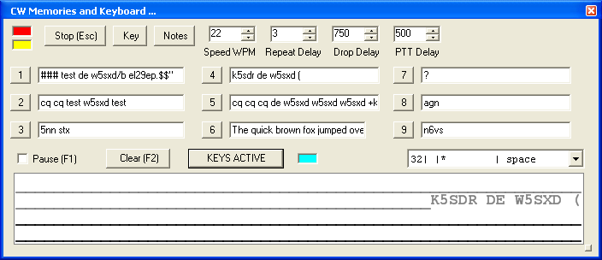
Figure 132: Extended CWX Form

Extended CWX Controls
- Keyboard area: the four-line text box at the bottom. Unsent characters are shown in black and sent characters in gray.
- KEYS ACTIVE. Clicking this button will enable you to use the keyboard to enter characters at the end of the unsent area. As soon as a character is typed it will be sent and then moved to the unsent area. If you type faster than the code is being sent, it will be buffered in the bottom area. cyan indicator shows that Keys Active is enabled.
  - The Backspace key will work in the unsent area.
  - Other editing keys like cut and paste are not implemented.
  - Pressing Alt 1 to Alt 9 or right clicking on the message number button will cause the numbered message memory to be copied into the unsent area just as if you had typed it.
  - The ditto character is ignored in the keyboard mode.
- Pause (F1): Clicking this button or the pressing the F1 key will cause keyboard buffer sending to pause.
- Clear (F2): Clicking this button or pressing the F2 key will clear the keyboard area and stop it sending. Of course, the Stop (Esc) button or the Esc key will do the same.
- PTT Delay: This control allows you to set the time delay between switching the radio to transmit and the first key closure.

[The rest of this page has been left blank intentionally]

Morse Definition Editor
The Morse definition editor allows you to define and even redefine almost all of the characters in the sixty-four-character set. The combo box control to the right of the cyan indicator lets you view and select any of the characters in the set. Each one is displayed as four fixed width fields separated by the | character. There are five special control characters that you may not change and they have an * in the element field.
Once you have selected the character that you wish to edit, left click to select and then right click to bring up the editor dialog.
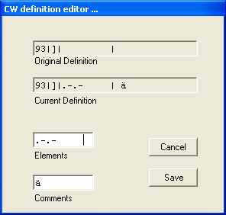
Figure 133: CW Definition Editor
The editor dialog example above shows the ‘]’ character being changed to send didahdidah which is the German code for ä (umlaut a). When your definition appears to be correct, click the Save button and the definition file will be resaved to the disk.
- The definition file is called morsedef.txt and can be found in the same folder as PowerSDR.exe and PowerSDR.mdb. It will not be automatically carried from one version to the next so if you make many changes you might want to save a copy elsewhere.
- The morsedef.txt file can be manually edited with a simple character editor like notepad (not Word), but the format must be followed exactly. Each line must be 26 characters long, not including the two end-of-line codes. It is not free-formatted. The line structure is: a two-digit number field (the decimal ASCII code) | a one-character code field | a nine character elements field | a ten-character comment field preceded by a space and followed by a carriage return and linefeed code. If you mess this file up too badly, simply close PowerSDR, delete morsedef.txt, and a clean, default copy will be created the next time you start. The editor makes simple changes relatively easy to do.

(32) Mixer
Figure 134: Audio Mixer Form
The Mixer controls the audio lines into and out of the FLEX-5000. In essence it is no different than the usual Windows sound card mixer.

Input
The FLEX-5000 has four possibles sources of input audio. These are the MIC connector on the Front Panel and on the Back Panel through the Line-In RCA connector, the Balanced Line In ¼” TRS connector and the FlexWire In (pin 2 of the FlexWire connector). Check to select the desired input source (only one may be selected at a time) and adjust its signal level with the corresponding slider. Click Mute All Inputs to mute all the inputs.

Output
There are three or four possible audio outputs depending on your radio model. These are the Internal Speaker (not available on the FLEX-5000A), the Front Panel Headphones connector and on the Back Panel the Powered Speaker and Line Out RCA connectors. The latter also adjust the FlexWire AF out (pin 9). More than one output can be selected at a time. Check to select the output and adjust its level with the slider. Click on Mute All Outputs to mute all the outputs.

[The rest of this page has been left blank intentionally]

(33) Antenna
The Antenna Selection Form offers two levels of complexity:
- Simple uses the same antenna ports and keying lines for all bands. Different antennas can be selected for each receiver and the transmitter, but they will remain the same for all bands. This is the recommended setting if you use only one antenna.
- Expert allows you to customize antenna ports and keying lines for each band.
WARNING! Make sure you have an antenna connected to the Transmit antenna port you selected. Failing to do so may damage your radio and void your warranty.
WARNING! Do not switch the transmit antenna while transmitting (hot switching). You could damage your radio and void your warranty.

Note: If you switch between the Expert and Simple levels your settings will be remembered should you decide to change back.

Simple
Figure 135: Antenna Selection Form - Simple
The following selections are possible:
- Receiver 1: ANT1 (default), ANT2, ANT3 or RX1 IN
- Use RX1 Out to RX1 In Loop: If either ANT1, ANT2 or ANT3 is selected for Receiver 1, then this option becomes available to enable the insertion of external signal enhancing devices such as preamps, filters and preselectors, without requiring complicated switching mechanisms to avoid transmitting through them. Check to
  - Direct the signal on the selected antenna port to RX1 OUT
  - Connect Receiver 1 to RX1 IN
- Receiver 2: (if installed) RX1 IN (default) or RX2 IN
- Transmit: ANT1 (default, except for 6m), ANT2 or ANT3. For 6m, the antenna port is fixed to ANT3 and cannot be changed.
- Switch Relay with TR: Select the keying line(s) you use, if any, to key your amplifier(s) or other external equipment.
Close the Antenna Form when you are done.

Expert
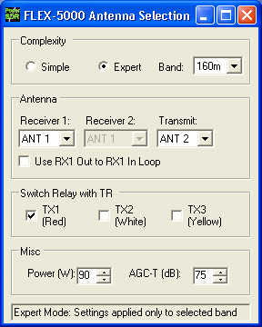Figure 136: Antenna Selection Form - Expert
In addition to the selections discussed for the Simple complexity level, the Expert level offers the following controls:
- Band: Band for which the antenna, key line, power and AGC Maximum Gain settings are valid.
- Power: Transmit power for the selected band.
- AGC-T: AGC Maximum Gain for the selected band.

[The rest of this page has been left blank intentionally]

(34) ATU
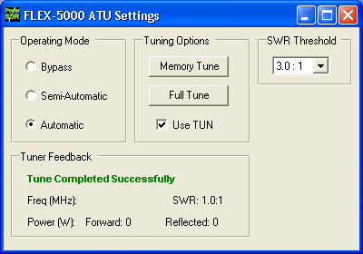Figure 137: ATU Settings Form
The ATU Settings form enables you to control the internal, optional ATU. If you do not have an ATU installed, this form will not be available to you.

Operating Mode
- Bypass: Bypasses the internal ATU. When selected the Tuning Options become unavailable.
- Semi-Automatic: Requires pressing either Memory Tune or Full Tune to find a match.
- Automatic: Will automatically tune when RF is detected. You do not need to press either Memory Tune or Full Tune. Once selected, you can close the form. The ATU will now continuously monitor the SWR and retune as required.
Note: When set to Automatic it is possible that the ATU frequently retunes. If this is the case you can either try to select a higher SWR Threshold or select Semi-Automatic instead.

Tuning Options
- Memory Tune: When pressed the ATU will perform a tuning cycle by first checking its memory for a match. If no match can be found, a Full Tune is performed. This is the fastest tuning option. While tuning is in progress, the button will be highlighted in yellow.
- Full Tune: When pressed, the ATU performs a tuning cycle ignoring its internal memory, which may take longer than Memory Tune. While tuning is in progress, the button will be highlighted in yellow.
- Use TUN: Check to transmit a carrier at the power level set by the Tune Power control on the Setup Form-Transmit Tab (see page 93). The ATU will use this carrier when either Memory Tune or Full Tune is selected.

SWR Threshold
Sets the maximum allowable SWR below which a match must be found. This is measured at the input to the ATU. Setting a higher threshold may result in finding a faster match. Setting may result in taking longer to find a match and even risk finding no match at all.

Tuner Feedback
Result of the tuning cycle. The possible messages are:
- Tune Completed Successfully: A match was found. The ATU will also display the detected Frequency of the input signal and the resulting SWR, Forward and Reflected Power, all measured at the input to the ATU.
- Failed Tune – RF Carrier Lost: ATU was attempting to tune, but the Input signal disappeared before a match could be found
- Failed Tune – Unable to Bring the SWR Down to the Threshold: No match could be found below the set SWR Threshold. If possible, try raising the threshold.
- Failed tune – No RF Detected: No input signal was detected while the ATU was attempting to tune.

Voltage and Temperature Information
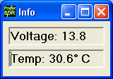Figure 138: Info Form

The keyboard combination Ctrl-Shift-I will display the voltage and temperature. Clicking on the temperature will alternate its value between Celsius and Fahrenheit. Either value may be displayed against a yellow or red background indicating higher levels of criticality.

[The rest of this page has been left blank intentionally]

Operation
This chapter is intended to provide the user with a clear understanding of how the FLEX-5000 should be used when performing basic operations such as Powering Up or making a voice transmission. We chose to use this section in this way in lieu of listing all of the features of the radio since the feature list would essentially repeat the information given in the three preceding chapters. Please refer to those chapters for complete feature descriptions and how to use the controls.
Note 1: For consistency we will use the same control identifiers as used in Figure 31 on page 40. For clarity we will leave out any identifiers of controls not referenced in the relevant section
Note 2: If you have any questions, issues or problems operating PowerSDR and/or the FLEX-5000, you may be able to find the solution on the Support Pages of our website, in our Knowledge Base, or through our highly active Reflector. If none of these sources provide you the assistance required, please contact FlexRadio Systems using the information provided on the Contact page of our website.

[The rest of this page has been left blank intentionally]

Power-Up Procedure
To power up the FLEX-5000
- Connect the FLEX-5000 at the least to the computer and power supply. Check the connections to ensure good contact.
- Boot up the computer and make sure PowerSDR is ready to be launched (no hour glass cursor).
- Turn on the power supply for the radio and press the FLEX-5000 Power switch. After a few seconds you will hear the internal power relay click and see the blue LED illuminate. The FLEX-5000 will be recognized by Windows and its driver will be available for PowerSDR to use.
- After waiting at least 30 seconds, start up PowerSDR. It will automatically recognize the FLEX-5000 driver. You are now ready to operate.

Power-Down Procedure
The power-down sequence is almost the reverse of the power-up procedure.
- Stop PowerSDR by clicking on the Start/Stop button.
- Close PowerSDR by clicking on the “X” in the upper right hand corner of the Front Console.
- Press the FLEX-5000 blue illuminated Power switch to turn off the power supply.
CAUTION: Make sure PowerSDR is shut-down before turning off the radio. Failing to do so may result in instability of your computer system, leading to a Blue Screen.

[The rest of this page has been left blank intentionally]

Tuning Methods

Spectrum Drag and Click
The easiest way to tune signals on the display when set to Panadapter is simply to click on the signal, and drag it into the filter area. You can also drag the displayed filter edges to adjust the filter width as well.

Mouse Wheel
A mouse wheel is the next easiest way to tune the radio. While the PowerSDR window is active, tune VFO A using the mouse wheel, with the mouse cursor anywhere on the screen. The frequency will change in steps equal to the selected Tune Step (2) for each click of the mouse wheel. Adjust the Tune Step using the controls, clicking the mouse wheel or pressing Ctrl + Left or Right Arrow key.
Note: When the Tune Step equals 1kHz, each click of the mouse wheel will first snap tune up or down to the nearest 1kHz and then change in 1kHz steps. E.g. if VFO A is tuned to say 14.000258MHz then with the tuning rate set to 1kHz, using the mouse wheel to tune up will first increase VFO A to 14.001000MHz and then to 14.002000MHz, and so on.

Hint: Holding down the Shift key while turning the mouse wheel will change VFO A at the next lower Tune Rate.

Mouse Wheel Hover
Hover with the mouse over a digit in either VFO A or VFO B and increase or decrease its value using the mouse wheel. The digit to be tuned will be underlined.

Spectrum Click Tuning
With the display set to Spectrum, Panadapter, Waterfall or Histogram, hover with the mouse over the display and right click to cycle through yellow cross-hairs to tune VFO A, red cross-hairs tune VFO B (only if VFO B is active, e.g. when SPLT (12) and/or MultiRX (10) are activated) or no cross-hairs (click tuning off). With the cross-hairs visible, hover over the desired signal in the display and click the left mouse button. The corresponding VFO will immediately tune to the frequency of the selected signal. When in CW, AM, SAM, DSB, FM, or DRM the VFO will tune the cursor frequency to the center of the filter pass band. In SSB the VFO will tune to the carrier frequency for the sideband selected.

[The rest of this page has been left blank intentionally]

Hint 1: You can very quickly center a CW, (S)AM, DSB or FM signal after click tuning it by clicking the 0 Beat (12) button on the Front Console (make sure the display AVG (9) button is on to enable 0 Beat).
Hint 2: If you have checked Snap Click Tune (Setup Form, General tab - Options sub-tab; see page 70) then spectrum click tuning will tune the VFO to the nearest discrete multiple of the Tune Step. E.g. if the Tune Step is set to 1kHz, the VFO will only click tune in steps of 1kHz.

Keyboard Keys
Use the following keys on your keyboard to tune the VFO.
- Numeric Keypad: Key any frequency in MHz (e.g. 7.250) into the numeric keypad and hit enter to immediately jump to that frequency.
- Mapped Keys: You can map keys on your keyboard to tune each of the digits in VFO A using the Keyboard Tab on the Setup Form (page 106).
- Ctrl +Arrow Keys: Hold the Control key and press the
  - Up or Down Arrow key to tune VFO A up or down by the Tune Step (2).
  - Right or Left Arrow key to increase or decrease the Tune Step (2).

USB Tuning Knob
Both the Griffin PowerMate and the Contour Designs Shuttle Pro v2 can be used to tune the radio. You can download the Griffin PowerMate Quick Start Guide and the Contour ShuttlePro v2 Quick Start Guide from the downloads page of our website to learn how to setup and use these controllers. Also available is the Contour ShuttlePro Default Preferences file, which can be imported as a good starting point when using this controller.

[The rest of this page is intentionally left blank]

Voice Transmission Operation
The following procedure outlines how to setup quickly for voice transmission operation (SSB, AM, or FMN). If something in this procedure is unclear, please contact us, as we would like this to be as simple as possible.
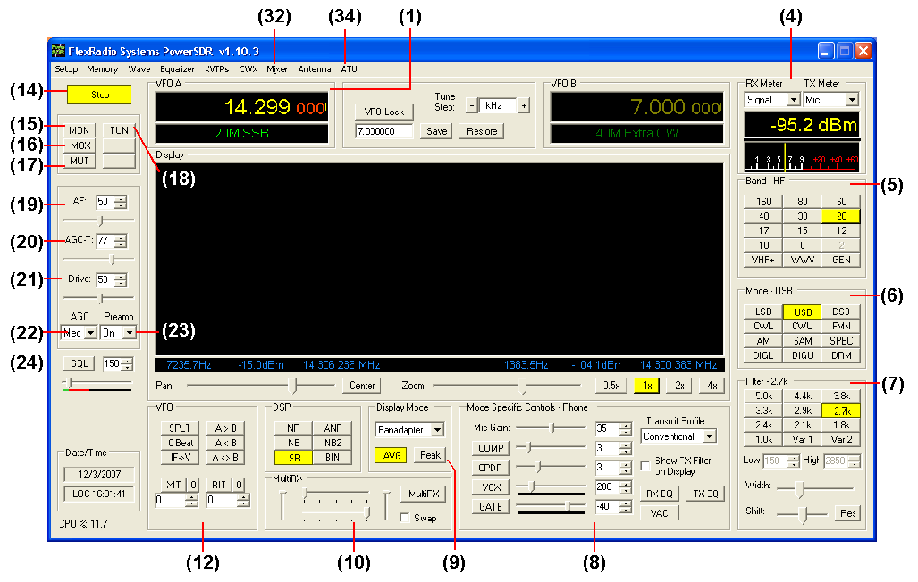
Figure 139 Front Panel Controls Used for Basic Voice Operation.
Please use Figure 139 to identify the controls referenced in the following step-by-step instruction. For consistency we have used the same control identifiers as in Figure 31 on page 40 and for clarity we have left out any identifiers of controls not referenced.

[The rest of this page has been left blank intentionally]
- Follow the Power Up Procedure, described on page 135. Then click the Start/Stop button (14). Set the following controls as specified in Table 10 below.
Table 10: Initial Control Values for Voice Operation
Ctrl | Value | Reference to Figure Above
VFO A | 14.3MHz | (1)
RX Meter | Signal | (4)
TX Meter | MIC | (4)
BAND | 20 | (5)
Mode | USB | (6)
Filter | 2.7kHz | (7)
MIC | 35 | (8)
COMP | Off | (8)
CPDR | Off | (8)
VOX | Off | (8)
GATE | Off | (8)
RX EQ | Off | (8)
TX EQ | Off | (8)
VAC | Off | (8)
Display Mode | Panadapter | (9)
AVG | On | (9)
PEAK | Off | (9)
MultiRX | Off | (10)
SPLT | Off | (12)
XIT | Off | (12)
RIT | Off | (12)
MUT | Off | (17)
AF | 50 | (19)
AGC-T | 70 | (20)
Drive | 50 | (21)
AGC | Med | (22)
Preamp | On | (23)
SQL | Off | (24)

- Connect a 50 ohm dummy load or tune VFO A (1) to a quiet frequency on the selected band. Use the TUN button (20) to verify power output on the TX Meter (4) (Set to Fwd Pwr). If using the optional, integrated ATU, select Automatic on the ATU Form (34) and then click the TUN button (20). See the section on the ATU Form on page 132 for more on how to use the ATU.
CAUTION: If not using the ATU and not using a 50 ohm dummy load, ensure that the antenna presents a 50 ohm load with a low SWR or damage may occur to the FLEX-5000 output transistors.
- Press the Push-to-talk button on the microphone or click the MOX button (16) and speak into the microphone to transmit your voice. Release the Push-to-talk button or click the MOX button (16) to switch the transceiver back to receive.
If you do not see modulation on the spectrum, please check that the correct input for your microphone is selected in the Mixer Form (32) (see page 128) and that your microphone is connected correctly (see pages 4 and 9 for pin-outs of the MIC connector and Balanced Line-In jack respectively). If you are using any external audio processing equipment, make sure it is turned on and hooked up correctly. Finally, if your audio level seems very low, you might try checking Mic Boost On on the Setup form – Audio tab, primary sub-tab (see page 74).
- Now that you can see the modulation on the spectrum, it is time to adjust the input. While transmitting, monitor the values with the TX Meter (4) set to Mic. Modify the MIC (8) setting until the TX Meter shows 0dB on peaks while talking in a normal voice at a normal distance from the microphone (above 0dB the signal will be compressed).
- You are now ready to begin a QSO. If a 50 ohm dummy load was connected, connect an antenna in its place. Tune to the desired frequency using one of the methods outlined in the Tuning Methods section above.
Use the Mode Specific Controls – Phone (8) including Compression, Compansion, VOX and Noise Gate. Generally, use the compressor to increase average power without adjusting the peaks. Check Show Transmit Filter on Display to visualize the band edges of the transmit filter. This filter can be adjusted on the Transmit Tab of the Setup Form.
Hint: For information on how to optimize your audio further, please refer to the Knowledge Base on our website.
- In order to monitor voice transmissions, enable the MON button (15). You may notice a delay due to buffering in the audio/DSP system. This processing delay is largest when using large buffer sizes and low sound card sampling rates. If you find this delay objectionable, try decreasing it by reducing the Buffer Size and increasing the Sample Rate settings on the Audio tab, Primary sub-tab (page 74) and/or DSP tab, Options sub-tab (page 77) of the Setup Form. Make sure that when changing either the Sample Rate or the Audio Buffer Size, you first Stop (14) PowerSDR and make the same changes in the FLEX-5000 Driver (see page 20) before Starting PowerSDR again. See also Appendix A.
- The Fwd Pwr setting on the TX Meter (4) will read out average power in Watts according to the PA ADC. While the average has a short time constant, it is still an average and will not approach 100W in voice modes if calibrated properly even when the Drive control (21) is set to 100. This is also true when monitoring voice transmissions on an external watt meter.

[The rest of this page has been left blank intentionally]
Note: The typical male voice has a peak to average power ratio of 14dB. Therefore a typical male voice transmission that is peaking at 100W will only average less than 10W. To raise the average power, use the COMP control (8) and the associated slider to increase the compression in 1dB steps. This must be done carefully and incrementally as adding too much compression can result in high levels of distortion.

[The rest of this page has been left blank intentionally]

CW Transmission Operation
The following procedure outlines how to setup quickly for CW transmissions using the Internal Keyer and paddles, an external keyer, the CWX-form or a third party program. For the latter, we will use MixW as an example.
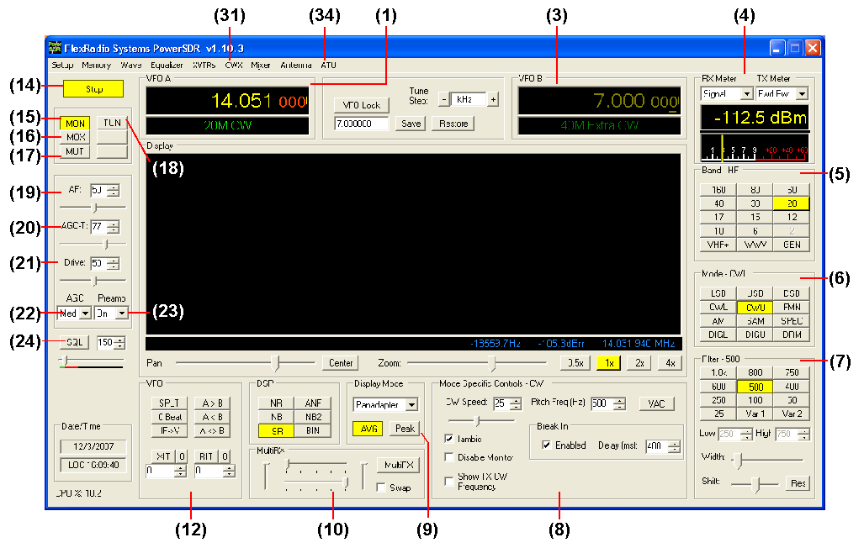
Figure 140: Front Panel Controls Used for CW Operation
Please use Figure 140 to identify the controls referenced in the following step-by-step instruction. For consistency we have used the same control identifiers as in Figure 31 on page 40 and for clarity we have left out any identifiers of controls not referenced.

[The rest of this page has been left blank intentionally]

Initial Settings
- Follow the Power Up Procedure, described on page 135. Then click the Start button (14). Set the following controls as specified in Table 11.
Table 11: Initial Control Values for CW Transmission
Ctrl | Value | Reference to Figure Above
VFO A | 14.05MHz | (1)
RX Meter | Signal | (4)
TX Meter | Fwd Pwr | (4)
Band | 20m | (5)
Mode | CWU | (6)
Filter | 500Hz | (7)
VAC | Off | (8)
Display Mode | Panadapter | (9)
AVG | On | (9)
PEAK | Off | (9)
MultiRX | Off | (10)
SPLT | Off | (12)
XIT | Off | (12)
RIT | Off | (12)
MON | On | (15)
MUT | Off | (17)
AF | 50 | (19)
AGC-T | 70 | (20)
Drive | 25 | (21)
AGC | Med | (22)
Preamp | On | (23)
SQL | Off | (24)

- Connect a 50 ohm dummy load or tune VFO A (1) to a quiet frequency on the selected band. Use the TUN button (18) to verify power output on the TX Meter (set to Fwd Pwr). If using the optional, integrated ATU, select Automatic on the ATU Form (34) and then click the TUN button (20). See the section on the ATU Form on page 132 for more on how to use the ATU.
CAUTION: If not using the ATU and not using a 50 ohm dummy load, ensure the antenna presents a 50 ohm load with a low SWR or damage may occur to the SDR output transistor.

[The rest of this page has been left blank intentionally]
Hint: There is a trade-off to be made of minimum latency versus sharpest (narrowest) filters. Both are driven by the buffer (DSP and Audio) settings and the sample rate setting. For optimal CW performance, you should only use the 48kHz and 96kHz sample rates, where the former is preferred in situations where the narrowest filters are required (contests, weak signal). Next you need to set your audio buffer as low as your computer system will tolerate. The DSP buffer setting should then be set as high as possible (preferably 4096), without introducing disturbing latency. See Appendix A for a more detailed explanation.

Note: CW VFO Frequency Offset
The VFO on the PowerSDR software is designed to show the zero beat of the CW tone relative to the selected CW Pitch. This allows click-tuning of CW signals as well as the traditional CW VFO readout. This also enables the VFO to remain constant when switching from CWL to CWU mode. Every effort is made to preserve a CW signal when switching between any SSB and CW modes.

Internal Keyer
If using PowerSDR’s internal keyer, open the Setup Form – DSP Tab, Keyer Sub-Tab shown Figure 141below. Several of the controls in this form are also available in the Mode Specific Controls – CW (8) section on the Front Console.

[The rest of this page has been left blank intentionally]
Figure 141: Setup Form – DSP Tab, Keyer Sub-Tab
- Connect your paddles or keyer to the Key jack on the back panel (see page 7) and set the Primary Connection to 5000.
- In the Options section, check Iambic for Iambic mode, otherwise leave unchecked (e.g. for a straight key). If the paddles seem reversed, check Rev. Paddle. The Break In option allows the radio to start transmitting simply with detection of keyer input. Set Delay to the amount of time between key up and when the radio will switch back to receive (a value of 70-75ms seems to work best in most cases).
- Select the settings for CW Pitch, Weight and Ramp as desired (refer to the Keyer Sub-Tab section on page 84 for more detail).
- If not using Break In, click MOX (16) on the Front Console and begin transmitting using your paddles. If using Break In (8), simply begin transmitting to key the radio. If using Iambic mode, adjust the speed with CW Speed (8) on the Front Console. If Disable Monitor is unchecked, you should hear the side tone. Verify with the TX Meter (4) set to Fwd Pwr that there is forward power.
- You are now ready to begin a QSO. If a 50 ohm dummy load was connected, connect an antenna in its place. Tune to the desired frequency using one of the methods outlined in the Tuning Methods section above. Select either CWL or CWU (6) and proceed with the QSO.

External Keyer
- Connect your paddles or keyer to the Key jack on the back panel (see page 7) and set the Primary Connection to 5000 (see Figure 141 above)
- In the Options section, leave Iambic unchecked. If your external keyer does not seem to be keying, try checking Rev. Paddle. If using an external keyer with a side tone, check the Disable Monitor check box to avoid hearing the side tone from the internal keyer. The Break In option allows the radio to start transmitting simply with detection of keyer input. Set Delay to the amount of time between key up and when the radio will switch back to receive.
- If using the side tone from the internal keyer, select the settings for CW Pitch. Select the settings for Weight and Ramp as desired (refer to the Keyer Sub-Tab section on page 84 for more detail).
- If not using Break In, click MOX (16) on the Front Console and begin transmitting using your external keyer. If using Break In, simply begin transmitting to key the radio If Disable Monitor is unchecked, you should hear the side tone. Verify with the TX Meter (4) set to Fwd Pwr that there is forward power.
- You are now ready to begin a QSO. If a 50 ohm dummy load was connected, connect an antenna in its place. Tune to the desired frequency using one of the methods outlined in the Tuning Methods section above. Select either CWL or CWU (6) and proceed with the QSO.

CWX Form
If you wish to send CW automatically, click on CWX (31) on the Front Console menu to open the CWX Form shown Figure 142 below. (Refer to the CWX Form section on page 123 for more detail on how to use this form).

[The rest of this page has been left blank intentionally]
Figure 142: CWX Form
- Click on one of the numbered buttons to start transmitting the corresponding CW sequence. Verify with the TX Meter (4) set to Fwd Pwr that there is forward power.
- You are now ready to begin a QSO. If a 50 ohm dummy load was connected, connect an antenna in its place. Tune to the desired frequency using one of the methods outlined in the Tuning Methods section above. Select either CWL or CWU (6) and proceed with the QSO.

[The rest of this page has been left blank intentionally]

Third Party Program
To operate CW with a third party program, you will need to download and install N8VB’s vCOM driver to create a virtual COM port pair through which PowerSDR can be connected to your third party program. The installation and setup of vCOM is described below in the Digital Mode Operation section on page 154.
In the following we will use MixW as an illustrative example and we will assume the COM6-COM16 virtual COM port pair. We will also assume that PowerSDR is connected to COM6 and MixW to COM16 of this pair (see page 154 for details on how to do this).
In PowerSDR open the Setup Form – DSP Tab, Keyer Sub-Tab shown Figure 143 below to access the Internal Keyer controls
Figure 143: Setup Form – DSP Tab, Keyer Sub-Tab
- Set Secondary Connection to CAT to use the same virtual COM port COM16, as selected on the CAT Control Tab. This will open up two additional selection boxes. Set PTT Line to DTR and Key Line to RTS as shown above.
- In MixW, click Configure on the Menu bar and then select TRCVR CAT/PTT to open the screen shown in Figure 144.
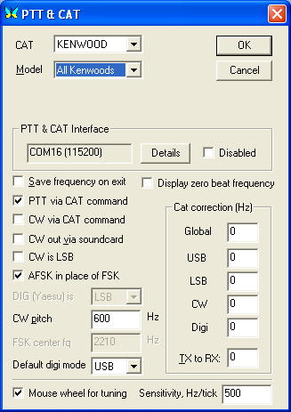
Figure 144: MixW PTT & CAT
- On the PTT & CAT Interface, click on the Details button to open the following form (Figure 145):

[The rest of this page has been left blank intentionally]

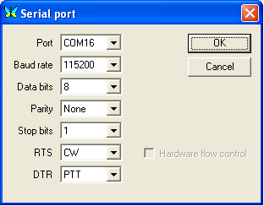
Figure 145: MixW Serial Port Details
- Set the Port to COM16, RTS to CW and DTR to PTT. Click OK on this form and the previous form.
- Change the mode in MixW to CW. Click on the TX button on MixW’s main panel. It should key PowerSDR without generating a tone. Click RX in MixW and PowerSDR should return to receive. If you have entered your callsign in MixW, click on the CQ button. It should key the radio and produce Morse code calling CQ with your call sign. Verify with the TX Meter (4) set to Fwd Pwr that there is forward power.
- You are now ready to begin a QSO. If a 50 ohm dummy load was connected, connect an antenna in its place. Tune to the desired frequency using one of the methods outlined in the Tuning Methods section above. Select either CWL or CWU (6) and proceed with the QSO.

[The rest of this page has been left blank intentionally]

Digital Mode Operation
To operate digital modes, PowerSDR needs to connect to third party digital mode programs with both CAT control and Audio connections. PowerSDR realizes the CAT control connection through N8VB’s virtual COM port utility (VCOM) and the Audio connection through the Virtual Audio Cable (VAC) utility. We will explain later in this section how to install and setup each of these two utilities. First, however, we will outline how to operate digital modes with these utilities installed and setup.
Note: Throughout this section we will refer to digital mode programs, which also include logging programs. For the latter the CAT control section applies to enable reading and possibly also controlling PowerSDR’s frequency, band, and operating mode. If the logging program includes a voice keyer, the VAC section may also be relevant.
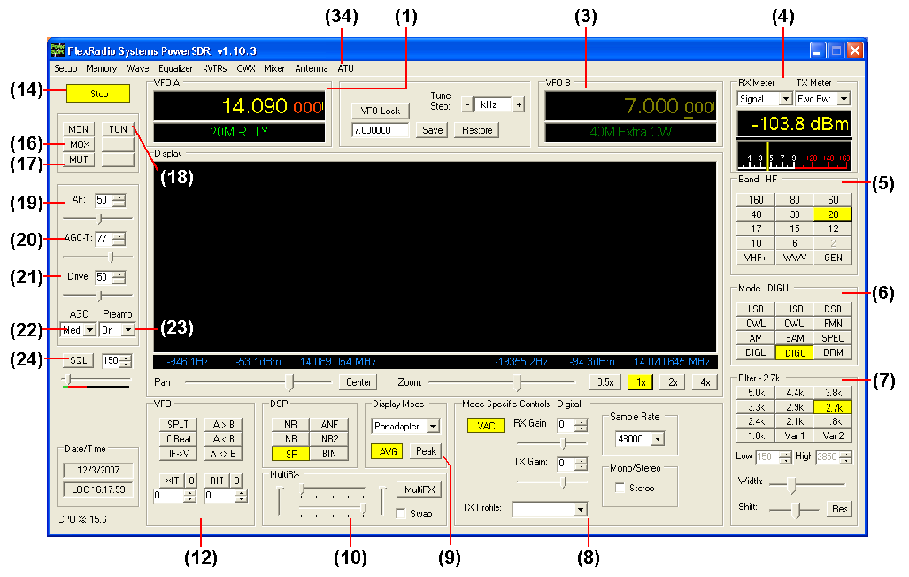
Figure 146: Front Panel Controls Used for Basic Digital Mode Operation
Please use Figure 146 to identify the controls referenced in the following step-by-step instruction. For consistency we have used the same control identifiers as in Figure 31 on page 40 and for clarity we have left out any identifiers of controls not referenced.
- Follow the Power Up Procedure, described on page 135. Then click the Start button (14). Set the following controls as specified in Table 12.
Table 12: Initial Control Values for Digital Mode Operation
Ctrl | Value | Reference to  Figure Above
VFO A | 14.09MHz | (1)
RX Meter | Signal | (4)
TX Meter | MIC | (4)
BAND | 20 | (5)
Mode | DIGU | (6)
Filter | 2.7kHz | (7)
VAC | On | (8)
Display Mode | Panadapter | (9)
AVG | On | (9)
PEAK | Off | (9)
MultiRX | Off | (10)
SPLT | Off | (12)
XIT | Off | (12)
RIT | Off | (12)
MUT | Off | (17)
AF | 50 | (19)
AGC-T | 70 | (20)
Drive | 25 | (21)
AGC | Med | (22)
Preamp | On | (23)
SQL | Off | (24)

- Ensure that on the PowerSDR Setup Form Cat Control is enabled (see page 108). Also check that VAC (8) is enabled (if VAC is auto-enabled on the Setup Form (see page 76) it will automatically be enabled when DIGL, DIGU or DRM (6) modes are selected).
- Start up your digital mode program and ensure its CAT control and sound card selection are configured to connect to PowerSDR. If so, your digital mode program’s frequency should correspond to PowerSDR’s VFO frequency and it should be receiving Audio from PowerSDR. Use the RX Gain (8) control to adjust the audio level going to your digital mode program (instead of the AF (19) ).
- Connect a 50 ohm dummy load or tune VFO A (1) to a quiet frequency on the selected band. Use the TUN button (18) to verify power output on the TX Meter (Set to Fwd Pwr). If using the optional, integrated ATU, select Automatic on the ATU Form (34) and then click the TUN button (20). See the section on the ATU Form on page 132 for more on how to use the ATU.
CAUTION: If not using the ATU and not using a 50 ohm dummy load, ensure that the antenna presents a 50 ohm load with a low SWR or damage may occur to the SDR output transistors.
[The rest of this page has been left blank intentionally]
- Click on the Transmit button of your digital mode program. It should switch PowerSDR to transmit. Transmit a test signal (e.g. several CQ calls) in the mode you plan to operate and use the TX Gain (8) control to adjust the volume of audio coming from your digital mode program. Set the TX Meter (4) to ALC and adjust for 0dB to calibrate transmit. Click on Receive on your digital mode program and PowerSDR should switch back to receive.
- You are now ready to begin a QSO. If a 50 ohm dummy load was connected, connect an antenna in its place. Tune to the desired frequency using one of the methods outlined in the Tuning Methods section above. Select either DIGL or DIGU (6) for lower or upper side band digital mode operation respectively. Select DRM (6) for DRM mode operation.
Note 1: The DIGL, DIGU and DRM (6) mode buttons bypass all signal processing in PowerSDR, except for AGC and Filtering. With DIGL and DIGU you have control over the filter width using the filter buttons (7). DRM mode invokes a fixed 10kHz wide double side band filter.
Note 2: DIGL and DIGU (6) apply an offset when using Spectrum Click Tuning (see page 70). By default, the offsets are set to 1200 Hz (SSTV) in DIGU mode and 2210 Hz (RTTY) in DIGL mode respectively. These offsets can be modified on the Setup Form - General Tab, Options Sub-Tab.

Hint 1: When operating digital modes you have two options with regard to using filters. On the one hand you can use a wide band-pass filter in PowerSDR and use the filters within your digital mode program for selectivity.
On the other hand you can home in on a specific signal with PowerSDR’s filters and ignore the filters in your digital mode program. Although circumstances and operator preference will dictate which to use, many operators have found the second option to be especially valuable to them. However for very narrow and/or steep filters, the latency versus minimum filter bandwidth trade-off holds just as much as with CW. See Appendix A for more detail.
Hint 2: Please check our Knowledge Base for more articles on how to use PowerSDR with various digital mode programs.
If you already have VCOM and VAC up and running, you may ignore the following sub-sections.
We will now focus on installing and setting up N8VB’s VCOM driver and VAC. We will then use MixW as an example on how to use these utilities to operate digital modes.
[The rest of this page has been left blank intentionally]

CAT Control Setup
The CAT control commands of PowerSDR are based on those of the Kenwood TS2000 and have been extended to cover PowerSDR’s many unique features. Additionally, PowerSDR can provide a virtual COM port connection to third party software through VCOM port driver. Special thanks go to N8VB, K5KDN, and KD5TFD for their work on the CAT interface to make all of this work.
The following procedure outlines how to install and setup VCOM.

Install VCOM
First download and install N8VB's Virtual Serial Port Driver (VCOM) from the Downloads page on the FlexRadio website. This program installs one or more pairs of virtual COM ports connected in null modem style. Locate the file you just downloaded (N8VBvCOMSetup-226a.exe) and double-click to start the Windows installer. The following screen will appear (Figure 147).

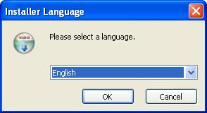
Figure 147: VCOM Installer Language
Select your language of choice and click OK. The welcome screen appears (Figure 148).

[The rest of this page has been left blank intentionally]
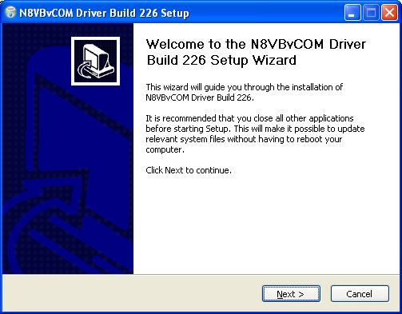.
Figure 148: VCOM Installer Welcome Screen.
Click the Next button to continue the driver installation (Figure 149).

[The rest of this page has been left blank intentionally]
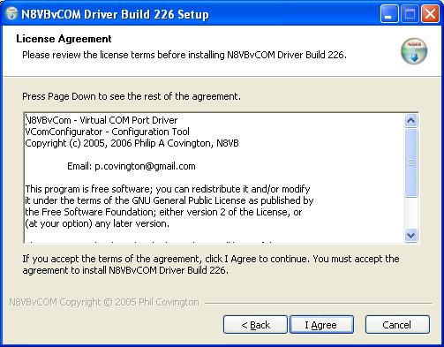
Figure 149: VCOM License Agreement.
Review the License Agreement and click the I Agree button.

[The rest of this page has been left blank intentionally]
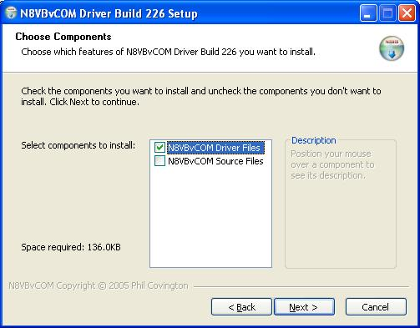
Figure 150: VCOM Installer Component Selection.
Select the components you wish to install and click the Next button.

[The rest of this page has been left blank intentionally]
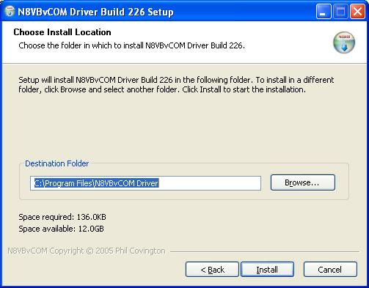
Figure 151: VCOM Install Location
Choose the folder in which to install the driver application in and click the Install button.

[The rest of this page has been left blank intentionally]
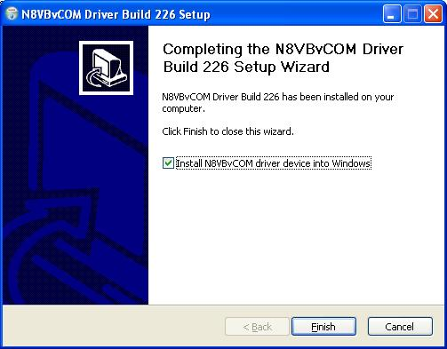
Figure 152: VCOM Installer Complete
Click the Finish button to complete the installation of VCOM. The virtual serial port driver will now be installed on your system. A Command Prompt window displaying status messages will open followed by the warning screen shown in Figure 153 below.

[The rest of this page has been left blank intentionally]

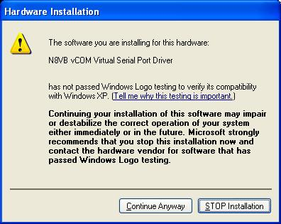
Figure 153: Hardware Installation Warning
Click on the Continue Anyway button to complete the installation.

Configure the VCOM Port Pairs
By default VCOM will install 4 COM port pairs. To view these pairs, to change the default or to remove the driver, locate and start the VCOMConfigurator application (Start→All Programs).

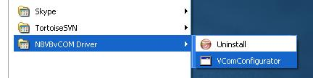
Figure 154: VCOMConfigurator Application
This will open the following screen (Figure 155).

[The rest of this page has been left blank intentionally]
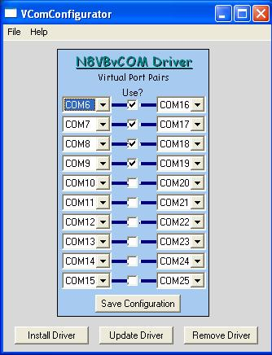
Figure 155: VCOMConfigurator
With VCOMConfigurator, you can select, unselect and modify the desired COM port pairs. Click the Save Configuration button to save your configuration and click Update Driver to update the driver with the new settings. From here you can also remove and install the driver. When you are finished, close VCOMConfigurator .
Now that the virtual COM port pairs are installed, we need to setup the applications to use them. We’ll start with the PowerSDR software. Start up the program and pull up the CAT Control Tab on the Setup Form. For the purpose of this example, we will use the COM6-COM16 pair.

[The rest of this page has been left blank intentionally]

Configure PowerSDR CAT Control
Figure 156: Setup Form Cat Control Tab
Set the controls in the CAT Control Group on the left side of this form to match those shown in Figure 156 to connect PowerSDR to COM 6 of the COM6-COM16 pair. (If you changed the COM port pair settings in VCOMConfigurator you will need to modify the COMx setting to match that change). Set the ID as TS-2000. Once all of the settings are correct, click the Enable CAT check box.
Note 1: Until external applications incorporate the FLEX-5000 with its extended set of CAT controls, it is more prudent to select the TS-2000.
Note 2: Some third party applications do not allow you to connect to a high COM port number. In such a case swap COM6 to COM16 above and connect the digital program to COM6. Alternatively, create an even lower virtual Com port number (e.g. COM3), that is not physically present.

[The rest of this page has been left blank intentionally]

Configure PowerSDR Keyer Connections
We can setup PowerSDR to connect to third party CW programs using the CAT port (i.e. the COM port used for CAT control - COM 6 in the previous figure). To do so, on the PowerSDR Setup Form, select the DSP Tab and then the Keyer Sub-Tab (Figure 157).
Figure 157: Setup Form - DSP Tab, Keyer Sub-Tab
Within the Connections Group, set Primary to the port you have your paddles or straight key connected to (Figure 157 shows 5000 to indicate the FLEX-5000 rear panel key jack). Set Secondary (used for keyers and programs) to CAT to use the same (virtual) COM port used for CAT Control. Set PTT Line to DTR and Key Line to RTS. Note that CAT Control must be enabled (see the previous section) before this will work. Click OK.

[The rest of this page has been left blank intentionally]

Virtual Sound Connection
Although you can use a second sound card to connect to an external digital mode program, PowerSDR has the ability to use a virtual sound connection. To do so you will first need to download and install the third party Virtual Audio Cable (VAC) application from one of many sources. VAC is neither free nor open source.
Note: PowerSDR will work correctly with VAC version 3.12 as well as version 4.02 and above. In the following we will use version 4 to illustrate, but version 3 works essentially the same way.
In essence VAC enables the creation of so called digital virtual audio cables between two software applications, in our case PowerSDR and a digital mode (or sound card program) as shown in Figure 158. When setup correctly, these cables appear as input and output audio devices, as if they belonged to a sound card.
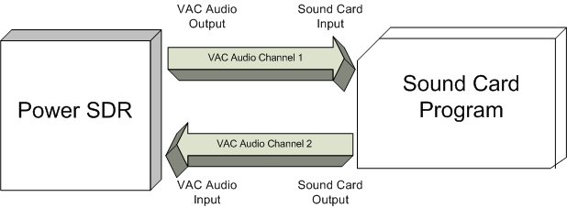Figure 158: VAC Connects Audio Digitally Between PowerSDR and a Digital Mode Program

Create the Virtual Audio Cables
The first step is to create the two identical virtual cables. To do so open the Virtual Audio Control Panel.

[The rest of this page has been left blank intentionally]
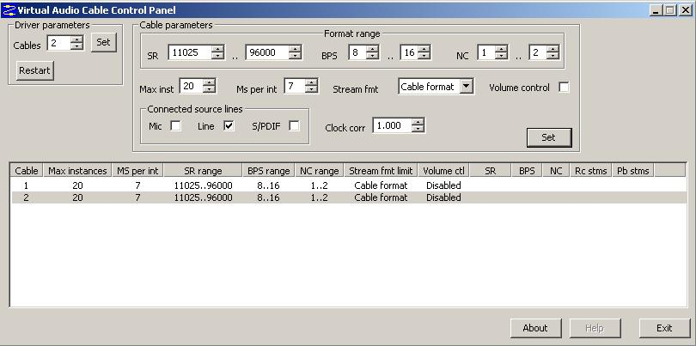
Figure 159: VAC Control Panel
By default two audio cables will be defined. Highlight the appropriate cable and change the values to match Figure 159. In the Ms per int box enter a value between 1 and 20 ms. The lower the value, the smaller the VAC audio buffer. In the example above, 7 ms was selected. Depending on your computer setup you may have to adjust this value to prevent the audio from dropping out or "popping".
You can choose two different Stream limit formats; cable format and cable range. Since PowerSDR defines both audio cables' format when VAC support is enabled, using the Cable format is recommended. If you decide to use the Cable range stream format, a required format conversion will use significant CPU resources and may noticeably slow your applications causing audio drops-outs. Using Cable format as the stream format may then help.
Repeat these changes for the second audio cable. After completing all of the necessary changes, click on Set for each cable when completed. Do not close the Control Panel just yet.
Note: Do NOT check the Volume Control box in the VAC control panel. This enables the Windows Mixer and can cause unpredictable results.

[The rest of this page has been left blank intentionally]

Setup VAC in PowerSDR
Next we need to connect PowerSDR to one side of each of these cables. Startup PowerSDR, but do not click on the Start button. Open the Setup Form, click on the Audio Tab and then click on the VAC Sub-Tab (Figure 160).
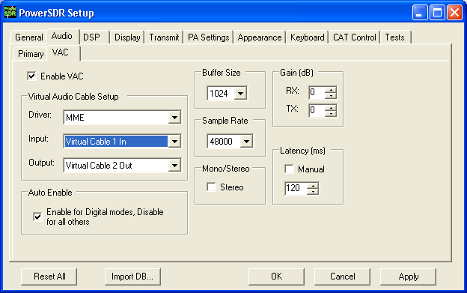
Figure 160: Setup Form - Audio Tab, VAC Sub-Tab
Configure the settings as shown above. If your selected Buffer Size setting is too small, you may experience audio popping or dropping out. Click Enable VAC to manually enable the virtual audio connection or click Auto Enable to automatically enable it when clicking the DigL, DigU or DRM mode button on the Front Console.
Note 1: Select a higher Sample Rate than the sample rate of the digital mode program for best audio quality. In some cases, however, the digital mode program can not handle format down conversion very well. In such cases, set the Sample Rate to exactly match that of the digital mode program.
Note 2: Certain DRM programs (DReaM, HamPal) require Stereo to be selected.

Setting up Third Party Digital Programs
Each third party program has its own method of configuring CAT Control and selecting the COM port and the sound card. In the following, we will use MixW as an illustrative example. We will also discuss how to deal with digital programs that are only able to connect to the default sound device.
Note: Instructions for MMTTY, MMSSTV and WSJT 6 and others can be found in the in our Knowledge Base.

Using MixW with PowerSDR
Start MixW, which may be downloaded from http://www.mixw.net/.
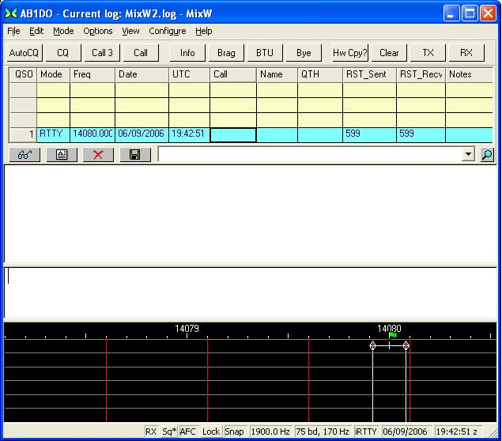
Figure 161: MixW Console
First we will configure MixW to connect through the virtual COM port pair to PowerSDR. Click Configure on the Menu bar and then select TRCVR CAT/PTT to open the following screen (Figure 162).
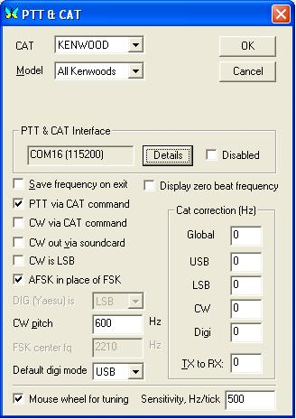
Figure 162: MixW PTT & CAT
Configure the controls as shown above. MixW does not recognize the extended FLEX-5000 CAT controls yet. Therefore we set it up as if PowerSDR were a Kenwood radio (In MixW All Kenwoods is the only option available when CAT is set to Kenwood).
On the PTT & CAT Interface, click on the Details button to open the following form (Figure 163):

[The rest of this page has been left blank intentionally]
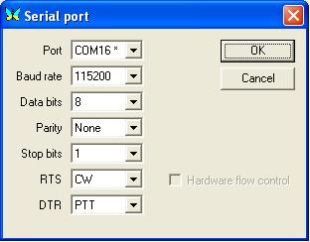
Figure 163: MixW Serial Port Settings
Recall that we are using the COM6-COM16 virtual COM port pair and that we setup PowerSDR to connect to the COM6 end of this pair (see the CAT Control Setup section above). We therefore now select COM16 as the Port in the form above. Set the Baud rate to 115200 (it makes no difference what you set this to).
For RTS and DTR we need to match the settings on the PowerSDR Setup Form, Keyer Sub-Tab. Therefore set RTS to CW and DTR to PTT as shown above. Click OK on this form and then on the PTT & CAT form respectively to accept the settings and close the forms.
On the MixW front console, click again on Configure on the menu bar and this time select Sound device settings… to open the following form (Figure 164):

[The rest of this page has been left blank intentionally]
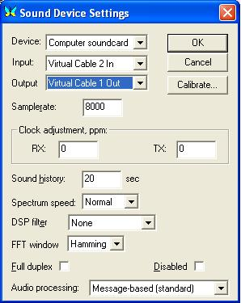
Figure 164: MixW Sound Device Settings
Recall that we previously created two virtual audio cables and then configured the PowerSDR VAC Input as Virtual Cable 1 In and Output as Virtual Cable 2 Out.
We now need to connect MixW to the other ends of those two virtual audio cables respectively. Therefore, set Device to Computer sound card, Input to Virtual Cable 2 In and Output to Virtual Cable 1 Out as shown in Figure 164 above. If you change the Sample rate setting, MixW will tell you to exit and restart MixW.
Exit MixW for now so we can illustrate the functioning of the virtual audio cables.
Click the Start button to turn PowerSDR on and make sure MixW is running. When you now view the VAC Control Panel it will look like Figure 165 below:

[The rest of this page has been left blank intentionally]
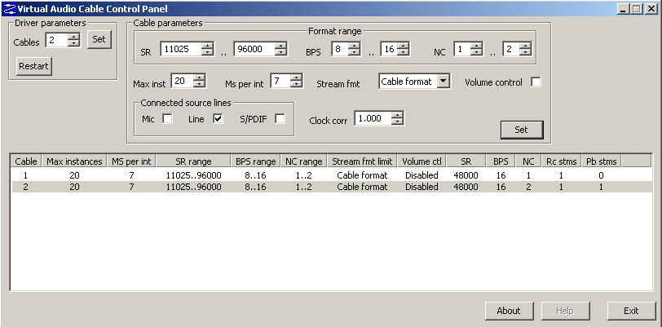
Figure 165: VAC Control Panel: PowerSDR Running and MixW Receiving

Notice that the value in the Rc Stream for Cable 2 has changed for a 0 to a 1. This indicates that cable 2, which is the input for MixW is actively receiving audio from PowerSDR. The Pb Stream value for VAC Audio Cable 1 is still 0. This will not change to a 1 until you start transmitting and MixW is sending audio through that cable.
Change the mode in MixW to CW. Click on the TX button on MixW’s main panel. It should key PowerSDR without generating a tone. Click RX in MixW and PowerSDR should return to receive. If you have entered your callsign in MixW, click on the CQ button. It should key the radio and produce Morse code calling CQ with your call sign. Close the VAC Control Panel; you will no longer need this, unless you intend to create more audio cables.

Programs Needing to Connect to the Default Sound Device
Certain digital programs can only select the default sound card (or at best choose a single card by index). For example, MMTTY and MMSSTV choose by index. To enable PowerSDR to work with these programs you will need to change the system default sound card. VAC offers the ability to continue to use your other audio applications through its Audio Repeater utility, which we will now discuss.
To change the default sound card, in Windows click Start and then Control Panel. In Control Panel, double-click on Sounds and Audio Devices to open the Sounds and Audio Devices Properties Form (Figure 166):

[The rest of this page has been left blank intentionally]
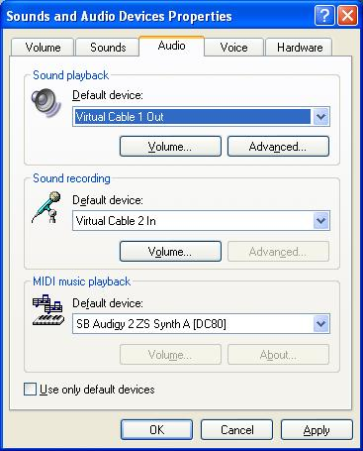
Figure 166: Sounds and Audio Devices Properties Form
Set up the Default device for Sound playback and Sound recording as shown above. (Midi playback is of no concern). Click Apply and then OK. If you now setup your digital program to select the default sound card, it will work with PowerSDR.
To enable you to continue using other sound programs (MP3 players, etc) despite changing your default sound card settings, VAC comes with a utility called Audio Repeater. Locate Audio Repeater in the VAC program folder and double-click to start it. You should see the following screen (Figure 167):

[The rest of this page has been left blank intentionally]
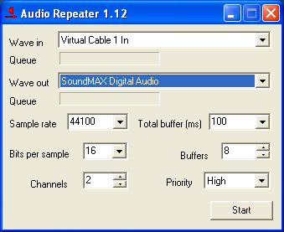
Figure 167: Audio Repeater Utility
To play back audio, set Wave in to Virtual Cable 1 In and Wave Out to the sound card you wish to use. You should keep the Total buffer (ms) as small as practicable to prevent long latency between the sound arriving at the virtual audio cable and it being played to the sound card.

[The rest of this page has been left blank intentionally]

Specifications and Architecture
Specifications are subject to change without notice or obligation, and are guaranteed only within the amateur radio bands.

FLEX-5000A Specifications
Table 13 on page 175 displays an overview of the specifications for the FLEX-5000A.

[The rest of this page has been left blank intentionally]
Table 13: Overview of FLEX-5000A Specifications
General
Receiver Frequency Range | 10 kHz – 65 MHz (operating); 160m – 6m (specified Amateur bands only)
Transmitter Frequency Range | 160m – 6m (specified Amateur bands only)
Frequency Stability | ±0.5 ppm 32 °F to 122 °F (0 °C to +50 °C)
Operating Temperature Range | 14 °F to 122 °F (–10 °C to +50 °C)
Emission Modes | A1A (CW), A3E (AM), J3E (LSB, USB), F3E (FM),  F1B (RTTY), F1D (PACKET), F2D (PACKET)
Frequency Steps | 1 Hz minimum
Antenna Impedance | 50 Ohms, unbalanced  6 - 1000 Ohms, unbalanced (With Optional Tuner ON, 160m - 10m Amateur bands)  16 - 150 Ohms, unbalanced (With Optional Tuner ON, 6m Amateur band)
Max Rating TX1-3 Key Lines | 50V, 400mA
Audio In/Out | Unbalanced:10dBV nominal (consumer level), Input Impedance: 5k Ohms Output Impedance 600 Ohms  Balanced: +4dBμ, Input Impedance >50k Ohm
Recommended Headphones | 40mW, 16 Ohms, 1% THD+N;higher impedance headphones will also work
Frequency Reference Input | 0 to +10dBm required
Power Consumption | Rx 1.5A (typ); Tx (100 W) 25A (max.)
Supply Voltage | DC 13.8 V ± 10%
Maximum Interconnect  Cable Length | 10 feet (3m),  No restriction on DC cable within voltage tolerance limits under load.
Special EMI/RFI Requirements | 1 snap on ferrite bead on DC cable,  2 snap on ferrite beads on FireWire cable, and  1 snap on ferrite bead on FlexWire cable.  All beads to be located adjacent to rear panel of radio.
Dimensions | (WxHxD): 9.3” x 8.7” x 13.8” (23.5 x 22.1 x 31.5 cm)
Weight (approx.): | 13 lbs (5.9 kg)
Receiver
Circuit Type | Direct conversion, low IF
Intermediate Frequency | Software selectable from DC to 20 kHz
MDS | 14 MHz Preamp off/on: 1.3/0.3 µV;  MDS: -123 dBm/-133 dBm in 500 Hz BW
IP3 | +30 dBm at 14 MHz with preamp off at 2 kHz or less tone spacing  (S5 IM3 method)
Selectivity (–6/–60 dB) | CW: 500 Hz –6/-60 dB: 5.00/6.40  SSB: 2.4 kHz –6/-60 dB: 2.39/2.54  AM: 6.6 kHz –6/-60 dB: 6.60/6.74
Image Rejection | 70 dB or better (160 - 6m Amateur bands)
Transmitter
Power Output | 100 watts PEP CW and SSB (25 watts AM carrier)
Power Out XVTR | up to +5dBm adjustable
Emission Modes | A1A (CWU, CWL), J3E (USB, LSB), A3E (AM), F3E (FM), DIGITAL
Harmonic Radiation | Better than –55 dB (160 - 10m Amateur bands)  Better than –65 dB (6m Amateur band)
SSB Carrier Suppression | At least 55 dB below peak output
Undesired Sideband Suppression | At least 55 dB below peak output
Audio Response | (SSB): Flat Response 10 Hz to 20 kHz, Software EQ optional
3rd Order IMD | Better than 33 dB below PEP @14.2 MHz 100 watts PEP
Microphone Impedance | 600 Ohms (200 to 10 kOhms)
Balanced Line In Impedance | 600 Ohms (200 to 10 kOhms)

FLEX-5000 Architecture
The FLEX-5000 full duplex/triplex architecture is shown in Figure 168 below.
Figure 168: FLEX-5000 Full Duplex/Triplex Architecture 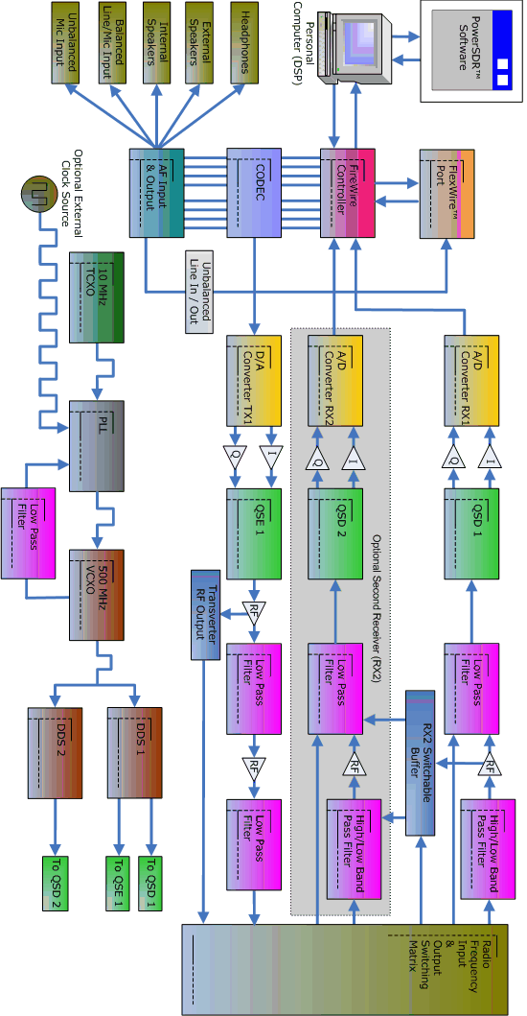

Declarations of Conformity

FCC
The FLEX-5000A complies with FCC Part 97 rules for the Amateur Radio Service.

EU Compliance

 European Union Declaration of Conformity

FLEX-5000A Amateur Radio Transceiver Series

Council Directive --- 89/336/33c; EMC Directive
Standards: EN 301 489-1
EN 301 489-15
EN 301 783-1 Essential Radio Test Suite

TYPE OF EQUIPMENT: Amateur Radio Base Station
EQUIPMENT CLASS: B

WE, THE UNDERSIGNED HEREBY DECLARE THAT THE EQUIPMENT SPECIFIED ABOVE CONFORMS TO THE ABOVE STANDARDS PER 89/336/EEC.

FlexRadio Systems Date of testing: August 23, 2007

FlexRadio Systems
8900 Marybank Drive
Austin, TX 78750

[The rest of this page has been left blank intentionally]

Buffers and Sample Rate
Rather than a theoretical discourse on the consequences of Buffer Size and Sample Rate settings, this appendix will attempt to illustrate how these settings effect both the minimum possible filter bandwidth, filter slope or steepness and latency for each of the settings available in PowerSDR. We will start with the filter effects and then move on to latency. Finally a little underlying theory is offered to help gain some more insight without the need to delve into a DSP tomb.

Filter Effects
The minimum filter width possible at a given DSP Buffer Size N and a Sample Rate f_{s} equals 1.5*f_{s}/N, where the factor 1.5 is due to the additional roll-off due to the Blackman-Harris window function. Therefore, for the steepest and narrowest filters we want a low Sample Rate and a high DSP Buffer Size. Exactly how this effects the filter shapes is shown on the following two pages in Figure 169 through 171 for a 2.7kHz LSB filter and in Figure 172 through 174 for a 25Hz CW filter.
It is clear that as the Sample Rate increases, the minimum possible filter width increases. The same is true for decreasing Buffer Sizes. Furthermore, we can draw the following conclusions for phone (ignoring latency issues for the moment):
- A Buffer Size of 512 should be avoided, except for casual QSOs and then only at Sample Rates of 48kHz and 96kHz
- In contest situations, where steep filters are required, Sample Rates of 48kHz and 96kHz can be used, but only with Buffer Sizes of 2048 and 4096.
For CW and digital modes requiring narrow, steep filters:
- Buffer Sizes of 512 and 1024 should be avoided.
- In contest situations, where the steepest filters are required only the Sample Rate of 48kHz should be used.

[The rest of this page has been left blank intentionally]
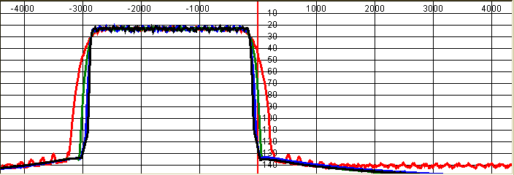Figure 169: 2.7kHz LSB Filter at 48kHz Sampling Rate
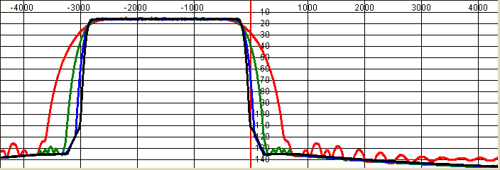Figure 170: 2.7kHz LSB Filter at 96kHz Sample Rate

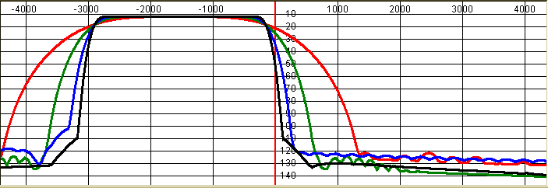Figure 171: 2.7kHz LSB Filter at 192kHz Sample Rate

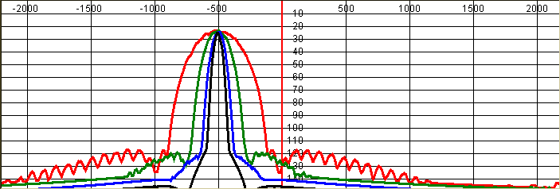Figure 172: 25Hz CWL Filter at 48kHz Sample Rate

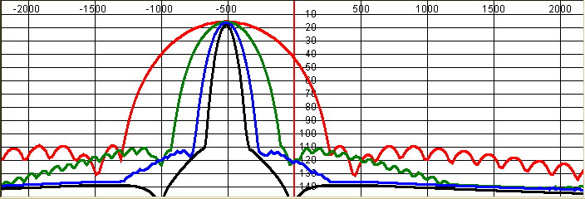Figure 173: 25Hz CWL filter at 96kHz Sample Rate

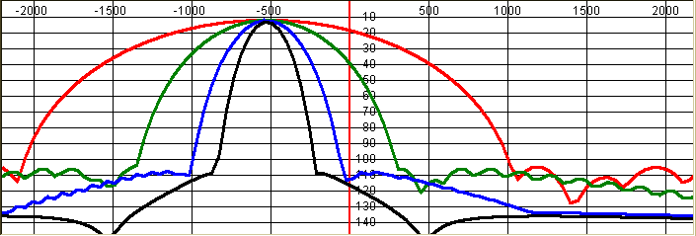Figure 174: 25Hz CWL Filter at 192kHz Sample Rate

Latency Effects
The latency in the system will be at least equal to the minimum of the Audio and DSP Buffer Sizes divided by the Sample Rate. Because both the DSP Buffer and the Sample Rate also determine the minimum filter width, setting the Audio Buffer as small as your computer system will tolerate is preferable. That way, latency will not be unnecessarily long. If latency is an issue with your computer system, you may have to resort to a smaller Buffer Size and/or a higher Sample Rate than you would otherwise prefer based on filter shapes.

Underlying Theory
To transform signals from the time domain to the frequency domain we start with the Discrete Fourier Transform (DFT), which is the Fourier Transform for time sampled signals (The FFT or Fast Fourier Transform is an efficient algorithm to calculate the DFT). It is important to realize that the result of the DFT is a continuous function of the frequency, from –infinity to +infinity. The annoying thing about this transform, however, is that it needs to “know” the temporal signal over a time domain of ±infinity. Needless to say, this is not practical.
We can limit the time domain T to a limited number of samples (equal to the “slice” of time represented by the DSP Buffer) if we assume the temporal signal to repeat continuously, with a period T. The result is, however, no longer a continuous function of the frequency, but a discrete function, that is, the power spectrum is only calculated at frequency intervals equal to 1/T. These discrete frequencies are called bins. These bins can be envisioned as a series of 1/T Hz wide parallel filters, spaced every 1/T Hz. Each bin “fills” with the average power at its center frequency and averaged over 1/T Hz. The frequency resolution is therefore limited to 1/T Hz.
- Because we assume the time domain signal at hand to repeat with period T, any discontinuity between the last sample in a buffer and the first sample in the next buffer will violate this condition. To understand this, it helps to know that the result of an FFT is complex, including magnitude and phase information (this is even true if the temporal signal is real). In other words, rather than on a straight line, the FFT writes the data on a circle in the complex plane, where one revolution represents N/T Hz (N being the number of samples in the DSP Buffer). When the last sample in the DSP Buffer meets the first sample in the next DSP Buffer, chances are they will not meet in a continuous fashion. Any discontinuity will lead to a wide associated spectrum across multiple bins, a phenomenon known as “bleed-through”.
- Another way of looking at this is that a signal with period T (and any harmonic thereof), can be represented as a combination of its fundamental frequency 1/T Hz and higher order harmonics, all spaced at multiples of its fundamental frequency. These spectral components are therefore at the center of each FFT bin. If on the other hand, the temporal signal does not have a periodicity equal to (an integer multiple of )the fundamental frequency, it's spectral components will not be centered on each bin and bleed through will occur from one bin to the next, resulting in a loss of frequency resolution.
- To avoid this happening, the samples in the DSP Buffer are first multiplied by a window function (see page 81 and Appendix D), such that the spectral smearing is limited, but it is not completely eliminated. Each window function has advantages and disadvantages depending on the situation at hand. For our purposes, the Blackman-Harris window offers the best trade-off between loss of frequency resolution and stop-band characteristics.
The time slice T that the DSP buffer represents, often called the FFT size, is a function of the number of samples it can hold (the buffer size) and the Sample Rate, e.g. if the Buffer size equals 1024 and the sample rate 96kHz, the DSP Buffer represents a time slice of 1024/96kHz = 10.67ms.
- With a Buffer of Size T, the minimum resolution in the time domain is now T seconds. If a signal suddenly appears, we will need to wait until the Buffer is filled, at which time it can be processed by the FFT. To increase temporal resolution, we must keep T small by using a small Buffer Size and a high Sample Rate. Temporal resolution is also called latency: a high temporal resolution equals a low latency.
- However, we have already seen that the frequency resolution equals 1/T Hz (ignoring effects due to windowing). Therefore to increase frequency resolution, we need to increase T as much as possible by using a large Buffer Size and a low Sample Rate. It is this frequency resolution that determines the possible steepness and narrowness of our filters. A higher resolution enables steeper and narrower filters.
- Therefore we cannot have both a high temporal and a high frequency resolution. We must make a trade-off by setting the temporal resolution (latency) to an acceptable level and accepting the resulting frequency resolution (filter width).

[The rest of this page has been left blank intentionally]

Updating the Flex-5000 Firmware

Download and Extract the Firmware
The most current version of the FLEX-5000 firmware can be downloaded as a zip-file from the Downloads page on our website, at http://support.flex-radio.com/Downloads.aspx?id=171.
Note: If you need to revert to an earlier version of the firmware, go to http://support.flex-radio.com/Downloads.aspx?fr=1 and select the version you are seeking from the list. If you don't see the firmware file you are looking for, try performing a search using “firmware” as the Keyword, “FLEX-5000” as the Related Product and “Software: FlexRadio” as the File Category.
Save the zip-file to a location on your computer, extract it and then open it. Inside you will find four files. Open the text file labeled FLEX-5000_Firmware_ReadMe.txt to verify you have the correct firmware version. This file also contains instructions on how to update the firmware. Close the file when you have finished reading it.

Update the Firmware
To update the firmware, power-up the FLEX-5000, make sure it is communicating with your computer. You can verify this by successfully opening the FLEX-5000 Driver Control Panel. Close this Control Panel if you opened it.
Next, locate the batch file labeled Burn.bat in the firmware folder (the same folder containing the ReadMe file) and double-click on it to open the window shown in Figure 175 below.

[The rest of this page has been left blank intentionally]
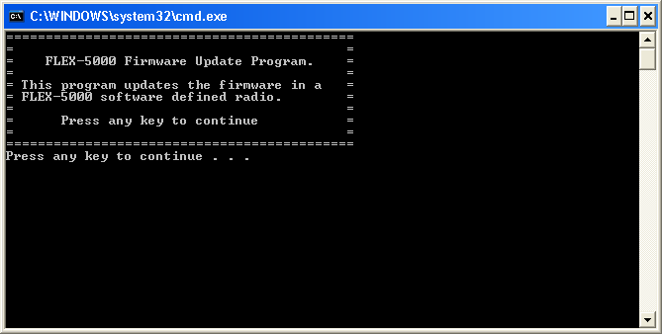Figure 175: Burn.bat Initial Screen
Press any key to continue and you will subsequently receive the message Uploading Binary, followed by Deleting Flash Image and then Programming Flash Image, each preceded by a progress counter. When the upgrade is completed successfully you will hear the relays click and see the screen shown in Figure 176 below.
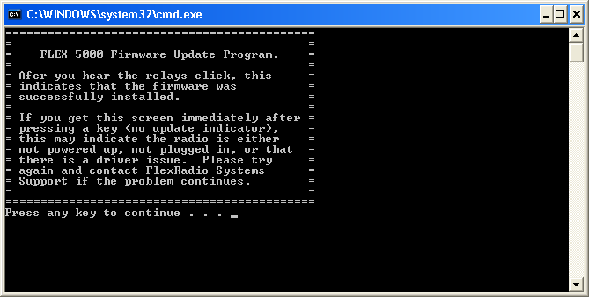Figure 176: Burn.bat Final Screen
Note: If you do not hear the relays click, switch off the FLEX-5000 and then switch it on again. Start up PowerSDR and if you do not get a firmware version error message (see Figure 24 on page 33) all is well. If you do get the error message, try updating the firmware again following the procedure described above.

[The rest of this page has been left blank intentionally]

Optimizing the AGC
To gain an understanding of how to set the AGC-T or Max Gain control it is helpful to think in terms of signal levels instead of gains. Figure 177 shows the input and output signal levels (pre and post AGC) at various settings of the Max Gain control with the Slope set to zero.
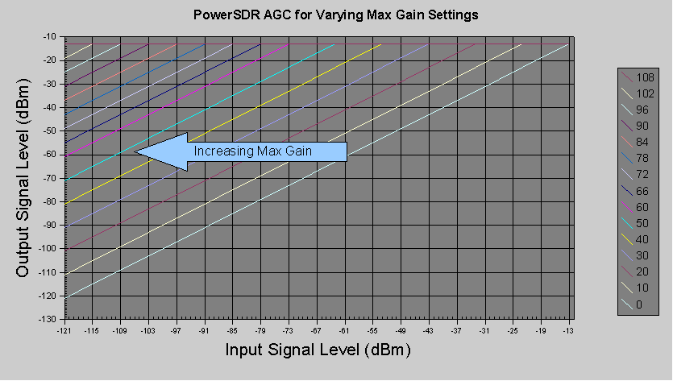Figure 177: Input and Output Signal Levels at Various Max Gain Settings
For example (assuming the preamp is off) the violet line (with a Max Gain setting of 60dB) shows that as the level of the input signal into the AGC increases from -121dBm (S1) to -73dBm (S9) the level of the output signal out of the AGC increases from -61dBm (-121dBm + 60dB) to -13dBm. For input signal levels higher than -73dBm, the output level remains constant at -13dBm because we have set the Slope to zero. The input signal level at which the output just reaches the maximum of -13dBm is known as the AGC Threshold (this is different from the Hang Threshold).
If the Max Gain setting is increased, say from 60dB to 78dB (the blue line), the output signal level reaches its maximum at a lower signal level. For a Max Gain of 78dB, the AGC Threshold is at -91 dBm (S6). If the preamp is turned on then that raises the input signal level into the AGC by 14dB. To keep the Threshold at -91dBm, we therefore need to reduce the Max Gain by the same 14dB to 64dB.
To obtain the most optimal Max Gain setting it is important to know where the Threshold is in relation to the desired input signal.
- If the Threshold is placed far to the right of the desired signal's input level (Max Gain is too low) then you may not be able to copy a weak signal. Also a suddenly appearing strong signal may blow your ears off.
- If the Threshold is placed far to the left of the desired signal's input level (Max Gain is too high) then the desired signal will sound as loud as the noise, because you have amplified everything up to the -13dBm level. In other words, you have destroyed your signal to noise ratio.
- If the Threshold is placed at or just above the desired signal's input level you will have amplified it to the maximum attainable without destroying the signal to noise level. A (suddenly appearing) much stronger signal will be kept at about the same output level as that of the desired signal and your ears will be thankful. If the desired signal is a very strong signal, the benefit will be that its output level can be reduced, thus also reducing the noise level.

[The rest of this page has been left blank intentionally]

Window Functions
In the following we will consider some of their characteristics, where we assume N to equal the number of samples in the DSP Buffer and n to be an integer with 0≤n≤N-1.
- Rectangular: This means the data has no window applied. No shaping is applied to the incoming signal. As a result, you will have the greatest sensitivity in the power spectrum and the greatest bleed through or interference with adjacent bins.
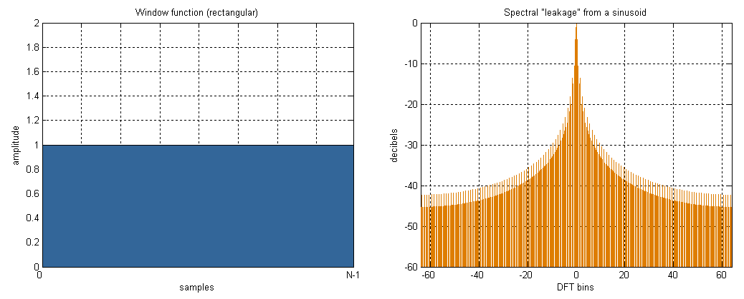Figure 178: Rectangular Window Function and Frequency Response to a Sinusoid

[The rest of this page has been left blank intentionally]

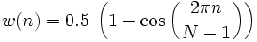
- Hanning, Hamming: These windows are based on a raised cosine shape. In addition to providing continuity (Hanning) or near continuity (Hamming), both provide a shape that makes the slopes of the signal agree at the beginning and the end of the signal buffer. This filter provides for both good sensitivity and less bleed-through in the FFT. In situations of low dynamic range requiring a higher spectral resolution, such as (weak signal) CW using the narrowest filters.
  - Hanning (also known as Hann):

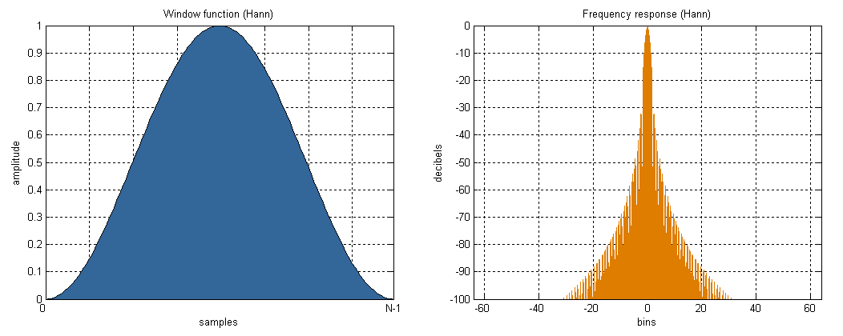Figure 179: Hanning Window Function and Frequency Response to a Sinusoid

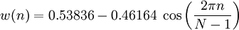
  - Hamming:

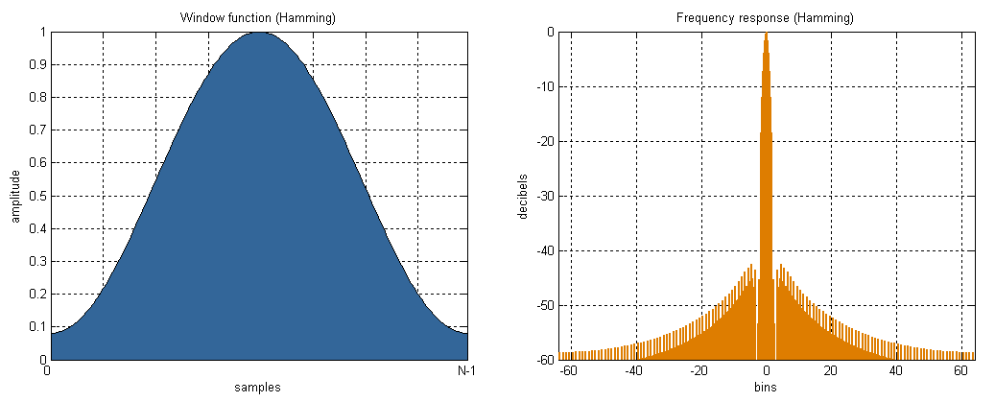Figure 180: Hamming Window Function and Spectral Response to a Sinusoid

- Blackman, Blackman-Harris and Blackman Nutall: We use Blackman-Harris to design all filters in the signal processing chain for all modes. This provides for minimal bleed through as we have described and the best shape factor for our needs in the overlap-save filtering routines. While it has some good features, these features are probably not ideal for the CW power spectrum displays. There is a penalty to pay for the smoothing near the ends afforded by the windows. If you have experience in the use of FFTs and the display of the power spectra that result, you know that a smaller FFT (smaller DSP Buffer) at a fixed sample rate causes a wider range of frequencies to be contained in one bin of the power spectral results. This means that a tone will look more like a large lobe or finger than a tone spike. The same phenomenon is present in the best windows. While the spreading of the “main lobe” of a tone is not as bad as taking an FFT of half the size, it is wider than one bin (see also Appendix A). The formulas for all of the Blackman filters are of this form:
The individual parameters by type:
- Blackman: a₀ = 0.42, a₁ = −0.5, a₂ = 0.08, a₃ = 0
- Blackman Harris: a₀ = 0.35875, a₁ = 0.48829, a₂ = 0.14128, a₃ = 0.01168
- Blackman Nuttall: a₀ = 0.3635819, a₁ = 0.4891775, a₂ = 0.1365995, a₃ = 0.0106411
- Their graphical representations are shown in Figure 178 through 179 respectively:

[The rest of this page has been left blank intentionally]
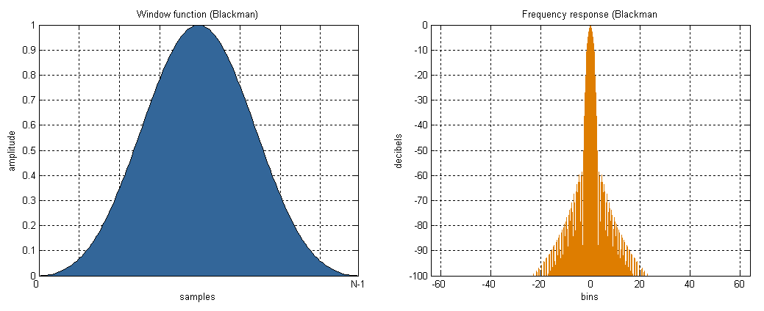Figure 181: Blackman Window Function and Frequency Response to a Sinusoid
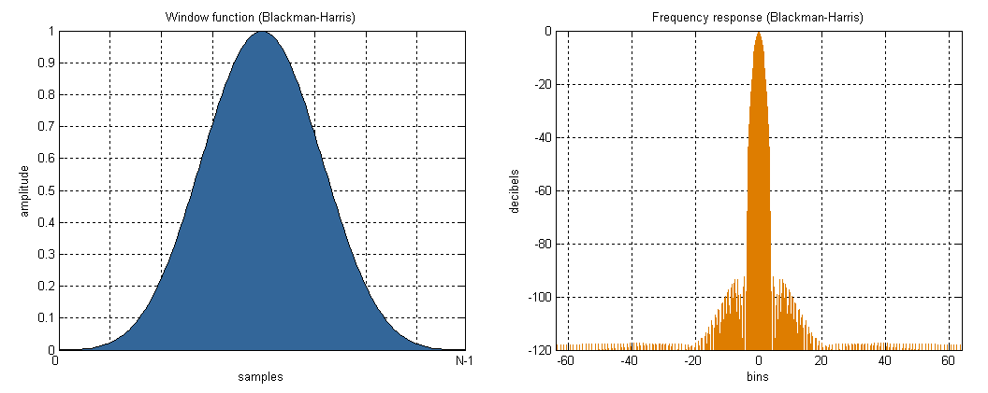Figure 182: Blackman-Harris Window Function and Frequency Response to a Sinusoid
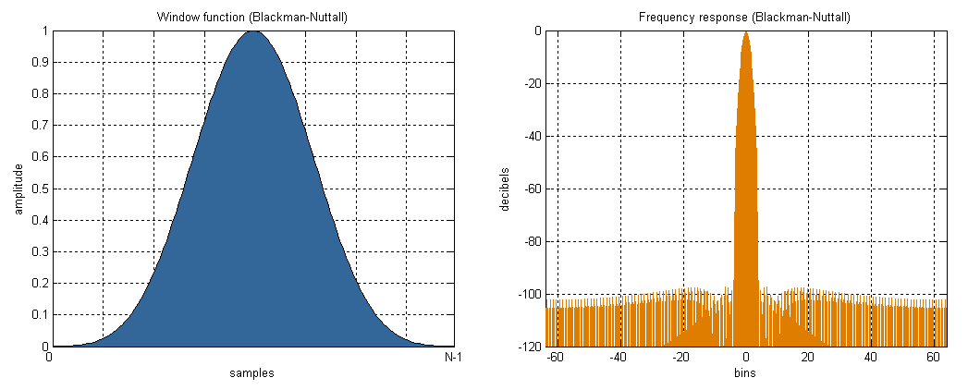Figure 183: Blackman-Nuttall Window Function and Frequency Response to a Sinusoid
- Parzen, Bartlett, Exponential, and Riemann: These windows are much less widely used and are included for completeness. They sometimes perform better for a particular application and some experimentation on the users part should be undertaken to find the window that gives the most pleasing display to you.
For further reading on windowing, including many more examples of window functions, please see the following link.

[The rest of this page has been left blank intentionally]

FlexRadio Systems and the FlexRadio Systems Logo are registered trademarks of Bronze Bear Communications, Inc. DBA FlexRadio Systems; FLEX-5000, PowerSDR, MultiRX and SDR-1000 are trademarks of Bronze Bear Communications, Inc.
FireWire is a registered trademark of Apple, Inc.
You may need to acquire a 4-pin to 6-pin cable for laptops
The pin-out is similar to that normally found on Yaesu radios
Second receiver is standard with the FLEX-5000D
FireWire is a registered trademark of Apple, Inc.
The FLEX-5000C and FLEX-5000D also have a built-in speaker
All screenshots in this manual are as they would appear when using the Microsoft Windows XP operating system. The screenshots may look slightly different when using Microsoft Vista, but the steps are the same.
This warning is displayed because the hardware driver has not passed the formal Windows Logo Testing program. The FLEX-5000 driver has, however, been extensively tested and will not destabilize or impair your system
Technically these Operation Modes control how successfully the hardware driver recovers from buffer over and under runs. Some hardware drivers and third-party applications issue what are called delayed procedure calls (DPCs). Higher Safe Modes allow the driver to handle longer DPC latencies at the cost of more audio latency.
Multiple versions of the .NET Framework can reside on your computer side by side.
Only the ANT3 port meets the -60dBc spurious output requirement at 6m.
Only the ANT3 port meets the -60dBc spurious output requirement at 6m.

